Supplementary material
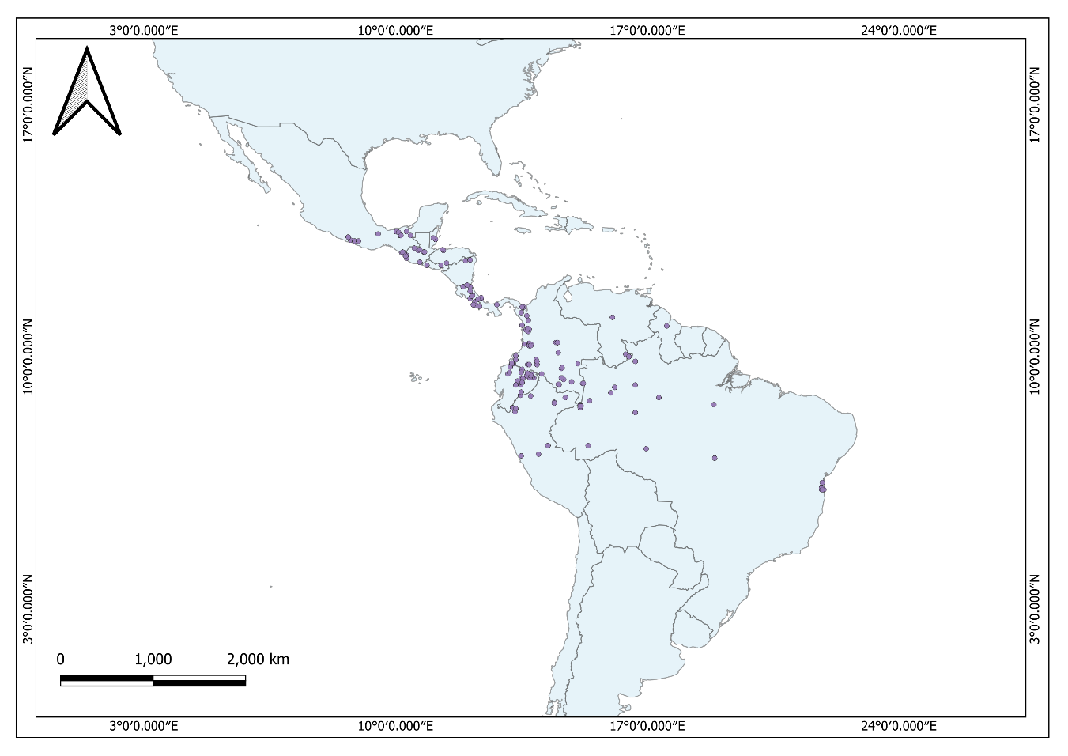
Figure S1: Theobroma bicolor occurrence data in the Americas, downloaded from GBIF (www.gbif.org)
Table S1: Coordinates of agroforestry systems where fruit and leaves of Theobroma bicolor were collected.
Site | Country | State | Cacao region | Latitude | Longitude
1 | Mexico | Tabasco | Chontalpa | 18.1867945 | -93.236017
2 | Mexico | Tabasco | Chontalpa | 18.1810181 | -93.2438954
3 | Mexico | Tabasco | Chontalpa | 18.1805661 | -93.2440083
4 | Mexico | Tabasco | Chontalpa | 18.1802675 | -93.2442064
5 | Mexico | Tabasco | Chontalpa | 18.1808008 | -93.244245
6 | Mexico | Tabasco | Chontalpa | 18.1808112 | -93.243167
7 | Mexico | Tabasco | Chontalpa | 18.230154 | -93.3572938
8 | Mexico | Tabasco | Chontalpa | 18.0085341 | -93.2981773
9 | Mexico | Tabasco | Chontalpa | 18.1826971 | -93.2435086
10 | Mexico | Tabasco | Chontalpa | 18.280802 | -93.266485
11 | Mexico | Tabasco | Sierra | 17.4637109 | -92.8329020
12 | Mexico | Oaxaca | Chinantla | 17.7910113 | -96.4847902
13 | Mexico | Oaxaca | Chinantla | 17.7810113 | -96.4847862
14 | Mexico | Oaxaca | Chinantla | 17.787039 | -96.4850601
15 | Mexico | Oaxaca | Chinantla | 17.7737455 | -96.4823427
16 | Mexico | Oaxaca | Chinantla | 17.7615608 | -96.3837116
17 | Mexico | Oaxaca | Chinantla | 17.7617349 | -96.3603433
18 | Mexico | Oaxaca | Chinantla | 17.7609008 | -96.3607702
19 | Mexico | Oaxaca | Chinantla | 17.7621783 | -96.3846451
20 | Mexico | Oaxaca | Chinantla | 17.7621789 | -96.3846451
21 | Mexico | Oaxaca | Chinantla | 17.7620567 | -96.3883889
22 | Mexico | Tabasco | Sierra | 17.4637106 | -92.8329019
23 | Mexico | Chiapas | Soconusco | 15.0481778 | -92.1886701
24 | Mexico | Chiapas | Soconusco | 15.08992 | -92.36014
25 | Mexico | Chiapas | Soconusco | 15.08773 | -92.35959
26 | Mexico | Chiapas | Soconusco | 14.85026 | -92.30088
27 | Mexico | Chiapas | Soconusco | 14.85023 | -92.30087
28 | Mexico | Chiapas | Soconusco | 14.85024 | -92.30086
29 | Mexico | Chiapas | Soconusco | 14.85023 | -92.30088
30 | Mexico | Chiapas | Soconusco | 14.92478 | -92.18675
31 | Mexico | Chiapas | Soconusco | 14.92276 | -92.18797
32 | Mexico | Chiapas | Soconusco | 14.92393 | -92.19036
33 | Mexico | Chiapas | Soconusco | 14.92396 | -92.19036
34 | Mexico | Chiapas | Soconusco | 14.92437 | -92.19196
35 | Mexico | Chiapas | Soconusco | 14.92508 | -92.18571
36 | Mexico | Guerrero | Costa Chica | 15.04846 | -92.18844
37 | Mexico | Guerrero | Costa Chica | 16.99315 | -99.31073
38 | Mexico | Guerrero | Costa Chica | 16.99447 | -9930196
39 | Mexico | Guerrero | Costa Chica | 17.00075 | -99303.318
40 | Mexico | Guerrero | Costa Chica | 17.01369 | -9927952
41 | Mexico | Guerrero | Costa Chica | 16.89715 | -9908179
42 | Mexico | Guerrero | Costa Chica | 16.8967 | -99.08064
43 | Mexico | Guerrero | Costa Chica | 16.89087 | -99.08864
44 | Mexico | Guerrero | Costa Chica | 16.89587 | -99.08332
45 | Mexico | Guerrero | Costa Chica | 16.89294 | -9908193
46 | Mexico | Guerrero | Costa Chica | 16.893 | -99.08196
47 | Mexico | Guerrero | Costa Chica | 17.02594 | -98.76976
48 | Mexico | Guerrero | Costa Chica | 17.0259 | -98.76976
49 | Mexico | Guerrero | Costa Chica | 17.02816 | -98.77396
50 | Mexico | Guerrero | Costa Chica | 17.02475 | -98.77718
51 | Mexico | Guerrero | Costa Chica | 17.03158 | -98.77768
52 | Mexico | Guerrero | Costa Chica | 17.03036 | -98.77767
53 | Mexico | Guerrero | Costa Chica | 17.02964 | -98.77876

Table S2: Molecular markers assayed for amplification of DNA fragments of pataxte samples (Theobroma bicolor Humb. & Bonpl.) collected at sites from five cacao-growing regionss of southeastern Mexico. *Chloroplast regions; +nuclear regions. NA = did not amplify; TA = annealing temperature; ta = annealing time; Size = expected size of the amplicon; Reference = reference where molecular markers are reported; Accession No. = GenBank accession number of the reference sequences.

Molecular marker | N | TA | ta | Size | Reference | Accession No.
trnH-psbA * | 9 | 58 °C | 40 min | 498 bp | Gutiérrez-López et al. 2016 | KU061059.1
trnL-trnF * | 21 | 58 °C | 2 min | 590 bp | Taberlet et al. 1991 | EF010969.1
psbJ-petA * | 26 | 51 °C | 1 min | 1269 bp | Shaw et al. 2007. | NC073584.1
psbD-trnT * | 7 | 51 °C | 1 min | 1218 bp | Shaw et al. 2007 | JQ228389.1
ITS 1+ | 7 | 57 °C | 0.45 seg | 2600 bp | White et al. 1990 | NA
WRKY11+ | 7 | 72 °C | 1 min | 1054 bp | Borrone et al. 2007 | AY331171.2
WRKY12+ | 9 | 60 °C | 1 min | 843 bp | Borrone et al. 2007 | NA
WRKY13+ | 6 | 62 °C | 1 min | 1165 bp | Borrone et al. 2007. | OY284462.1
WRKY14+ | 21 | 60 °C | 1 min | 486 bp | Borrone et al. 2007 | AY331177.1

Literature Cited

Borrone JW, Meerow AW, Kuhn DN, Whitlock BA, Schnell RJ. 2007. The potential of the WRKY gene family for phylogenetic reconstruction: an example from the Malvaceae. Molecular Phylogenetic Evolution 44: 1141-1154. DOI: https://doi.org/10.1016/j.ympev.2007.06.012
Gutiérrez-López N, Ovando-Medina I, Salvador-Figueroa M, Molina-Freaner F, Avendaño-Arrazate CH, Vázquez-Ovando A. 2016. Unique haplotypes of cacao trees as revealed by trnH-psbA chloroplast DNA. PeerJ 4: e1855. DOI: https://doi.org/10.7717/peerj.1855
Shaw J, Lickey EB, Schilling EE, Small RL. 2007. Comparison of whole chloroplast genome sequences to choose noncoding regions for phylogenetic studies in angiosperms: the tortoise and the hare III. American Journal of Botany 94: 275-288. DOI: https://doi.org/10.3732/ajb.94.3.275
Taberlet P, Gielly L, Pautou G, Bouvet J. 1991. Universal primer for amplification of three non-coding regions of chloroplast DNA. Plant Molecular Biology 17: 1105-1109. DOI: https://doi.org/10.1007/BF00037152
White TJ, Bruns T, Lee S, Taylor J. 1990. Amplification and direct sequencing of fungal ribosomal RNA genes for phylogenetics. In: Inis MA, Gelfand DH, Sninsky JJ, White TJ, eds. PCR- Protocols and Applications- a Laboratory Manual. California, USA: Academic Press. Pp. 315-322. ISBN 0-12-372180-6

