Material Suplementario
Tabla S1. Especies de macrohongos observadas: frecuencia de ocurrencia, hábito ecológico y fenología estacional.
Especie |  | Mes de colecta |  |  |  |  |  |  |  |  |  |  |  | Hábito |  | Fenología de los esporomas
 |  | Jun. |  | Jul. |  | Ago. |  | Sep. |  | Oct. |  | Nov.
Familia Agaricaceae
Agaricaceae sp. 1 |  |  |  |  |  | X |  |  |  |  |  |  |  | L |  | V
Agaricaceae sp. 2 |  |  |  |  |  |  |  | X |  |  |  |  |  | L |  | V
Género Agaricus
Agaricus aff. denisi |  |  |  |  |  |  |  |  |  |  |  | X |  | H |  | O
Agaricus aff. atroumbonatus |  |  |  |  |  |  |  |  |  |  |  | X |  | H |  | O
Agaricus aff. dulcidulos |  |  |  |  |  |  |  |  |  |  |  | X |  | H |  | V
Agaricus sp.1 |  |  |  |  |  | X |  |  |  |  |  |  |  | T |  | O
Agaricus sp.2 |  |  |  |  |  |  |  |  |  |  |  | X |  | T |  | O
Agaricus sp.3 |  |  |  |  |  |  |  |  |  |  |  | X |  | T |  | O
Coprinus
Coprinus sp.1 |  |  |  | X |  |  |  |  |  |  |  |  |  | L |  | V
Lepiota
Lepiota aff. mucronata |  |  |  |  |  |  |  |  |  |  |  | X |  | H |  | O
Lepiota sp.1 |  |  |  |  |  |  |  |  |  |  |  | X |  | H |  | O
Amanitaceae
Amanita
Amanita aff. vaginata |  |  |  |  |  |  |  |  |  |  |  | X |  | T |  | O
Amanita sp.1 |  |  |  |  |  |  |  | X |  |  |  |  |  | L |  | V
Auriculariaceae
Auricularia
Auricularia aff. cornea |  |  |  |  |  |  |  |  |  |  |  | X |  | L |  | O
Auricularia fuscosuccinea (Mont.) Henn. |  |  |  |  |  |  |  | X |  |  |  |  |  | L |  | V-O
Bolbitiaceae
Especie |  | Mes de colecta |  |  |  |  |  |  |  |  |  |  |  | Hábito |  | Fenología de los esporomas
 |  | Jun. |  | Jul. |  | Ago. |  | Sep. |  | Oct. |  | Nov.
Conocybe
Conocybe sp.1 |  | X |  |  |  | X |  | X |  |  |  |  |  | H, T |  | P-V
Conocybe sp.2 |  |  |  |  |  | X |  | X |  |  |  |  |  | H, L |  | V
Conocybe sp.3 |  |  |  |  |  | X |  |  |  |  |  |  |  | H |  | V
Conocybe sp.4 |  |  |  |  |  | X |  |  |  |  |  |  |  | H |  | V
Conocybe sp.5 |  |  |  |  |  | X |  |  |  |  |  |  |  | L |  | V
Boletaceae
Boletaceae sp.1 |  |  |  |  |  |  |  | X |  |  |  |  |  | L |  | V
Boletaceae sp.2 |  |  |  |  |  | X |  | X |  |  |  |  |  | L |  | V
Cortinariaceae
Cortinariaceae sp.1 |  |  |  |  |  |  |  |  |  |  |  | X |  | L |  | O
Entomolataceae
Entoloma
Entoloma sp.1 |  |  |  |  |  |  |  |  |  |  |  | X |  | H |  | O
Fomitopsidaceae
Rhodofomitopsis
Rhodofomitopsis feei (Fr.) B.K.Cui, M.L.Han & Y.C.Dai |  | X |  | X |  | X |  | X |  | X |  |  |  | L |  | P-V-O
Geastraceae
Geastrum
Geastrum campestre Morgan |  |  |  |  |  | X |  | X |  |  |  |  |  | L |  | V
Geastrum schweinitzii (Berk. & M.A.Curtis) Zeller |  |  |  |  |  | X |  |  |  |  |  |  |  | L |  | V
Geastrum sp.1 |  |  |  |  |  | X |  |  |  |  |  |  |  | T |  | V
Geastrum sp.2 |  |  |  |  |  |  |  | X |  |  |  |  |  | T
Geastrum spegazzinianum De Toni |  |  |  |  |  | X |  | X |  |  |  | X |  | H, T |  | O
Gomphaceae
Phaeoclavulina
Phaeoclavulina cyanocephala (Berk. & MA Curtis) Giachini |  |  |  |  |  |  |  | X |  |  |  |  |  | T |  | V
Ramaria
Ramaria sp.1* |  |  |  |  |  |  |  | X |  |  |  |  |  | T |  | O
Especie |  | Mes de colecta |  |  |  |  |  |  |  |  |  |  |  | Hábito |  | Fenología de los esporomas
 |  | Jun. |  | Jul. |  | Ago. |  | Sep. |  | Oct. |  | Nov.
Ramaria sp.2* |  |  |  |  |  |  |  |  |  |  |  | X |  | L, T |  | O
Ramaria sp.3* |  |  |  |  |  |  |  |  |  |  |  | X |  | H |  | O
Hymenochaetaceae
Fuscoporia
Fuscoporia sp.1 |  |  |  |  |  |  |  | X |  |  |  |  |  | L |  | V
Phellinus
Phellinus sp.1 |  |  |  | X |  |  |  |  |  |  |  |  |  | L |  | V
Phylloporia
Phylloporia sp.1 |  |  |  | X |  | X |  | X |  | X |  |  |  | T |  | V-O
Phylloporia verae-crucis (Berk. ex Sacc.) Ryvarden |  |  |  |  |  |  |  | X |  |  |  |  |  | H, T |  | V
Hypoxylaceae
Daldinia
Daldinia childiae J.D. Rogers & Y.M. Ju |  |  |  |  |  |  |  |  |  |  |  | X |  | L |  | O
Marasmiaceae
Marasmiaceae sp.1 |  |  |  |  |  | X |  | X |  |  |  |  |  | H, L |  | V
Marasmiaceae sp.2 |  |  |  |  |  | X |  |  |  |  |  |  |  | L |  | V
Marasmius
Marasmius aciculiformis Berk. & M.A. Curtis |  |  |  |  |  | X |  |  |  |  |  |  |  | L |  | V
Marasmius crinis-equi F. Muell. ex Kalchbr. |  |  |  |  |  | X |  | X |  |  |  |  |  | L |  | V
Marasmius elegans (Cleland) Grgur. |  |  |  |  |  |  |  |  |  |  |  | X |  | L |  | O
Marasmius fulvoferrugineus Gilliam |  |  |  |  |  |  |  |  |  |  |  | X |  | L |  | O
Marasmius haematocephalus (Mont.) Fr. |  |  |  |  |  |  |  | X |  |  |  |  |  | L |  | O
Marasmius sp.1 |  |  |  | X |  | X |  | X |  |  |  |  |  | L |  | O
Marasmius sp.2 |  |  |  |  |  | X |  |  |  |  |  |  |  | H, L |  | V-O
Marasmius sp.3 |  |  |  |  |  |  |  | X |  |  |  |  |  | H, L |  | V
Marasmius sp.4 |  |  |  |  |  |  |  | X |  |  |  |  |  | L |  | V
Marasmius sp.5 |  |  |  |  |  |  |  |  |  |  |  | X |  | L |  | O
Marasmius sp.6 |  |  |  |  |  |  |  |  |  |  |  | X |  | L |  | O
Trogia
Especie |  | Mes de colecta |  |  |  |  |  |  |  |  |  |  |  | Hábito |  | Fenología de los esporomas
 |  | Jun. |  | Jul. |  | Ago. |  | Sep. |  | Oct. |  | Nov.
Trogia cantharelloides (Mont.) Pat. |  |  |  |  |  |  |  | X |  |  |  | X |  | H, L |  | V-O
Trogia sp.1 |  |  |  |  |  |  |  | X |  | X |  |  |  | L |  | O
Mycenaceae
Mycena
Mycena holoporphyra (Berk. & M.A. Curtis) Singer |  |  |  |  |  |  |  | X |  |  |  |  |  | L |  | V
Mycena sp.1 |  |  |  |  |  |  |  | X |  |  |  |  |  | L |  | V
Phallaceae
Clathrus
Clathrus ruber P. Micheli ex Pers. |  |  |  | X |  |  |  |  |  |  |  |  |  | T |  | V
Pleurotaceae
Pleurotus
Pleurotus djamor (Rumph. ex Fr.) Boedijn |  |  |  |  |  | X |  | X |  |  |  |  |  | L |  | V
Pluteaceae
Pluteus
Pluteus oligocystis Singer |  |  |  |  |  |  |  |  |  |  |  | X |  | L |  | O
Polyporaceae
Polyporaceae sp.1 |  |  |  |  |  | X |  |  |  |  |  |  |  | L |  | V
Polyporaceae sp.2 |  |  |  |  |  |  |  |  |  |  |  | X |  | L |  | O
Cellulariella
Cellulariella acuta (Berk.) Zmitr. & Malysheva |  |  |  |  |  | X |  |  |  |  |  |  |  | L |  | V
Cerioporus
Cerioporus varius (Pers.) Zmitr. & Kovalenko |  |  |  | X |  |  |  |  |  |  |  |  |  | L |  | V
Coriolopsis
Coriolopsis byrsina (Mont.) Ryvarden |  |  |  | X |  |  |  |  |  |  |  |  |  | L |  | V
Favolus
Favolus philippinensis (Berk.) Sacc. |  |  |  |  |  |  |  |  |  |  |  | X |  | L |  | O
Favolus tenuiculus P. Beauv. |  |  |  |  |  |  |  | X |  |  |  | X |  | L |  | V-O
Hexagonia
Hexagonia sp.1 |  |  |  |  |  | X |  |  |  |  |  |  |  | L |  | V
Especie |  | Mes de colecta |  |  |  |  |  |  |  |  |  |  |  | Hábito |  | Fenología de los esporomas
 |  | Jun. |  | Jul. |  | Ago. |  | Sep. |  | Oct. |  | Nov.
Lentinus
Lentinus aff. crinitus |  |  |  |  |  |  |  |  |  |  |  | X |  | L |  | O
Lentinus sp.1 |  |  |  |  |  |  |  |  |  | X |  |  |  | L |  | O
Polyporus
Polyporus sp.1 |  |  |  |  |  |  |  | X |  |  |  |  |  | L |  | V
Trametes
Trametes maxima (Mont.) A. David & Rajchenb. |  | X |  |  |  | X |  | X |  |  |  | X |  | L |  | P-V-O
Trametes sp.1 |  | X |  |  |  |  |  | X |  |  |  |  |  | L |  | P-O
Trametes versicolor (L.) Lloyd |  | X |  |  |  | X |  |  |  |  |  | X |  | L |  | P-V-O
Rickenellaceae
Cotylidia
Cotylidia aurantiaca (Pat.) A.L. Welden |  |  |  | X |  | X |  | X |  | X |  |  |  | H, L |  | V-O
Cotylidia sp.1 |  |  |  |  |  |  |  | X |  |  |  |  |  | L |  | V
Sarcoscyphaceae
Cookeina
Cookeina speciosa (Fr.) Dennis |  |  |  |  |  |  |  |  |  |  |  | X |  | L |  | O
Cookeina sulcipes (Berk.) Kuntze |  |  |  |  |  |  |  |  |  |  |  | X |  | L |  | O
Cookeina tricholoma (Mont.) Kuntze |  |  |  |  |  |  |  | X |  | X |  |  |  | L |  | V-O
Schizophyllaceae
Schizophyllum
Schizophyllum commune Fr. |  |  |  |  |  | X |  | X |  |  |  | X |  | L |  | V-O
Steccherinaceae
Steccherinum
Steccherinum nitidum (Pers.) Vesterh. |  | X |  |  |  |  |  |  |  |  |  |  |  | L |  | P
Thelephoraceae
Thelephora
Thelephora aff. versatilis* |  |  |  | X |  | X |  | X |  | X |  | X |  | L |  | V-O
Thelephora sp.2* |  |  |  |  |  |  |  | X |  |  |  |  |  | L |  | V
Thelephora sp.3* |  |  |  |  |  |  |  | X |  |  |  |  |  | L |  | V
Especie |  | Mes de colecta |  |  |  |  |  |  |  |  |  |  |  | Hábito |  | Fenología de los esporomas
 |  | Jun. |  | Jul. |  | Ago. |  | Sep. |  | Oct. |  | Nov.
Tricholomataceae
Leucopaxillus
Leucopaxillus gracillimus Singer & A.H. Sm.* |  |  |  |  |  |  |  |  |  |  |  | X |  | L |  | O
Volvariellaceae
Volvariella
Volvariella sp.1 |  |  |  |  |  |  |  |  |  |  |  | X |  | H |  | O
Xylariaceae
Xylaria
Xylaria hypoxylon (L.) Grev. |  | X |  |  |  |  |  |  |  |  |  | X |  | L |  | P
Xylaria polymorpha (Pers.) Grev. |  |  |  |  |  | X |  | X |  |  |  | X |  | L, T |  | O
Xylaria sp.1 |  | X |  |  |  | X |  | X |  | X |  |  |  | L, H |  | P-V-O
Xylaria sp.2 |  |  |  |  |  |  |  | X |  |  |  | X |  | L |  | V-O
Xylaria sp.3 |  |  |  |  |  |  |  | X |  |  |  |  |  | L |  | V
Xylaria sp.4 |  |  |  |  |  | X |  |  |  |  |  |  |  | L |  | V
Xylaria sp.5 |  |  |  |  |  |  |  |  |  |  |  | X |  | L |  | V
Xylocoremium sp.1 |  |  |  |  |  |  |  |  |  |  |  | X |  | L |  | O
Sin identificación
Agarical sp.1 |  |  |  |  |  | X |  |  |  |  |  |  |  | H, T |  | V
Agarical sp.2 |  |  |  |  |  | X |  | X |  |  |  |  |  | H |  | V
Agarical sp.3 |  |  |  | X |  |  |  |  |  |  |  |  |  | T |  | V
Agarical sp.4 |  |  |  |  |  | X |  |  |  |  |  |  |  | H |  | V
Agarical sp.5 |  |  |  |  |  | X |  |  |  |  |  |  |  | L |  | V
Agarical sp.6 |  |  |  |  |  | X |  | X |  |  |  |  |  | L |  | V
Agarical sp.7 |  |  |  |  |  |  |  | X |  |  |  |  |  | H |  | V
Agarical sp.8 |  |  |  |  |  |  |  | X |  |  |  |  |  | H |  | V
Agarical sp.9 |  |  |  |  |  |  |  | X |  |  |  | X |  | H |  | V
Polyporaceo sp.1 |  |  |  |  |  | X |  |  |  |  |  |  |  | L |  | V
Polyporaceo sp.2 |  |  |  |  |  |  |  | X |  |  |  |  |  | L |  | V
Polyporaceo sp.3 |  |  |  |  |  |  |  | X |  |  |  |  |  | L |  | V
Especie |  | Mes de colecta |  |  |  |  |  |  |  |  |  |  |  | Hábito |  | Fenología de los esporomas
 |  | Jun. |  | Jul. |  | Ago. |  | Sep. |  | Oct. |  | Nov.
Polyporaceo sp.4 |  |  |  |  |  |  |  | X |  |  |  |  |  | L |  | V
Polyporaceo sp.5 |  |  |  |  |  |  |  |  |  |  |  | X |  | L |  | V
Taxón sp.01 |  | X |  |  |  | X |  |  |  |  |  |  |  | H, L |  | V
Taxón sp.06 |  |  |  |  |  | X |  |  |  |  |  |  |  | L |  | V
Taxón sp.08 |  |  |  |  |  |  |  | X |  |  |  |  |  | H |  | V
Taxón sp.09 |  |  |  |  |  |  |  | X |  |  |  |  |  | L |  | V
Taxón sp.10 |  |  |  |  |  | X |  |  |  |  |  |  |  | H |  | V
Taxón sp.12 |  |  |  |  |  | X |  |  |  |  |  |  |  | H |  | V
Taxón sp.13 |  |  |  |  |  | X |  |  |  |  |  |  |  | L |  | V
Taxón sp.14 |  |  |  |  |  |  |  | X |  |  |  |  |  | L |  | O
Taxón sp.15 |  |  |  |  |  |  |  | X |  |  |  |  |  | H, L |  | V
Taxón sp.16 |  |  |  |  |  | X |  | X |  |  |  |  |  | H, L |  | V
Nota: Abreviaciones; L = Lignícola; H = Humícola; T = Terrícola; * = Ectomicorriza; P = Primavera; V = Verano; O = Otoño

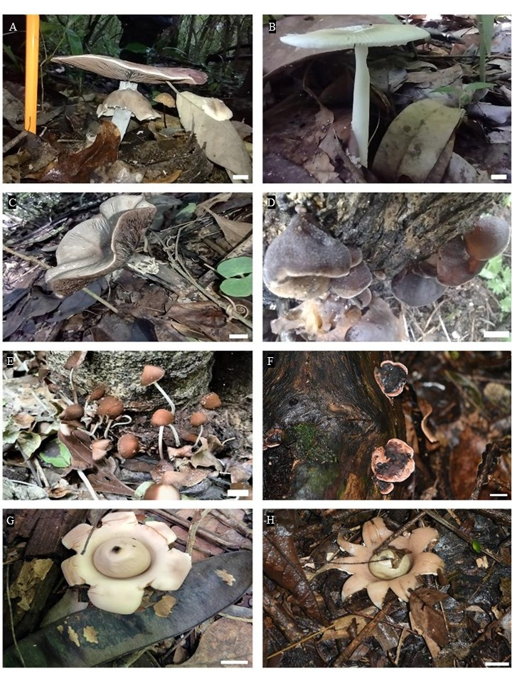
Figura S1. Diversidad de macrohongos recolectados en una selva mediana subperennifolia en trópico subhúmedo: A) Agaricus sp.1; B) Agaricus sp.2; C) Agaricus sp.3; D) Auricularia fuscosuccinea; E) Conocybe sp.1; F) Rhodofomitopsis feei; G) Geastrum spegazzinianum; H) Geastrum sp.1. Barra de escala = 10 mm
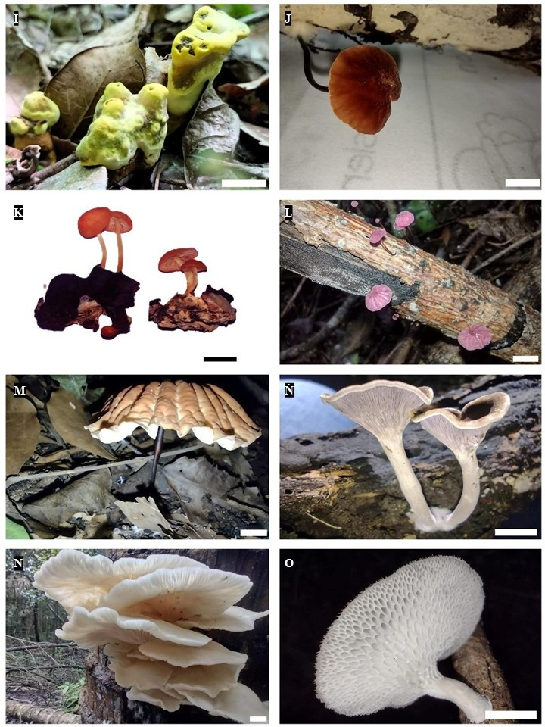
Figura S2. I) Phylloporia sp.1; J) Marasmius crinis-equi; K) Marasmius elegans; L) Marasmius haematocephalus; M) Marasmius sp.1; Ñ) Trogia cantharelloides; N) Pleurotus djamor; O) Favolus tenuiculus. Barra de escala = 10 mm
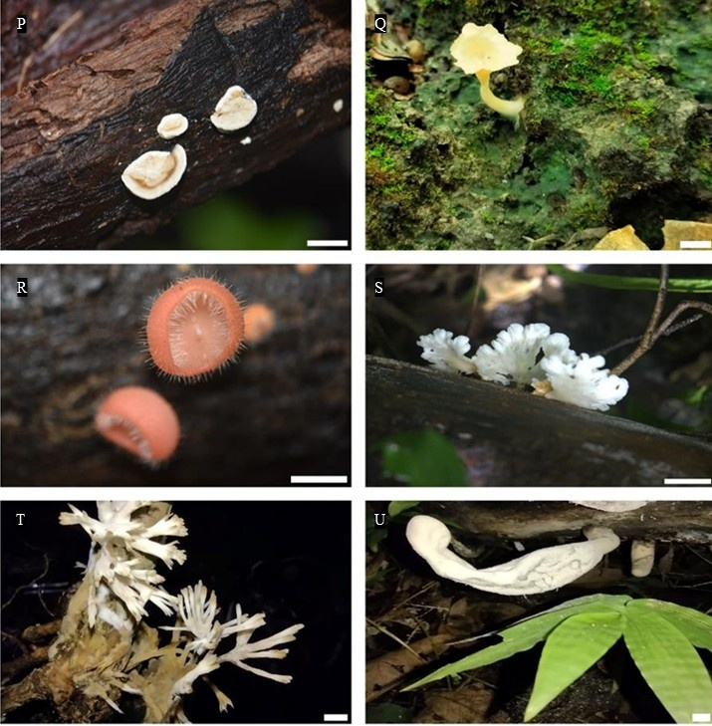
Figura S3. P) Trametes sp.1; Q) Cotylidia aurantiaca; R) Cookeina tricholoma; S) Schizophyllum commune; T) Thelephora aff. versatilis; U) Xylaria polimorpha. Barra de escala = 10 mm

