Supplementary material

Table S1. Functional traits mean value per species. Species abbreviations: Af: Adenostoma fasciculatum, Cd: Cneoridium dumosum, Ef: Eriogonum fasciculatum, Fp: Fraxinus parryi, Ml: Malosma laurina, Oo: Ornithostaphylos oppositifolia, Sa: Salvia apiana, Rc: Rhamnus crocea, Xb: Xylococcus bicolor. Trait abbreviations: biomass: above-ground biomass (dry mass g / m²), phenology (unitless), stem growth (cm), NDVI: Normalized difference vegetation index (-1 to 1, unitless), PRI: Photochemical Reflectance Index(-1 to 1, unitless), WBI: Water based Index (-1 to 1, unitless), Cover: canopy cover per m² in %, Basal_stem: Basal stem diameter (mm), H: plant height (m), LA: leaf area (cm²), Lth: Leaf thickness (mm), Lden: Leaf density (g/cm³), LMA: Leaf dry mass per unit area (g / cm²), LDMC: Leaf dry mass content (%). ND = Non-determined.

Species | Af | SE | Cd | SE | Ef | SE | Fp | SE | Ml | SE | Oo | SE | Sa | SE | Rc | SE | Xb | SE
Biomass | 9.8 | ND | 3.08 | ND | 10.8 | ND | 0.55 | ND | 16.6 | ND | 15.2 | ND | 0.99 | ND | 0.03 | ND | 0.92 | ND
Phenology | 0.26 | 0.03 | 0.34 | 0.06 | 0.39 | 0.07 | 0.67 | 0.18 | 0.10 | 0.04 | 0.26 | 0.06 | 0.47 | 0.13 | 0.31 | 0.06 | 0.27 | 0.08
Growth | 0.51 | 0.5 | 0.34 | 0.3 | 0.31 | 0.2 | 2.34 | 1.3 | 0.77 | 0.3 | 0.74 | 0.4 | 2.07 | 0.8 | 0.11 | 0.07 | 0.40 | 0.2
NDVI | 0.32 | 0.07 | 0.40 | 0.04 | 0.34 | 0.06 | 0.51 | 0.04 | 0.33 | 0.02 | 0.24 | 0.03 | 0.29 | 0.02 | 0.33 | 0.03 | 0.51 | 0.03
PRI | 0.21 | 0.01 | 0.34 | 0.01 | 0.08 | 0.02 | 0.10 | 0.01 | 0.15 | 0.01 | 0.08 | 0.03 | 0.91 | 0.004 | 0.48 | 0.008 | 0.27 | 0.006
WBI | 0.07 | 0.06 | 0.26 | 0.02 | 0.04 | 0.07 | 0.03 | 0.003 | 0.03 | 0.006 | 0.03 | 0.006 | 0.12 | 0.005 | 0.40 | 0.02 | 0.04 | 0.02
Cover | 12.4 | 2.3 | 11 | 1.9 | 5.35 | 1.3 | 30.5 | 8.5 | 40 | 10.2 | 28.5 | 4.9 | 8.5 | 0.3 | 19.7 | 5 | 21.3 | 5.1
Basal_stem | 13.8 | ND | 60.3 | ND | 11 | ND | 23.3 | ND | 18.2 | ND | 20.5 | ND | ND | ND | 32.2 | ND | 21.5 | ND
H | 1.8 | 0.1 | 1.3 | 0.06 | 1.1 | 0.1 | 3.6 | 0.4 | 2.2 | 0.2 | 2.2 | 0.2 | 1 | 0.2 | 1.6 | 0.06 | 1.6 | 0.1
LA | 0.06 | 0.003 | 0.68 | 0.02 | 0.08 | 0.03 | 1.45 | 0.05 | 11.6 | 0.02 | 1.37 | 0.02 | 0.3 | ND | 0.53 | 0.02 | 2.46 | 0.02
Lth | 0.86 | 0.06 | 0.30 | 0.02 | 0.47 | 0.03 | 0.17 | 0.02 | 0.42 | 0.06 | 0.42 | 0.08 | ND | ND | 0.34 | 0.01 | 0.46 | 0.03
Lden | 0.03 | 0.004 | 0.07 | 0.005 | 0.06 | 0.01 | 0.12 | 0.01 | 0.08 | 0.01 | 0.09 | 0.02 | ND | ND | 0.06 | 0.003 | 0.08 | 0.006
LMA | 0.02 | 0.003 | 0.021 | 0.002 | 0.026 | 0.006 | 0.02 | 0.003 | 0.032 | 0.002 | 0.028 | 0.003 | 0.014 | ND | 0.02 | 0.001 | 0.036 | 0.003
LDMC | 63 | 2.8 | 61 | 1.8 | 75 | 6.5 | 95 | 5.7 | 55 | 2.9 | 59 | 4.1 | 31 | ND | 52 | 8.3 | 57 | 2.5

Table S2. Linear correlation coefficients among 11 functional traits and three vegetation indices for average data for six individuals of nine species measured during nine months (Oct 2017 to May 2018) in chaparral shrub vegetation in Rancho El Mogor, Baja California, México. Trait abbreviations: biomass: above ground biomass (dry mass g / m²), phenology (unitless), stem growth (cm), NDVI: Normalized difference vegetation index (-1 to 1, unitless), PRI: Photochemical Reflectance Index (-1 to 1, unitless), WBI: Water based Index (-1 to 1, unitless), Cover: canopy cover per m² in %, Basal stem: Basal stem diameter (mm), H: plant height (m), LA: leaf area (cm²), Lth: Leaf thickness (mm), Lden: Leaf density (g/cm³), LMA: Leaf dry mass per unit area (g / cm²), LDMC: Leaf dry mass content (%).
Pearson's Correlations
Variable |  |  |  | biomass |  | relative_cover |  | phenology |  | growth |  | ndvi |  | pri |  | wbi |  | Basal_stem |  | H |  | LA |  | Lth |  | Lden |  | LMA |  | LDMC
1. biomass |  | Pearson's r |  | —
 |  | p-value |  | —
2. relative_cover |  | Pearson's r |  | 0.621 |  | —
 |  | p-value |  | 0.074 |  | —
3. phenology |  | Pearson's r |  | -0.620 |  | -0.257 |  | —
 |  | p-value |  | 0.075 |  | 0.505 |  | —
4. growth |  | Pearson's r |  | -0.485 |  | 0.053 |  | 0.161 |  | —
 |  | p-value |  | 0.186 |  | 0.892 |  | 0.679 |  | —
5. ndvi |  | Pearson's r |  | 0.163 |  | -0.160 |  | -0.105 |  | -0.118 |  | —
 |  | p-value |  | 0.676 |  | 0.682 |  | 0.788 |  | 0.762 |  | —
6. pri |  | Pearson's r |  | 0.082 |  | 0.219 |  | 0.433 |  | 0.276 |  | -0.122 |  | —
 |  | p-value |  | 0.833 |  | 0.571 |  | 0.244 |  | 0.473 |  | 0.755 |  | —
7. wbi |  | Pearson's r |  | 0.392 |  | 0.318 |  | 0.159 |  | -0.340 |  | 0.166 |  | 0.165 |  | —
 |  | p-value |  | 0.297 |  | 0.404 |  | 0.683 |  | 0.370 |  | 0.669 |  | 0.672 |  | —
8. Basal_stem |  | Pearson's r |  | -0.462 |  | -0.418 |  | 0.138 |  | 0.127 |  | -0.266 |  | -0.332 |  | -0.575 |  | —
 |  | p-value |  | 0.249 |  | 0.303 |  | 0.745 |  | 0.764 |  | 0.524 |  | 0.422 |  | 0.136 |  | —
9. H |  | Pearson's r |  | 0.072 |  | -0.077 |  | 0.436 |  | -0.507 |  | 0.413 |  | -7.196×10⁻⁴ |  | 0.265 |  | -0.191 |  | —
 |  | p-value |  | 0.853 |  | 0.845 |  | 0.241 |  | 0.164 |  | 0.269 |  | 0.999 |  | 0.491 |  | 0.650 |  | —
10. LA |  | Pearson's r |  | 0.516 |  | -0.270 |  | -0.543 |  | -0.627 |  | 0.282 |  | -0.327 |  | 0.078 |  | -0.171 |  | 0.265 |  | —
 |  | p-value |  | 0.155 |  | 0.483 |  | 0.131 |  | 0.071 |  | 0.463 |  | 0.391 |  | 0.842 |  | 0.685 |  | 0.490 |  | —
11. Lth |  | Pearson's r |  | 0.400 |  | 0.453 |  | -0.542 |  | -0.001 |  | 0.284 |  | -0.017 |  | 0.016 |  | -0.466 |  | -0.391 |  | -0.100 |  | —
 |  | p-value |  | 0.326 |  | 0.260 |  | 0.165 |  | 0.998 |  | 0.496 |  | 0.967 |  | 0.970 |  | 0.245 |  | 0.338 |  | 0.814 |  | —
12. Lden |  | Pearson's r |  | -0.168 |  | -0.209 |  | 0.427 |  | -0.015 |  | 0.090 |  | -7.172×10⁻⁴ |  | 0.061 |  | 0.082 |  | 0.737 |  | 0.232 |  | -0.811 |  | —
 |  | p-value |  | 0.691 |  | 0.620 |  | 0.291 |  | 0.972 |  | 0.832 |  | 0.999 |  | 0.885 |  | 0.846 |  | 0.037 |  | 0.580 |  | 0.015 |  | —
13. LMA |  | Pearson's r |  | 0.448 |  | 0.202 |  | -0.462 |  | -0.274 |  | -0.302 |  | 0.009 |  | -0.274 |  | -0.334 |  | 0.093 |  | 0.555 |  | 0.045 |  | 0.192 |  | —
 |  | p-value |  | 0.227 |  | 0.603 |  | 0.211 |  | 0.476 |  | 0.430 |  | 0.982 |  | 0.476 |  | 0.418 |  | 0.812 |  | 0.121 |  | 0.916 |  | 0.648 |  | —
14. LDMC |  | Pearson's r |  | 0.064 |  | 0.067 |  | 0.608 |  | -0.241 |  | 0.095 |  | 0.656 |  | 0.091 |  | -0.182 |  | 0.683 |  | -0.086 |  | -0.337 |  | 0.513 |  | 0.121 |  | —
 |  | p-value |  | 0.869 |  | 0.865 |  | 0.082 |  | 0.532 |  | 0.808 |  | 0.055 |  | 0.816 |  | 0.666 |  | 0.043 |  | 0.827 |  | 0.414 |  | 0.194 |  | 0.757 |  | —
Table S3. Component loadings of a principal component analysis summarizing five functional traits (Phen: average relative leaf number, LA: leaf area, LMA: leaf mass per unit area, H: shrub height, Growth: stem longitudinal growth), and three vegetation indices (NDVI: Normalized Difference Vegetation Index, PRI: Photochemical Reflectance Index, WBI: Water Based Index).

Component Loadings
 |  | RC1 |  | RC2 |  | RC3 |  | Uniqueness
Growth |  | 1.034 |  |  |  |  |  | 0.021
Phen |  | 0.723 |  | -0.406 |  | 0.406 |  | 0.051
LMA |  | -0.594 |  | 0.477 |  |  |  | 0.136
H |  | 0.461 |  | 0.417 |  | 0.485 |  | 0.262
LA |  |  |  | 0.888 |  |  |  | 0.274
WBI |  |  |  | -0.782 |  |  |  | 0.346
NDVI |  |  |  |  |  | 0.896 |  | 0.283
PRI |  |  |  |  |  | -0.623 |  | 0.257
Note. Applied rotation method is promax.

Figure S1. Location of individuals and species within the Rancho El Mogor, Valle de Guadalupe, Baja California, México.
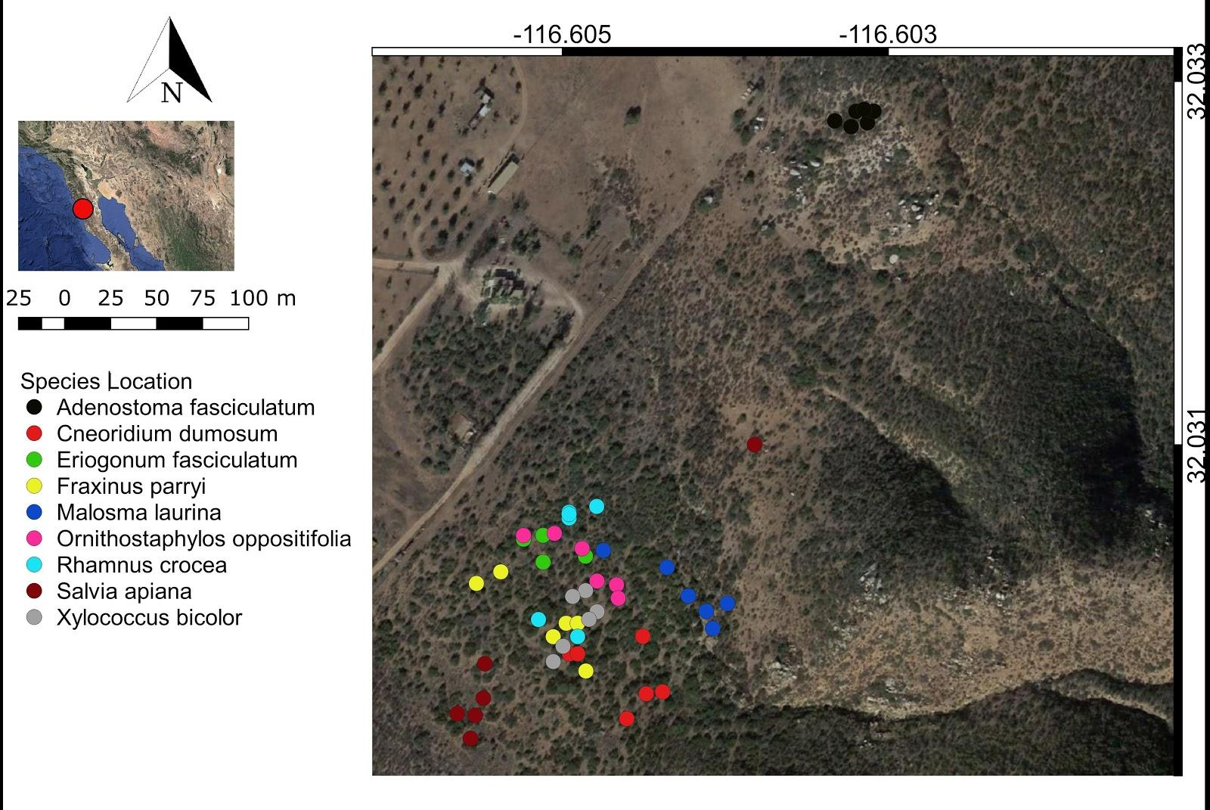

Figure S2. Scree Plot of a principal component analysis summarizing five functional traits and three spectral traits for nine shrub species within the Rancho El Mogor, Valle de Guadalupe, Baja California, México.
