Supplementary Material
Table S1. A total of 178 Species of Ipomoea L. has records for Mexico. The table provides the names of all 178 species, the number of records in our dataset, and whether they were excluded from analyses in this study due to having fewer than 8 records. Figures are based on our final dataset (after curation and manually georeferencing 7,409 records) which consists of a total of 30,989 records.

n | Species name | n records | Excluded
1 | I. acanthocarpa | 1 | *
2 | I. aegyptius | 3 | *
3 | I. alba | 257
4 | I. amnicola | 19
5 | I. ampullacea | 17
6 | I. ancisa | 7 | *
7 | I. anisomeres | 329
8 | I. aquatica | 4 | *
9 | I. arborescens | 631
10 | I. argentifolia | 2 | *
11 | I. aristolochiifolia | 147
12 | I. asarifolia | 4 | *
13 | I. aurantiaca | 62
14 | I. barbatisepala | 90
15 | I. batatas | 252
16 | I. batatoides | 201
17 | I. bernoulliana | 87
18 | I. bombycina | 25
19 | I. bracteata | 170
20 | I. cairica | 115
21 | I. calcicola | 1 | *
22 | I. capillacea | 1,401
23 | I. cardiophylla | 106
24 | I. carnea | 1,187
25 | I. caudata | 16
26 | I. chamelana | 29
27 | I. chenopodiifolia | 123
28 | I. chilopsidis | 42
29 | I. cholulensis | 500
30 | I. ciervensis | 28
31 | I. cissoides | 1 | *
32 | I. clavata | 106
33 | I. coccinea | 20
34 | I. concolor | 15
35 | I. conzattii | 321
36 | I. cordatotriloba | 2 | *
37 | I. corymbosa | 543
38 | I. costellata | 926
39 | I. crinicalyx | 516
40 | I. cristulata | 573
41 | I. cuprinacoma | 39
42 | I. decasperma | 20
43 | I. decemcornuta | 10
44 | I. diegoae | 3 | *
45 | I. discoidea | 1 | *
46 | I. dumetorum | 195
47 | I. dumosa | 622
48 | I. durangensis | 38
49 | I. electrina | 18
50 | I. elongata | 356
51 | I. eximia | 3 | *
52 | I. expansa | 13
53 | I. fimbriosepala | 26
54 | I. fissifolia | 1 | *
55 | I. funis | 183
56 | I. furcyensis | 1 | *
57 | I. gesnerioides | 8
58 | I. gloverae | 19
59 | I. hamiltonii | 1 | *
60 | I. hartwegii | 178
61 | I. hastigera | 126
62 | I. hederacea | 113
63 | I. hederifolia | 571
64 | I. heptaphylla | 67
65 | I. heterodoxa | 437
66 | I. ignava | 14
67 | I. imperati | 130
68 | I. indica | 206
69 | I. intrapilosa | 157
70 | I. invicta | 12
71 | I. jacalana | 2 | *
72 | I. jalapa | 347
73 | I. jicama | 71
74 | I. kahloae | 1 | *
75 | I. kruseana | 3 | *
76 | I. lacunosa | 2 | *
77 | I. laeta | 54
78 | I. lambii | 15
79 | I. lenis | 75
80 | I. leonensis | 1 | *
81 | I. leptophylla | 8
82 | I. leucantha | 67
83 | I. leucotricha | 19
84 | I. lindenii | 114
85 | I. lindheimeri | 105
86 | I. littoralis | 5 | *
87 | I. lobata | 87
88 | I. longifolia | 509
89 | I. lottiae | 38
90 | I. lozanii | 23
91 | I. lutea | 35
92 | I. macdonaldii | 17
93 | I. madrensis | 110
94 | I. mairetii | 314
95 | I. mcvaughii | 2 | *
96 | I. meyeri | 215
97 | I. microdactyla | 1 | *
98 | I. microsepala | 392
99 | I. minutiflora | 271
100 | I. miquihuanensis | 2 | *
101 | I. mitchelliae | 9
102 | I. muricata | 8
103 | I. murucoides | 1,053
104 | I. neei | 260
105 | I. neurocephala | 18
106 | I. nil | 228
107 | I. noctulifolia | 8
108 | I. ochracea | 2 | *
109 | I. oranensis | 1 | *
110 | I. orizabensis | 863
111 | I. parasitica | 38
112 | I. passifloroides | 1 | *
113 | I. pauciflora | 112
114 | I. pedicellaris | 751
115 | I. perpartita | 4 | *
116 | I. pes-caprae | 1,466
117 | I. peteri | 871
118 | I. petrophila | 15
119 | I. philomega | 55
120 | I. pinnatifida | 2 | *
121 | I. plummerae | 229
122 | I. populina | 252
123 | I. praecana | 64
124 | I. proxima | 121
125 | I. pruinosa | 4 | *
126 | I. pseudoracemosa | 17
127 | I. pubescens | 281
128 | I. puncticulata | 19
129 | I. purga | 185
130 | I. purpurea | 585
131 | I. quamoclit | 654
132 | I. quinquefolius | 1 | *
133 | I. ramosissima | 17
134 | I. reticulata | 24
135 | I. robinsonii | 50
136 | I. rubens | 45
137 | I. rupicola | 54
138 | I. rzedowskii | 76
139 | I. sagittata | 31
140 | I. santillanii | 169
141 | I. schaffneri | 1 | *
142 | I. scopulorum | 101
143 | I. seaania | 21
144 | I. seducta | 85
145 | I. sescossiana | 25
146 | I. setifera | 4 | *
147 | I. setosa | 258
148 | I. silvicola | 69
149 | I. simulans | 107
150 | I. sororia | 17
151 | I. spectata | 37
152 | I. splendor-sylvae | 232
153 | I. squamosa | 128
154 | I. stans | 133
155 | I. steerei | 175
156 | I. suaveolens | 228
157 | I. subrevoluta | 2 | *
158 | I. suffulta | 212
159 | I. tacambarensis | 18
160 | I. tastensis | 10
161 | I. tehuantepecensis | 15
162 | I. temascaltepecensis | 3 | *
163 | I. tentaculifera | 14
164 | I. tenuifolia | 1 | *
165 | I. tenuiloba | 58
166 | I. teotitlanica | 6 | *
167 | I. ternifolia | 2,149
168 | I. thurberi | 45
169 | I. tiliacea | 155
170 | I. tricolor | 1,167
171 | I. trifida | 630
172 | I. triloba | 325
173 | I. tuberosus | 1 | *
174 | I. tubulata | 52
175 | I. villifera | 50
176 | I. violacea | 76
177 | I. wolcottiana | 471
178 | I. zimmermanii | 2 | *

Table S2 . Climatic variables from WorldClim v. 2.1 included in this study, their units and metrics (www.worldclim.org; Fick & Hijmans 2017) at a resolution of 30s, cropped to Mexico, and loadings for the first five principal components (PC) from our Principal Component Analysis. Highlighted in red are the highest and lowest loadings for the first three PCs, which together explain 83.9 % of the variation in the original 19 climatic variables. Analyses were performed with base R function ‘princomp’ (with cor = T; R Core Team, 2022). T = temperature; P = precipitation.

Bio | Variable | PC1 | PC2 | PC3 | PC4 | PC5
BIO_01 | Annual Mean Temperature (ºC ×10) | 0.2368 | 0.3180 | 0.1180 | 0.0687 | 0.0179
BIO_02 | Mean Diurnal Range  (Mean of monthly (maxT - min T)) | -0.2635 | 0.0231 | 0.0644 | -0.2635 | -0.6464
BIO_03 | Isothermality (BIO2/BIO7) (×100) | 0.1649 | -0.2298 | 0.3538 | 0.1548 | -0.4526
BIO_04 | T Seasonality (standard deviation ×100) | -0.2311 | 0.2368 | -0.2684 | -0.1945 | 0.1445
BIO_05 | Max T of Warmest Month | 0.0317 | 0.4586 | -0.0032 | -0.1297 | -0.1900
BIO_06 | Min T of Coldest Month | 0.3005 | 0.1293 | 0.1484 | 0.1923 | 0.0566
BIO_07 | T Annual Range (BIO5-BIO6) | -0.2788 | 0.1581 | -0.1494 | -0.2722 | -0.1750
BIO_08 | Mean T of Wettest Quarter | 0.1149 | 0.3970 | 0.0018 | -0.1629 | 0.1106
BIO_09 | Mean T of Driest Quarter | 0.2292 | 0.2654 | 0.1681 | 0.0268 | -0.2723
BIO_10 | Mean T of Warmest Quarter | 0.1006 | 0.4515 | -0.0212 | -0.0400 | 0.0745
BIO_11 | Mean T of Coldest Quarter | 0.2868 | 0.1460 | 0.2225 | 0.1389 | -0.0724
BIO_12 | Annual Mean Precipitation (mm) | 0.3034 | -0.1257 | -0.1077 | -0.1775 | 0.0126
BIO_13 | P of Wettest Month | 0.2856 | -0.1328 | 0.0052 | -0.3213 | 0.0970
BIO_14 | P of Driest Month | 0.2363 | -0.0497 | -0.3975 | 0.0602 | -0.1409
BIO_15 | P Seasonality (Coefficient of Variation) | -0.0307 | -0.0627 | 0.4164 | -0.5141 | 0.0456
BIO_16 | P of Wettest Quarter | 0.2836 | -0.1442 | 0.0224 | -0.3147 | 0.0744
BIO_17 | P of Driest Quarter | 0.2369 | -0.0515 | -0.4092 | 0.0471 | -0.1532
BIO_18 | P of Warmest Quarter | 0.2322 | -0.1387 | -0.0273 | -0.4213 | 0.1183
BIO_19 | P of Coldest Quarter | 0.2142 | -0.0396 | -0.3879 | -0.0816 | -0.3384
 | Standard deviation | 2.9858 | 2.0917 | 1.6261 | 1.2369 | 0.7533
 | Variance | 8.9151 | 4.3753 | 2.6443 | 1.5300 | 0.5675
 | Proportion of Variance | 0.4692 | 0.2303 | 0.1392 | 0.0805 | 0.0299
 | Cumulative Proportion | 0.4692 | 0.6995 | 0.8387 | 0.9192 | 0.9491

Table S3. Variables and their transformations.
variable | W statistic | P value | interpret | selected
Geo range hull (km2) | 0.8887 | 8.67E-09 | not normal
Geo range hull (log) | 0.8058 | 2.74E-12 | not normal
Geo range hull (sqrt) | 0.9612 | 0.0006 | not normal | selected
Geo range buffer (km2) | 0.7479 | 3.65E-14 | not normal
Geo range buffer (log) | 0.9746 | 0.0106 | not normal | selected
Geo range buffer (sqrt) | 0.9047 | 6.25E-08 | not normal
climatic amplitude PC 1 | 0.9710 | 0.0047 | no normal
climatic amplitude PC 1 (log) | 0.8603 | 3.89E-10 | no normal
climatic amplitude PC 1 (sqrt) | 0.9778 | 0.0230 | no normal | selected
climatic amplitude PC 2 | 0.9801 | 0.0402 | no normal | selected
climatic amplitude PC 2 (log) | 0.8147 | 5.73E-12 | no normal
climatic amplitude PC 2 (sqrt) | 0.9422 | 1.62E-05 | no normal
climatic amplitude PC 3 | 0.9426 | 1.73E-05 | no normal
climatic amplitude PC 3 (log) | 0.8948 | 1.80E-08 | no normal
climatic amplitude PC 3 (sqrt) | 0.9872 | 0.2285 | normal | selected
amplitude annual T (bio 01) | 0.9747 | 0.0109 | not normal | selected
amplitude annual T (bio 01) (log) | 0.7928 | 9.64E-13 | not normal
amplitude annual T (bio 01) (sqrt) | 0.9236 | 8.43E-07 | not normal
amplitude T seasonality (bio 04) | 0.9322 | 3.15E-06 | not normal
amplitude T seasonality (bio 04) (log) | 0.9008 | 3.79E-08 | not normal
amplitude T seasonality (bio 04) (sqrt) | 0.9579 | 0.0003 | not normal | selected
amplitude annual P (bio 12) | 0.9712 | 0.0049 | not normal | selected
amplitude annual P (bio 12) (log) | 0.8754 | 1.93E-09 | not normal
amplitude annual P (bio 12) (sqrt) | 0.9429 | 1.83E-05 | not normal
amplitude P seasonality (bio 15) | 0.9820 | 0.0644 | normal | selected
amplitude P seasonality (bio 15) (log) | 0.8650 | 6.34E-10 | not normal
amplitude P seasonality (bio 15) (sqrt) | 0.9530 | 0.0001 | not normal

Table S4. Estimates and coefficients on linear models examining climatic amplitude as a predictor of geographic range for Ipomoea L. (Convolvulaceae) in Mexico. General linear models were implemented using base functions in R (R Core Team, 2022).

Formula: | hull_sqrt ~ ampPC1_sqrt
Coefficient | Estimate | Std. Error | t value | Pr (> |t|) | Significance
(Intercept) | -361.69 | 70.15 | -5.156 | 8.64E-07 | ***
ampPC1_sqrt | 414.50 | 25.41 | 16.314 | < 2e-16 | ***
multR² | adjR² | F-stat | DF 1 | DF 2 | P value
0.660 | 0.658 | 266.2 | 1 | 137 | < 2.2e-16

Formula: | hull_sqrt ~ amp_mxPC2
Coefficient | Estimate | Std. Error | t value | Pr (> |t|) | Significance
(Intercept) | -32.37 | 66.76 | -0.485 | 6.29E-01
amp_mxPC2 | 122.07 | 9.91 | 12.318 | < 2e-16 | ***
multR² | adjR² | F-stat | DF 1 | DF 2 | P value
0.526 | 0.522 | 151.7 | 1 | 137 | < 2.2e-16

Formula: | hull_sqrt ~ ampPC3_sqrt
Coefficient | Estimate | Std. Error | t value | Pr (> |t|) | Significance
(Intercept) | -137.53 | 74.51 | -1.846 | 6.71E-02 | .
ampPC3_sqrt | 12,363.63 | 29.45 | 12.349 | < 2e-16 | ***
multR² | adjR² | F-stat | DF 1 | DF 2 | P value
0.527 | 0.523 | 152.5 | 1 | 137 | < 2.2e-16

Formula: | hull_sqrt ~ ampPC1_sqrt + amp_mxPC2 + ampPC3_sqrt
Coefficient | Estimate | Std. Error | t value | Pr (> |t|) | Significance
(Intercept) | -388.11 | 66.71 | -5.818 | 4.12E-08 | ***
ampPC1_sqrt | 356.91 | 73.06 | 4.885 | 2.88E-06 | ***
amp_mxPC2 | 46.94 | 11.65 | 4.028 | 9.33E-05 | ***
ampPC3_sqrt | -47.98 | 63.39 | -0.757 | 0.45
multR² | adjR² | F-stat | DF 1 | DF 2 | P value
0.701 | 0.694 | 105.5 | 3 | 135 | < 2.2e-16

Formula: | poly_log ~ ampPC1_sqrt
Coefficient | Estimate | Std. Error | t value | Pr (> |t|) | Significance
(Intercept) | 5.1236 | 0.2300 | 22.27 | < 2e-16 | ***
ampPC1_sqrt | 1.1668 | 0.0833 | 14 | < 2e-16 | ***
multR² | adjR² | F-stat | DF 1 | DF 2 | P value
0.589 | 0.586 | 196.1 | 1 | 137 | < 2.2e-16

Formula: | poly_log ~ amp_mxPC2
Coefficient | Estimate | Std. Error | t value | Pr (> |t|) | Significance
(Intercept) | 5.8405 | 0.1904 | 30.67 | < 2e-16 | ***
amp_mxPC2 | 0.3775 | 0.0283 | 13.36 | < 2e-16 | ***
multR² | adjR² | F-stat | DF 1 | DF 2 | P value
0.566 | 0.562 | 178.4 | 1 | 137 | < 2.2e-16

Formula: | poly_log ~ ampPC3_sqrt
Coefficient | Estimate | Std. Error | t value | Pr (> |t|) | Significance
(Intercept) | 5.6307 | 0.224 | 25.14 | < 2e-16 | ***
ampPC3_sqrt | 1.0758 | 0.0885 | 12.16 | < 2e-16 | ***
multR² | adjR² | F-stat | DF 1 | DF 2 | P value
0.519 | 0.515 | 147.8 | 1 | 137 | < 2.2e-16

Formula: | poly_log ~ ampPC1_sqrt + amp_mxPC2 + ampPC3_sqrt
Coefficient | Estimate | Std. Error | t value | Pr (> |t|) | Significance
(Intercept) | 5.0545 | 0.2069 | 24.43 | < 2e-16 | ***
ampPC1_sqrt | 0.3951 | 0.2266 | 1.744 | 0.0835 | .
amp_mxPC2 | 0.2177 | 0.0361 | 6.023 | 1.53E-08 | ***
ampPC3_sqrt | 0.3129 | 0.1966 | 1.591 | 0.1139
multR² | adjR² | F-stat | DF 1 | DF 2 | P value
0.676 | 0.669 | 94.05 | 3 | 135 | < 2.2e-16

formula: | hull_sqrt ~ bio_01_range
Coefficient | Estimate | Std. Error | t value | Pr (> |t|) | significance
(Intercept) | 12.38 | 73.95 | 0.167 | 8.67E-01
bio_01_range | 65.46 | 6.28 | 10.424 | < 2e-16 | ***
multR² | adjR² | F-stat | DF 1 | DF 2 | P value
0.442 | 0.438 | 108.7 | 1 | 137 | < 2.2e-16

formula: | hull_sqrt ~ bio_04_range_sqrt
Coefficient | Estimate | Std. Error | t value | Pr (> |t|) | significance
(Intercept) | -161.166 | 74.797 | -2.155 | 3.29E-02 | *
bio_04_range_sqrt | 22.528 | 1.786 | 12.614 | < 2e-16 | ***
multR² | adjR² | F-stat | DF 1 | DF 2 | P value
0.537 | 0.534 | 159.1 | 1 | 137 | < 2.2e-16

formula: | hull_sqrt ~ bio_01_range + bio_04_range_sqrt
Coefficient | Estimate | Std. Error | t value | Pr (> |t|) | significance
(Intercept) | -264.728 | 72.561 | -3.648 | 3.75E-04 | ***
bio_01_range | 33.100 | 6.838 | 4.841 | 3.46E-06 | ***
bio_04_range_sqrt | 16.002 | 2.135 | 7.495 | 7.64E-12 | ***
multR² | adjR² | F-stat | DF 1 | DF 2 | P value
0.605 | 0.599 | 104.3 | 2 | 136 | < 2.2e-16

formula: | poly_log ~ bio_01_range
Coefficient | Estimate | Std. Error | t value | Pr (> |t|) | significance
(Intercept) | 6.0151 | 0.2168 | 27.75 | < 2e-16 | ***
bio_01_range | 0.1991 | 0.0184 | 10.81 | < 2e-16 | ***
multR² | adjR² | F-stat | DF 1 | DF 2 | P value
0.461 | 0.457 | 117 | 1 | 137 | < 2.2e-16

formula: | poly_log ~ bio_04_range_sqrt
Coefficient | Estimate | Std. Error | t value | Pr (> |t|) | significance
(Intercept) | 5.5580 | 0.2246 | 24.75 | < 2e-16 | ***
bio_04_range_sqrt | 0.0667 | 0.0054 | 12.44 | < 2e-16 | ***
multR² | adjR² | F-stat | DF 1 | DF 2 | P value
0.531 | 0.527 | 154.8 | 1 | 137 | < 2.2e-16

formula: | poly_log ~ bio_01_range + bio_04_range_sqrt
Coefficient | Estimate | Std. Error | t value | Pr (> |t|) | significance
(Intercept) | 5.2241 | 0.2150 | 24.298 | < 2e-16 | ***
bio_01_range | 0.1067 | 0.0203 | 5.268 | 5.26E-07 | ***
bio_04_range_sqrt | 0.0457 | 0.0063 | 7.221 | 3.32E-11 | ***
multR² | adjR² | F-stat | DF 1 | DF 2 | P value
0.610 | 0.604 | 106.4 | 2 | 136 | < 2.2e-16

formula: | hull_sqrt ~ bio_12_range
Coefficient | Estimate | Std. Error | t value | Pr (> |t|) | significance
(Intercept) | -144.712 | 53.2 | -2.72 | 7.37E-03 | **
bio_12_range | 120.842 | 6.804 | 17.76 | < 2e-16 | ***
multR² | adjR² | F-stat | DF 1 | DF 2 | P value
0.697 | 0.695 | 315.4 | 1 | 137 | < 2.2e-16

formula: | hull_sqrt ~ bio_15_range
Coefficient | Estimate | Std. Error | t value | Pr (> |t|) | significance
(Intercept) | 56.206 | 70.273 | 0.8 | 4.25E-01
bio_15_range | 53.229 | 5.122 | 10.39 | < 2e-16 | ***
multR² | adjR² | F-stat | DF 1 | DF 2 | P value
0.441 | 0.437 | 108 | 1 | 137 | < 2.2e-16

formula: | hull_sqrt ~ bio_12_range + bio_15_range
Coefficient | Estimate | Std. Error | t value | Pr (> |t|) | significance
(Intercept) | -196.821 | 55.143 | -3.569 | 4.95E-04 | ***
bio_12_range | 103.454 | 9.086 | 11.386 | < 2e-16 | ***
bio_15_range | 14.111 | 5.033 | 2.803 | 5.80E-03 | **
multR² | adjR² | F-stat | DF 1 | DF 2 | P value
0.714 | 0.709 | 169.5 | 2 | 136 | < 2.2e-16

formula: | poly_log ~ bio_12_range
Coefficient | Estimate | Std. Error | t value | Pr (> |t|) | significance
(Intercept) | 5.5965 | 0.1595 | 35.09 | < 2e-16 | ***
bio_12_range | 0.3593 | 0.0204 | 17.62 | < 2e-16 | ***
multR² | adjR² | F-stat | DF 1 | DF 2 | P value
0.694 | 0.692 | 310.3 | 1 | 137 | < 2.2e-16

formula: | poly_log ~ bio_15_range
Coefficient | Estimate | Std. Error | t value | Pr (> |t|) | significance
(Intercept) | 5.9485 | 0.1871 | 31.79 | < 2e-16 | ***
bio_15_range | 0.1778 | 0.0136 | 13.04 | < 2e-16 | ***
multR² | adjR² | F-stat | DF 1 | DF 2 | P value
0.554 | 0.550 | 170 | 1 | 137 | < 2.2e-16

formula: | poly_log ~ bio_12_range + bio_15_range
Coefficient | Estimate | Std. Error | t value | Pr (> |t|) | significance
(Intercept) | 5.3064 | 0.1532 | 34.65 | < 2e-16 | ***
bio_12_range | 0.2625 | 0.0252 | 10.4 | < 2e-16 | ***
bio_15_range | 0.0786 | 0.0139 | 5.62 | 1.04E-07 | ***
multR² | adjR² | F-stat | DF 1 | DF 2 | P value
0.752 | 0.748 | 205.6 | 2 | 136 | < 2.2e-16

formula: | bio_01_range ~ bio_12_range
Coefficient | Estimate | Std. Error | t value | Pr (> |t|) | significance
(Intercept) | 3.8228 | 0.7316 | 5.225 | 6.33E-07 | ***
bio_12_range | 0.9811 | 0.0935 | 10.485 | < 2e-16 | ***
multR² | adjR² | F-stat | DF 1 | DF 2 | P value
0.445 | 0.441 | 109.9 | 1 | 137 | < 2.2e-16

formula: | bio_04_range_sqrt ~ bio_15_range
Coefficient | Estimate | Std. Error | t value | Pr (> |t|) | significance
(Intercept) | 19.3352 | 2.4228 | 7.98 | 5.23E-13 | ***
bio_15_range | 1.5914 | 0.1766 | 9.012 | 1.57E-15 | ***
multR² | adjR² | F-stat | DF 1 | DF 2 | P value
0.372 | 0.367 | 81.21 | 1 | 137 | 1.57E-15

Table S5. Estimates and coefficients on PGLS models examining climatic amplitude as a predictor of geographic range for Ipomoea L. (Convolvulaceae) in Mexico. Phylogenetic generalized least squares (PGLS) models were implemented using ‘pgls’ function (lambda = “ML”) in R library ‘caper’ (Orme et al. 2018), with using a pruned ASTRAL-II published phylogeny inferred based on 605 putative single-copy nuclear coding regions (Muñoz et al. 2019). For ease of visualization, significance levels are depicted as follows: 0.05 < P ≤ 0.1 (•), 0.001 < P ≤ 0.01 (*), 0.0001 < P ≤ 0.001 (**), P ≤ 0.0001 (***).

PGLS formula: | hull_sqrt ~ ampPC1_sqrt
Coefficient | Estimate | Std. Error | t value | Pr (> |t|) | Significance
(Intercept) | -254.354 | 165.329 | -1.5385 | 0.13
ampPC1_sqrt | 390.458 | 53.536 | 7.2934 | 1.03E-09 | ***
multR² | adjR² | F-stat | DF 1 | DF 2 | P value
0.483 | 0.474 | 53.19 | 1 | 57 | 1.03E-09

PGLS formula: | hull_sqrt ~ amp_mxPC2
Coefficient | Estimate | Std. Error | t value | Pr (> |t|) | Significance
(Intercept) | 165.3 | 108.13 | 1.5287 | 0.1319
amp_mxPC2 | 108.005 | 14.543 | 7.4266 | 6.19E-10 | ***
multR² | adjR² | F-stat | DF 1 | DF 2 | P value
0.492 | 0.483 | 55.15 | 1 | 57 | 6.19E-10

PGLS formula: | hull_sqrt ~ ampPC3_sqrt
Coefficient | Estimate | Std. Error | t value | Pr (> |t|) | Significance
(Intercept) | 207.607 | 152.453 | 1.3618 | 0.1786
ampPC3_sqrt | 260.117 | 53.318 | 4.8786 | 8.96E-06 | ***
multR² | adjR² | F-stat | DF 1 | DF 2 | P value
0.295 | 0.282 | 23.8 | 1 | 57 | 8.96E-06

PGLS formula: | hull_sqrt ~ ampPC1_sqrt + amp_mxPC2 + ampPC3_sqrt
Coefficient | Estimate | Std. Error | t value | Pr (> |t|) | Significance
(Intercept) | -275.265 | 150.159 | -1.8332 | 0.07219 | •
ampPC1_sqrt | 301.432 | 109.488 | 2.7531 | 0.00798 | **
amp_mxPC2 | 65.093 | 17.211 | 3.782 | 0.00039 | ***
ampPC3_sqrt | -60.734 | 82.595 | -0.7353 | 0.46527
multR² | adjR² | F-stat | DF 1 | DF 2 | P value
0.600 | 0.578 | 27.53 | 3 | 55 | 5.26E-11

PGLS formula: | poly_log ~ ampPC1_sqrt
Coefficient | Estimate | Std. Error | t value | Pr (> |t|) | Significance
(Intercept) | 4.98955 | 0.5489 | 9.09 | 1.10E-12 | ***
ampPC1_sqrt | 1.20082 | 0.17774 | 6.756 | 8.11E-09 | ***
multR² | adjR² | F-stat | DF 1 | DF 2 | P value
0.445 | 0.435 | 45.64 | 1 | 57 | 8.11E-09

PGLS formula: | poly_log ~ amp_mxPC2
Coefficient | Estimate | Std. Error | t value | Pr (> |t|) | Significance
(Intercept) | 6.137567 | 0.340111 | 18.0458 | < 2.2e-16 | ***
amp_mxPC2 | 0.352537 | 0.045743 | 7.7069 | 2.11E-10 | ***
multR² | adjR² | F-stat | DF 1 | DF 2 | P value
0.5103 | 0.502 | 59.4 | 1 | 57 | 2.11E-10

PGLS formula: | poly_log ~ ampPC3_sqrt
Coefficient | Estimate | Std. Error | t value | Pr (> |t|) | Significance
(Intercept) | 6.17022 | 0.47467 | 12.999 | < 2.2e-16 | ***
ampPC3_sqrt | 0.88748 | 0.16601 | 5.3461 | 1.65E-06 | ***
multR² | adjR² | F-stat | DF 1 | DF 2 | P value
0.334 | 0.322 | 28.58 | 1 | 57 | 1.65E-06

PGLS formula: | poly_log ~ ampPC1_sqrt + amp_mxPC2 + ampPC3_sqrt
Coefficient | Estimate | Std. Error | t value | Pr (> |t|) | Significance
(Intercept) | 5.043636 | 0.486815 | 10.3605 | 1.55E-14 | ***
ampPC1_sqrt | 0.427516 | 0.354959 | 1.2044 | 0.2336
amp_mxPC2 | 0.247293 | 0.055798 | 4.4319 | 4.50E-05 | ***
ampPC3_sqrt | 0.198104 | 0.267771 | 0.7398 | 0.4626
multR² | adjR² | F-stat | DF 1 | DF 2 | P value
0.591 | 0.568 | 26.47 | 3 | 55 | 9.93E-11

 | PGLS formula: |  | hull_sqrt ~ bio_01_range
 | Coefficient |  | Estimate |  | Std. Error |  | t value |  | Pr (> |t|) |  | Significance
 | (Intercept) |  | 253.0010 |  | 136.6270 |  | 1.8518 |  | 0.0692 |  | •
 | bio_01_range |  | 54.6080 |  | 10.6170 |  | 5.1434 |  | 3.45E-06 |  | ***
 | multR² |  | adjR² |  | F-stat |  | DF 1 |  | DF 2 |  | P value
 | 0.317 |  | 0.305 |  | 26.45 |  | 1 |  | 57 |  | 3.45E-06
PGLS formula: |  | hull_sqrt ~ bio_04_range_sqrt
Coefficient |  | Estimate |  | Std. Error |  | t value |  | Pr (> |t|) |  | Significance
(Intercept) |  | 54.5143 |  | 151.2298 |  | 0.3605 |  | 0.7198
bio_04_range_sqrt |  | 19.0332 |  | 3.2016 |  | 5.9449 |  | 1.77E-07 |  | ***
multR² |  | adjR² |  | F-stat |  | DF 1 |  | DF 2 |  | P value
0.383 |  | 0.372 |  | 35.34 |  | 1 |  | 57 |  | 1.77E-07

PGLS formula: | hull_sqrt ~ bio_12_range
Coefficient | Estimate | Std. Error | t value | Pr (> |t|) | Significance
(Intercept) | 11.2160 | 104.9500 | 0.1069 | 0.9153
bio_12_range | 109.1150 | 11.9600 | 9.1232 | 9.72E-13 | ***
multR² | adjR² | F-stat | DF 1 | DF 2 | P value
0.594 | 0.586 | 83.23 | 1 | 57 | 9.72E-13

PGLS formula: | hull_sqrt ~ bio_15_range
Coefficient | Estimate | Std. Error | t value | Pr (> |t|) | Significance
(Intercept) | 296.7496 | 114.2146 | 2.5982 | 0.0119 | *
bio_15_range | 44.4513 | 7.6026 | 5.8468 | 2.56E-07 | **
multR² | adjR² | F-stat | DF 1 | DF 2 | P value
0.375 | 0.364 | 34.19 | 1 | 57 | 2.56E-07

PGLS formula: | hull_sqrt ~ bio_01_range + bio_04_range_sqrt
Coefficient | Estimate | Std. Error | t value | Pr (> |t|) | Significance
(Intercept) | -102.701 | 151.7659 | -0.6767 | 0.5014
bio_01_range | 32.4026 | 11.0284 | 2.9381 | 0.0048 | **
bio_04_range_sqrt | 13.7793 | 3.4982 | 3.9390 | 0.0002 | ***
multR² | adjR² | F-stat | DF 1 | DF 2 | P value
0.465 | 0.446 | 24.35 | 2 | 56 | 2.46E-08

PGLS formula: | hull_sqrt ~ bio_12_range + bio_15_range
Coefficient | Estimate | Std. Error | t value | Pr (> |t|) | Significance
(Intercept) | -74.5183 | 105.6329 | -0.7054 | 0.4835
bio_12_range | 88.5342 | 13.9637 | 6.3403 | 4.23E-08 | ***
bio_15_range | 18.3226 | 7.1575 | 2.5599 | 0.0132 | *
multR² | adjR² | F-stat | DF 1 | DF 2 | P value
0.636 | 0.623 | 48.95 | 2 | 56 | 5.09E-13

PGLS formula: | poly_log ~ bio_01_range
Coefficient | Estimate | Std. Error | t value | Pr (> |t|) | Significance
(Intercept) | 6.1641 | 0.4062 | 15.1743 | < 2.2e-16 | ***
bio_01_range | 0.1995 | 0.0316 | 6.3192 | 4.29E-08 | ***
multR² | adjR² | F-stat | DF 1 | DF 2 | P value
0.412 | 0.402 | 39.93 | 1 | 57 | 4.29E-08

PGLS formula: | poly_log ~ bio_04_range_sqrt
Coefficient | Estimate | Std. Error | t value | Pr (> |t|) | Significance
(Intercept) | 5.8729 | 0.4894 | 12.000 | < 2.2e-16 | ***
bio_04_range_sqrt | 0.0600 | 0.0104 | 5.7907 | 3.16E-07 | ***
multR² | adjR² | F-stat | DF 1 | DF 2 | P value
0.370 | 0.359 | 33.53 | 1 | 57 | 3.16E-07

PGLS formula: | poly_log ~ bio_12_range
Coefficient | Estimate | Std. Error | t value | Pr (> |t|) | Significance
(Intercept) | 5.7702 | 0.3495 | 16.5092 | < 2.2e-16 | ***
bio_12_range | 0.3399 | 0.0398 | 8.5336 | 9.00E-12 | ***
multR² | adjR² | F-stat | DF 1 | DF 2 | P value
0.561 | 0.553 | 72.82 | 1 | 57 | 9.00E-12

PGLS formula: | poly_log ~ bio_15_range
Coefficient | Estimate | Std. Error | t value | Pr (> |t|) | Significance
(Intercept) | 6.2536 | 0.3215 | 19.4536 | < 2.2e-16 | ***
bio_15_range | 0.1674 | 0.0214 | 7.8224 | 1.36E-10 | ***
multR² | adjR² | F-stat | DF 1 | DF 2 | P value
0.518 | 0.509 | 61.19 | 1 | 57 | 1.36E-10

PGLS formula: | poly_log ~ bio_01_range + bio_04_range_sqrt
Coefficient | Estimate | Std. Error | t value | Pr (> |t|) | Significance
(Intercept) | 5.1977 | 0.4614 | 11.2643 | 4.44E-16 | ***
bio_01_range | 0.1392 | 0.0335 | 4.1500 | 0.0001 | ***
bio_04_range_sqrt | 0.0374 | 0.0106 | 3.5195 | 0.0009 | ***
multR² | adjR² | F-stat | DF 1 | DF 2 | P value
0.518 | 0.501 | 30.15 | 2 | 56 | 1.30E-09

PGLS formula: | poly_log ~ bio_12_range + bio_15_range
Coefficient | Estimate | Std. Error | t value | Pr (> |t|) | Significance
(Intercept) | 5.3008 | 0.3148 | 16.8394 | < 2.2e-16 | ***
bio_12_range | 0.2272 | 0.0416 | 5.4602 | 1.13E-06 | ***
bio_15_range | 0.1003 | 0.0213 | 4.7037 | 1.71E-05 | ***
multR² | adjR² | F-stat | DF 1 | DF 2 | P value
0.685 | 0.674 | 60.97 | 2 | 56 | 8.75E-15

Figure S1. Histograms of two measures of geographic range (convex hull polygons and polygons estimated on buffered areas around each point) and candidate transformations for Mexican Ipomoea L.

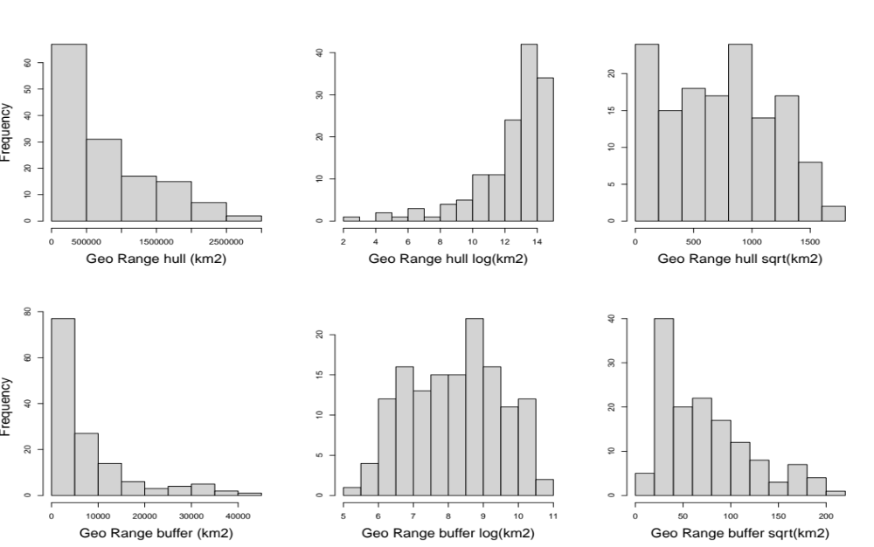

Figure S2. Histograms of climatic amplitude for the first three axes resulting from a Principal Components Analyses and candidate transformations for Mexican Ipomoea L.

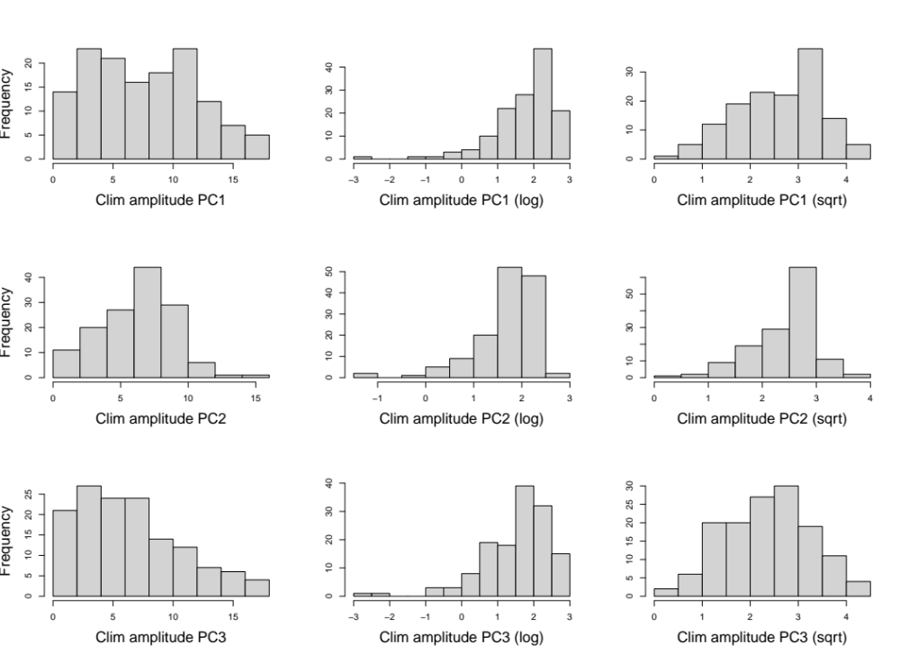

Figure S3. Histograms of amplitude for four selected climatic variables from Worldclim v.2.1. and their transformations: Annual mean temperature (Bio 01), Temperature Seasonality (Bio 04), Annual Mean Precipitation (Bio 12), and Precipitation Seasonality (Bio 15).
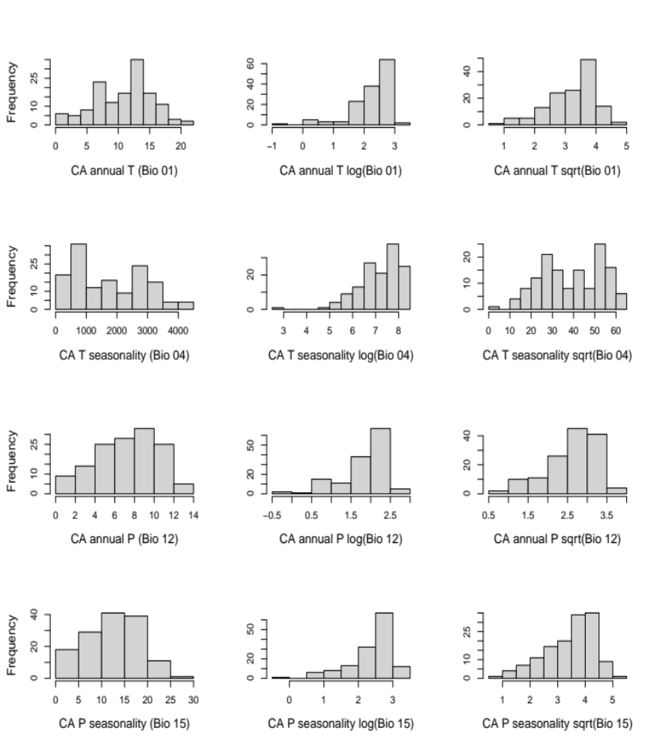

Figure S4. Ipomoea covers most of the available territory in Mexico. Map shows 30,942 records for 139 species (mean = 105 records/species; median = 222.6, min = 8, max = 2,149) after data curation and manually georeferencing 7,409 that lacked latitude and longitude information. Records were derived from the Global Biodiversity Information Facility (GBIF) and IBdata-UNAM online repositories (www.gbif.org and www.ibdata.abaco3.org, respectively).

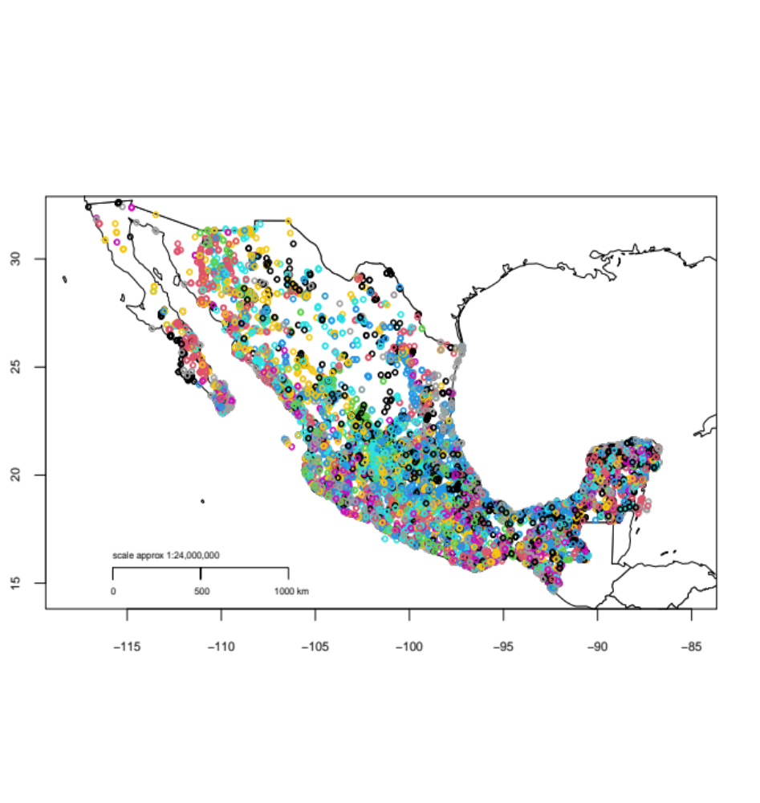

Figure S5. Biplot of PCA showing the variance explained by the first PCs.

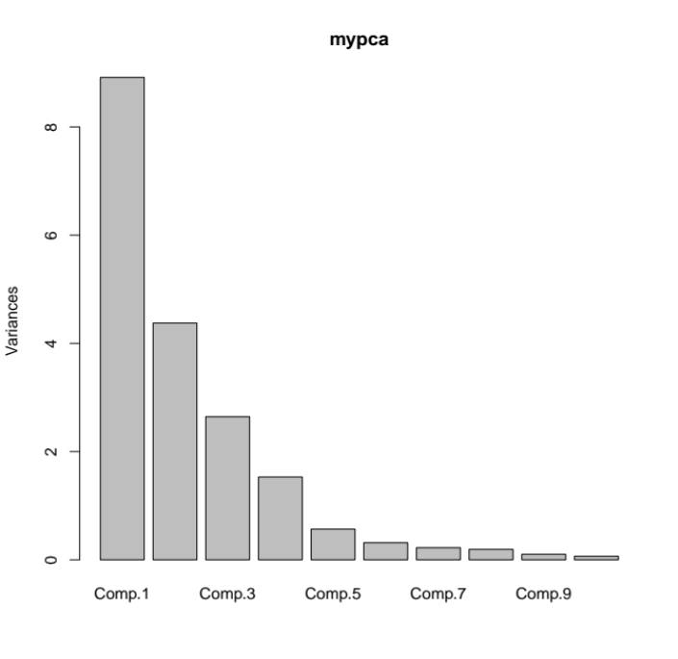

Figure S6. Visualization on PGLS models examining climatic amplitude as a predictor of geographic range for Ipomoea L. (Convolvulaceae) in Mexico, both for geographic ranges (GR) estimated as Hull polygons (A, C, E, G, I, K, M) and with buffered areas (B, D, F, H, J, L, N). For ease of visualization, significance levels are depicted as follows: 0.05 < P ≤ 0.1 (•), 0.001 < P ≤ 0.01 (*), 0.0001 < P ≤ 0.001 (**), P ≤ 0.0001 (***).
A B
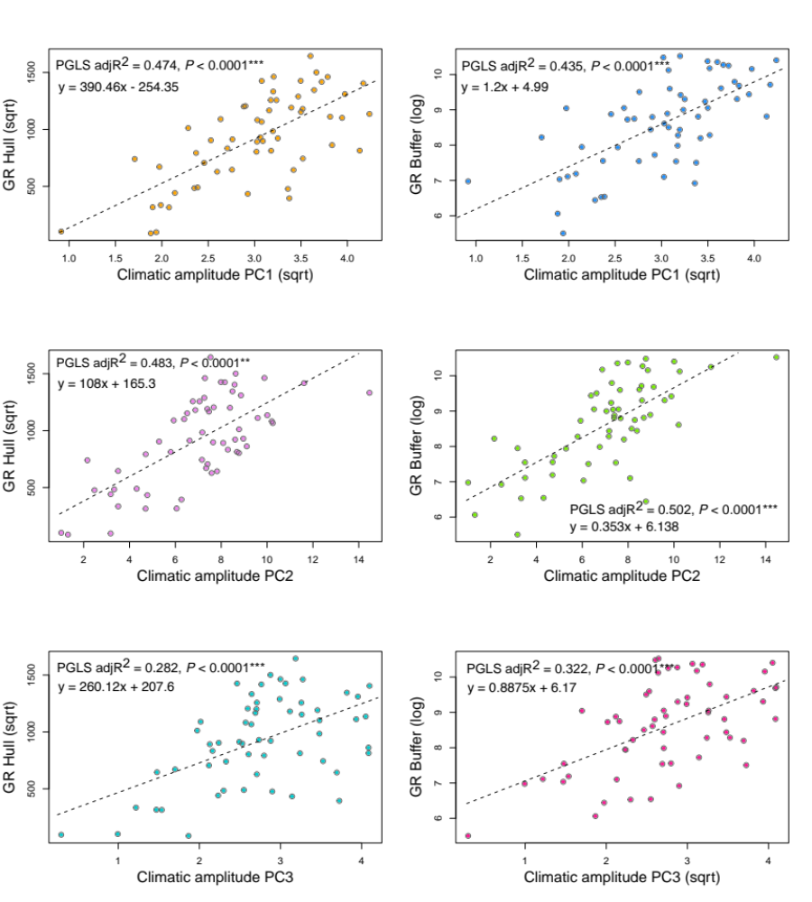
C D
E F

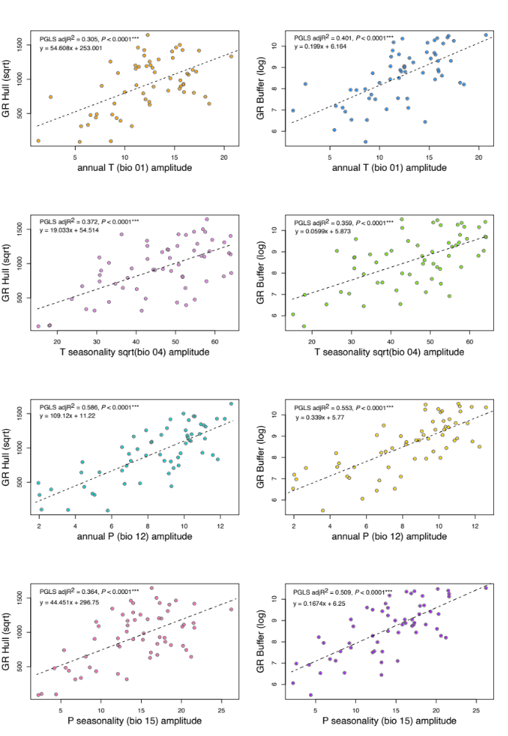
M N
K L
G H
I J
Figure S7. Visualization on PGLS models examining potential tradeoffs of temperature and precipitation breadths in amounts (A) and seasonality (B) for Ipomoea L. (Convolvulaceae) in Mexico.
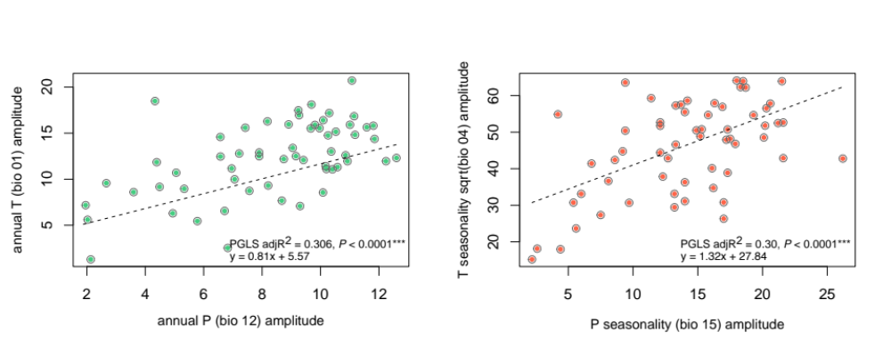
A B

Figure S8. Maps displaying species of Ipomoea in Mexico that exhibit peculiar relationships of geographic range size with climatic breadth in temperature, precipitation, and their seasonality. A) Ipomoea imperati (Vahl) Griseb., B) I. violacea L., C) I. heptaphylla Sweet, D) I. chenopodiifolia (M.Martens & Galeotti) Hemsl., E) I. silvicola House, F) I. bernoulliana Peter.
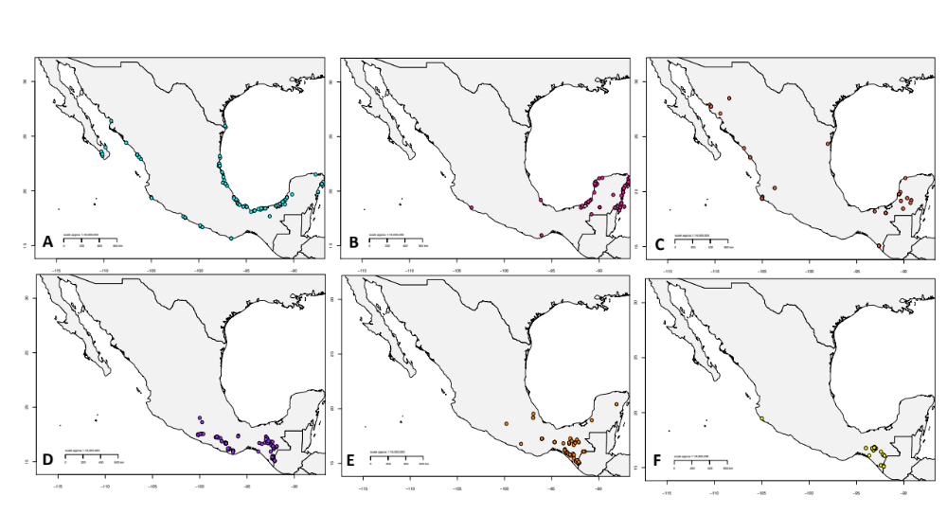

Literature cited

Fick SE, Hijmans RJ. 2017. WorldClim 2: new 1‐km spatial resolution climate surfaces for global land areas. International Journal of Climatology 37: 4302-4315. DOI: https://doi.org/10.1002/joc.5086
R Core Team 2022. R: A language and environment for statistical computing. https://www.r-project.org/
Orme D, Freckleton R, Thomas G, Petzoldt T, Fritz S, Isaac N, Pearse W. 2018. caper: Comparative analyses of phylogenetics and evolution in R. R packages version 1.0.1. https://cran.r-project.org/package=caper
Muñoz-Rodríguez P, Carruthers T, Wood JRI, Williams BRM, Weitemier K, Kronmiller B, Goodwin Z, Sumadijaya A, Anglin NL, Filer D, Harris D, Rausher MD, Kelly S, Liston A, Scotland RW. 2019. A taxonomic monograph of Ipomoea integrated across phylogenetic scales. Nature Plants 5: 1136-1144. DOI: https://doi.org/10.1038/s41477-019-0535-4

