Supplementary Material

Table S1. Species composition and characteristics of the three sampling sites: One conserved (S1) and two regeneration sites following selective logging (S2 and S3).
Site | Description | Species composition
S1 | Few M. iltisiana individuals, no seedlings.  Transition between oak and pine forest on the SW portion of the transect.  No wood exploitation. | Aiouea pachypoda, Carpinus tropicalis, Clethra fragans, Cornus disciflora, Dendropanax arboreum, Euphorbia schlechtendalii, Inga hintonii, Magnolia iltisiana, Meliosma dentata, Myrsine juergensenii, Parathesis villosa, Persea hintonii, Quercus acutifolia, Quercus uxoris, Saurauia serrata, Solanum aphyodendron, Styrax ramirezii, Symplococarpon purpusii, Symplocos citrea, Tilia mexicana, Turpina occidentalis, and Zinowiewia concinna
S2 | Mostly saplings and seedlings of M. iltisiana  Presence of two big forest clearings  Selective logging prior to the LJSS establishment. | Aiouea pachypoda, Carpinus tropicalis, Citharexylum mocinoi Clethra fragans, Cleyera integrifolia Cornus disciflora, Fraxinus uhdei, Magnolia iltisiana, Myrsine juergensenii, Persea hintonii, Pinus douglasiana, Prunus serotina, Quercus calophylla, Quercus nixoniana, Styrax ramirezii, Symplococarpon purpusii, Viburnum hartwegii, and Zinowiewia concinna
S3 | Mostly juveniles, saplings, and seedlings of M. iltisiana  Presence of a big forest clearing.  Selective logging prior to the LJSS establishment and current presence of free-ranging cattle. | Aiouea pachypoda, Citharexylum mocinoi, Cornus disciflora, Magnolia iltisiana, Meliosma dentata, Myrsine juergensenii, Parathesis villosa, Persea hintonii, Pinus douglasiana, Quercus calophylla, and Styrax ramirezii

Table S2. Significant Linkage Disequilibrium (LD) between loci
Loci | P-value
M6D3 & MA42_481 | 0.017
M6D3 & STM0200 | 0.045
MA42_481 & M15D5 | 0.021
STM0383 & STM0200 | 0.0005
STM0218 & STM0200 | 0.019
M15D5 & STM0200 | 0.002

Table S3. AMOVA of seven microsatellite loci among four life stages in Magnolia iltisiana: A adults, J juveniles, Sa saplings and Se seedlings in a conserved site S1 and two regeneration sites (S2 and S3). Abbreviation: df degrees of freedom, SS sum of squares. P-value after 9,999 permutations.
Source of variation | df | SS | Percentage of variation | P value
Between life stages | 3 | 10.502 | -1.016 | 0.7733
Between sites within life stages | 7 | 28.422 | 3.782 | 0.0001
Within sites | 200 | 503.467 | 97.234 | 0.0001
Total | 210 | 542.391 | 100.000

Table S4. Pairwise F_{ST} genetic distance between sites of Magnolia iltisiana population. FST values below the diagonal and P values over the diagonal (Arlequin v.3.5.2.2).

 | S1 | S2 | S3
S1 | - | 0.000+0.000 | 0.000+0.000
S2 | 0.029 | - | 0.000+0.000
S3 | 0.017 | 0.032 | -

Table S5. Pairwise F_{ST} genetic distance between life stages on Magnolia iltisiana population. F_{ST} values below the diagonal and P values over the diagonal (Arlequin v. 3.5.2.2).

 | Adults | Juveniles | Saplings | Seedlings
Adults | - | 0.126+0.004 | 0.072+0.003 | 0.052+0.002
Juveniles | 0.010 | - | 0.449+0.005 | 0.091+0.003
Saplings | 0.012 | 0.0002 | - | 0.068+0.002
Seedlings | 0.018 | 0.006 | 0.004 | -

Figure S1. A. Best value of K clusters identified by Evanno’s method. B. STRUCTURE plot (k = 2 to 6) for the assignment of Magnolia iltisiana individuals to the three sampled sites: Conserved (S1), and regeneration sites with a history of selective logging (S2 and S3).

Figure S2. Discriminant Analysis of principal Components (DAPC) plot among four life stages per study sites in Magnolia iltisiana: A adults, J juveniles, Sa saplings and Se seedlings in a conserved site S1 and two regeneration sites (S2 and S3).

Figure S3: Frequency distribution of Sp values (n = 1000) from the permutation test for both regeneration sites after selective logging (S2 and S3). The dashed red lines indicate the proportion of resampled Sp values that fall within the observed value at each site, while the blue dashed lines correspond to the values similar to the observed one for the conserved site (S1).
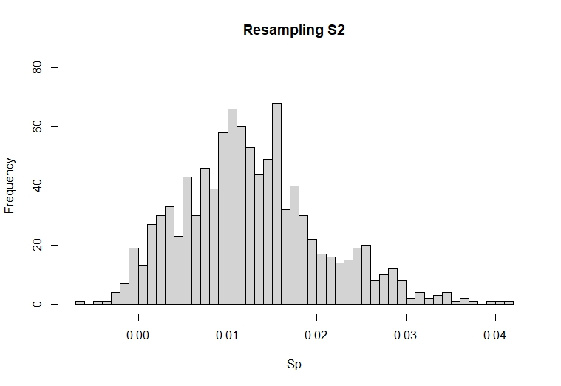
S2 Sp = 0.0119
S1 Sp = 0.001

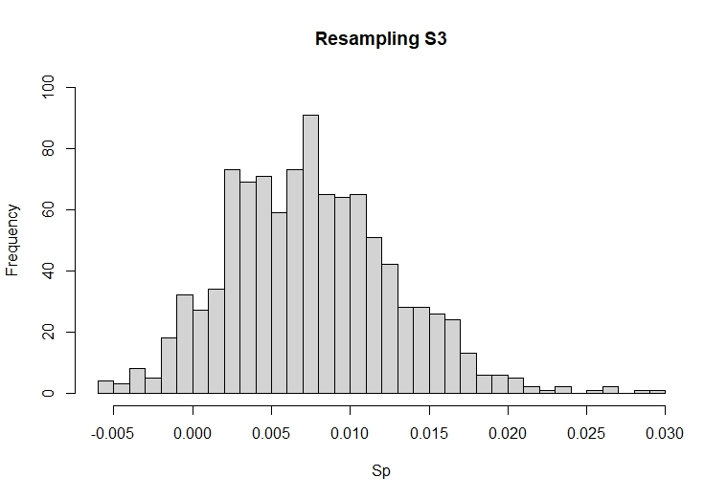
S3 Sp = 0.007
S1 Sp = 0.001

