Supplementary Material
In the U.S., P. albidus occurs in open prairie grassland in sandy or silty loam (Strickler 1997, Nold 1999) from Montana to Texas (Fig. 1) in the area known as the Great Plains and belongs to subgenus Penstemon. It has a white corolla with pink lines (guidelines), purportedly to direct pollinators to the nectar (Fig. 2). Penstemon fruticosus is a woody species split into three varieties, P. fruticosus var. fruticosus, P. fruticosus var. scouleri, and P. fruticosus var. serratus. This species belongs to the earliest diverged Penstemon lineage, subgenus Dasanthera. Its distribution is restricted to the Pacific Northwest and Canada (Fig. 2) where it grows in exposed rocky slopes from the foothills to mountain tops (Strickler 1997). Penstemon glandulosus belongs to the traditional subgenus Saccanthera and has two varieties, P. glandulosus var. glandulosus and P. glandulosus var. chelanensis. They have a disjunct distribution, with variety chelanensis restricted to Chelan County, WA, and variety glandulosus occurring at the border of Oregon, Idaho, and Washington (Fig. 1). The corolla of both varieties is light purple (Fig. 2), and the leaves are glandular and pubescent. Penstemon glandulosus inhabits rocky hillsides with scattered vegetation (Strickler 1997). Penstemon speciosus, which means, according to Panayoti Kelaidis, impossibly beautiful (Nold, 1999), was placed in subgenus Habroanthus section Glabri (Crosswhite, 1967). The corolla is sky blue and white at the corolla throat (Fig. 2), which may function as a nectar guide for pollinators. It is widely distributed from Washington to California including Idaho, Nevada, and Oregon (Fig. 1) and it grows in sagebrush prairies, ponderosa pine forests, and subalpine habitats (Strickler, 1997). Finally, P. whippleanus is also a member of the subgenus Penstemon. In contrast with P. albidus, this species typically has a dark purple corolla. Additionally, three color morphs are less common: white, yellow, and blue corollas (Fig. 2). This species is frequently found in Colorado, Utah, and Wyoming, but it also occurs in New Mexico and Arizona (Fig. 1). It grows in subalpine and alpine rocky slopes and meadows (Strickler, 1997; Nold, 1999).

Table S1. Geographic location of the samples included in this study.

Species | Population (# ind) | Longitude | Latitude
P. albidus
 | 2 (20)* | -103.1591190 | 35.798352
 | 3 (14) | -103.1253660 | 35.771684
 | 4 (5) | -104.6202760 | 40.723870
 | 5 (8) | -104.6491000 | 40.725062
 | 6 (8) | -105.2802550 | 42.853064
 | 7 (13)* | -104.9198550 | 43.635799
 | 9 (2) | -106.1624730 | 48.852961
 | 10 (11) | -101.9839790 | 35.264909
 | 11 (9) | -104.3396950 | 40.646503
 | 12 (5) | -105.4734700 | 43.722957
 | 13 (5) | -105.4649270 | 44.023685
 | 14 (10) | -109.2027180 | 45.444733
 | 15 (5) | -109.1079910 | 45.454061
Total | 13 (115)
P. fruticosus
 | 1 (9) | -120.6540060 | 47.3965130
 | 2 (14) * | -116.6868100 | 43.0389865
 | 3 (8)* | -115.3268720 | 43.2952560
 | 4 (3) | -115.4469590 | 43.3571530
 | 5 (16) | -115.2180720 | 44.2327840
 | 6 (14)* | -116.0973430 | 44.9570295
 | 8 (11) | -117.8369860 | 46.1070395
 | 10 (8)* | -117.6702150 | 48.3619488
Total | 8 (83)
P. glandulosus
 | 1 (8)* | -116.8964785 | 44.3886345
 | 2 (8)* | -116.9153165 | 44.4440760
 | 3 (4) | -116.8960000 | 44.3957520
 | 4 (14) | -120.1828880 | 47.2658736
 | 5 (5) | -116.8263780 | 44.5170140
 | 6 (10) | -116.7610960 | 44.5526100
 | 7 (10) | -116.7577190 | 44.6124920
Total | 7 (56)
P. speciosus
 | 1 (1) | -120.5398060 | 46.1121260
 | 2 (5) | -120.3964490 | 46.1256280
 | 3 (6) | -120.5391250 | 46.1149720
 | 4 (15) | -116.4878177 | 42.9676683
 | 5 (18)* | -115.0222426 | 41.0620266
 | 6 (6) | -116.6437570 | 43.0573960
 | 7 (16)* | -115.3269844 | 43.2955417
 | 8 (3) | -115.4443670 | 43.3565930
 | 9 (5) | -115.464784 | 43.3248210
 | 10 (5) | -115.235694 | 44.2182160
 | 12 (5) | -118.966654 | 45.2903560
 | 13 (12) | -119.199511 | 44.7349100
 | 14 (8) | -116.998797 | 39.4622000
 | 15 (10) | -119.912941 | 38.7753160
 | 16 (10) | -119.986445 | 38.6934910
 | 17 (2) | -119.583360 | 38.3092960
 | 18 (6) | -119.396324 | 38.3511660
 | 19 (8) | -118.960083 | 37.7082170
Total | 18 (146)
P. whippleanus
 | 1 (1) | -105.403384 | 36.228198
 | 2 (5) | -107.703200 | 37.915582
 | 3 (16)* | -107.713241 | 37.819575
 | 4 (5) | -105.403384 | 36.228198
 | 5 (5) | -106.378306 | 38.803752
 | 8 (16)* | -106.628496 | 40.400099
 | 10 (12) | -111.312074 | 39.614729
 | 11 (10) | -111.479767 | 39.322507
 | 12 (10) | -108.105885 | 39.031747
 | 13 (12) | -106.324935 | 38.519098
 | 14 (4) | -105.801546 | 35.796544
Total | 11 (96)
Overall total | 57 (496)
#ind represents the total number of individuals sampled in a population. *Represents populations that were sampled in 2017 and 2018.

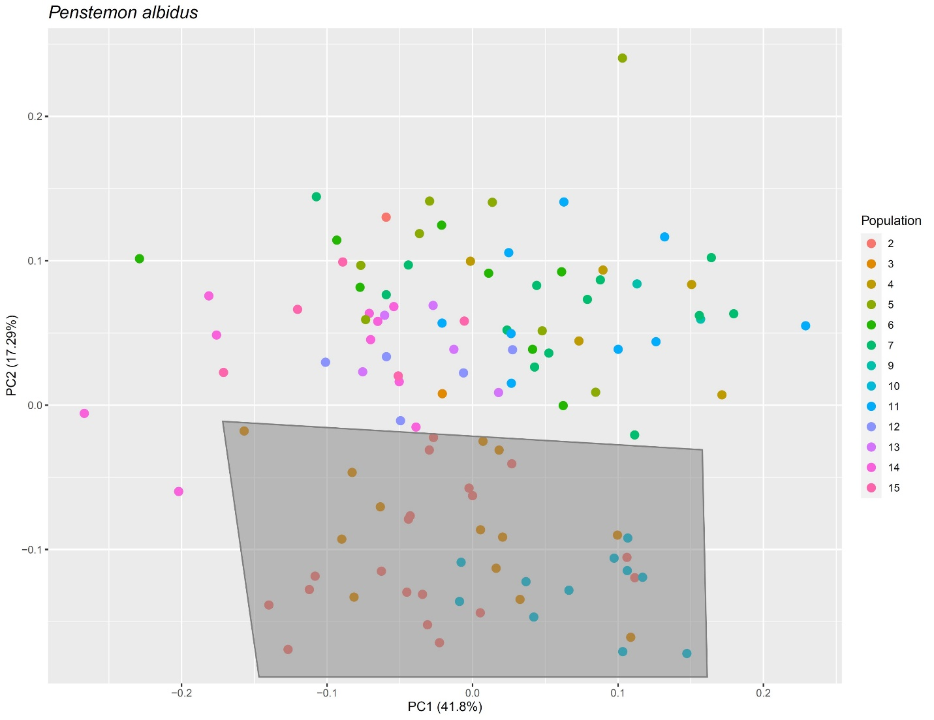
Figura S1. Plot of PC1 and PC2. The dots represent individuals colored by population. This graph shows two clusters: 1) with individuals from south of Colorado, populations 2, 3, and 10 (gray shape), and 2) populations sampled in and north of Colorado.

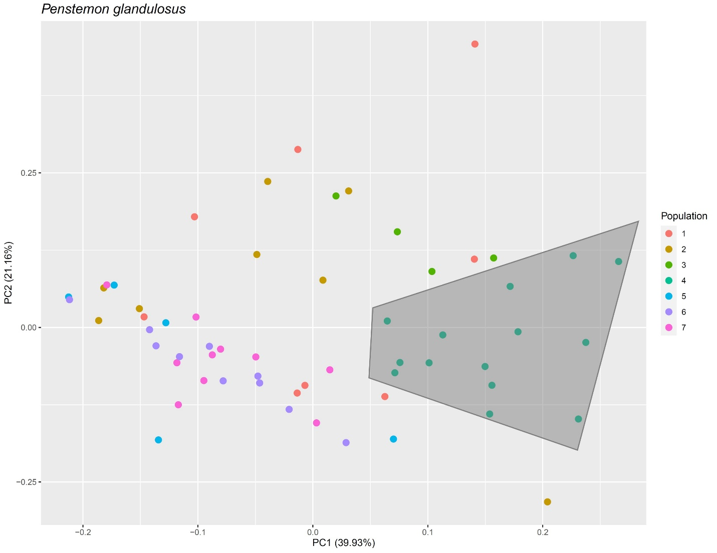Figure S2. Plot of PC1 and PC2. The dots represent individuals colored by population. This graph shows that individuals from population 4 that belong to P. glandulosus var. chelanensis (gray shape) form a separate cluster. There are two less distinctive groups formed by populations 1, 2, and 3 and by populations 5, 6, and 7. These two groups are also geographically separated.

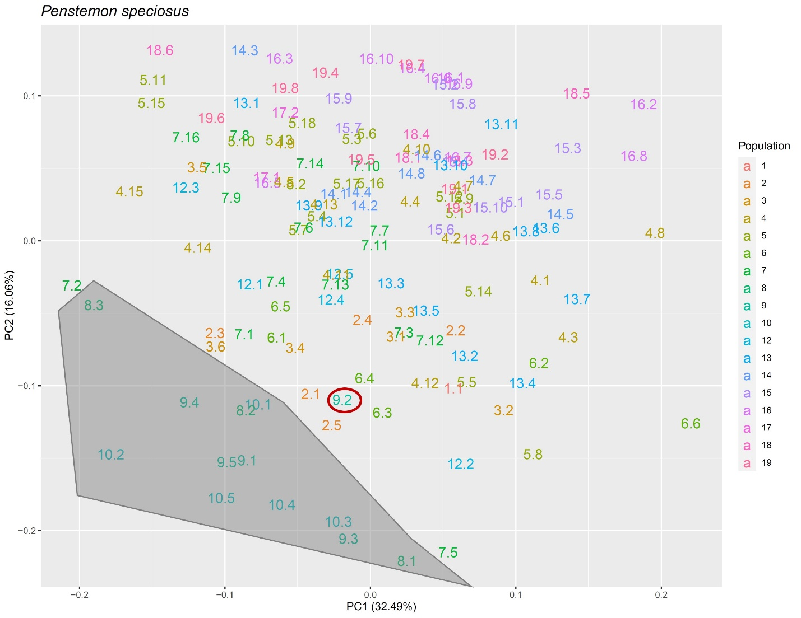
Figure S3. Plot of PC1 and PC2. The numbers in the plot represent the population number and the individual number separated by a period. This graph shows that individuals do not group by population. There is, however, a small cluster of populations enclosed in the gray shape. This cluster represents almost all individuals (see red circle) for populations 8, 9, and 10. Note that population 7 is geographically closer to populations 8 and 9 than population 10 is, but population 7 is not part of the cluster. Numbers instead of standard dots were used in this graph to enhance clarity.

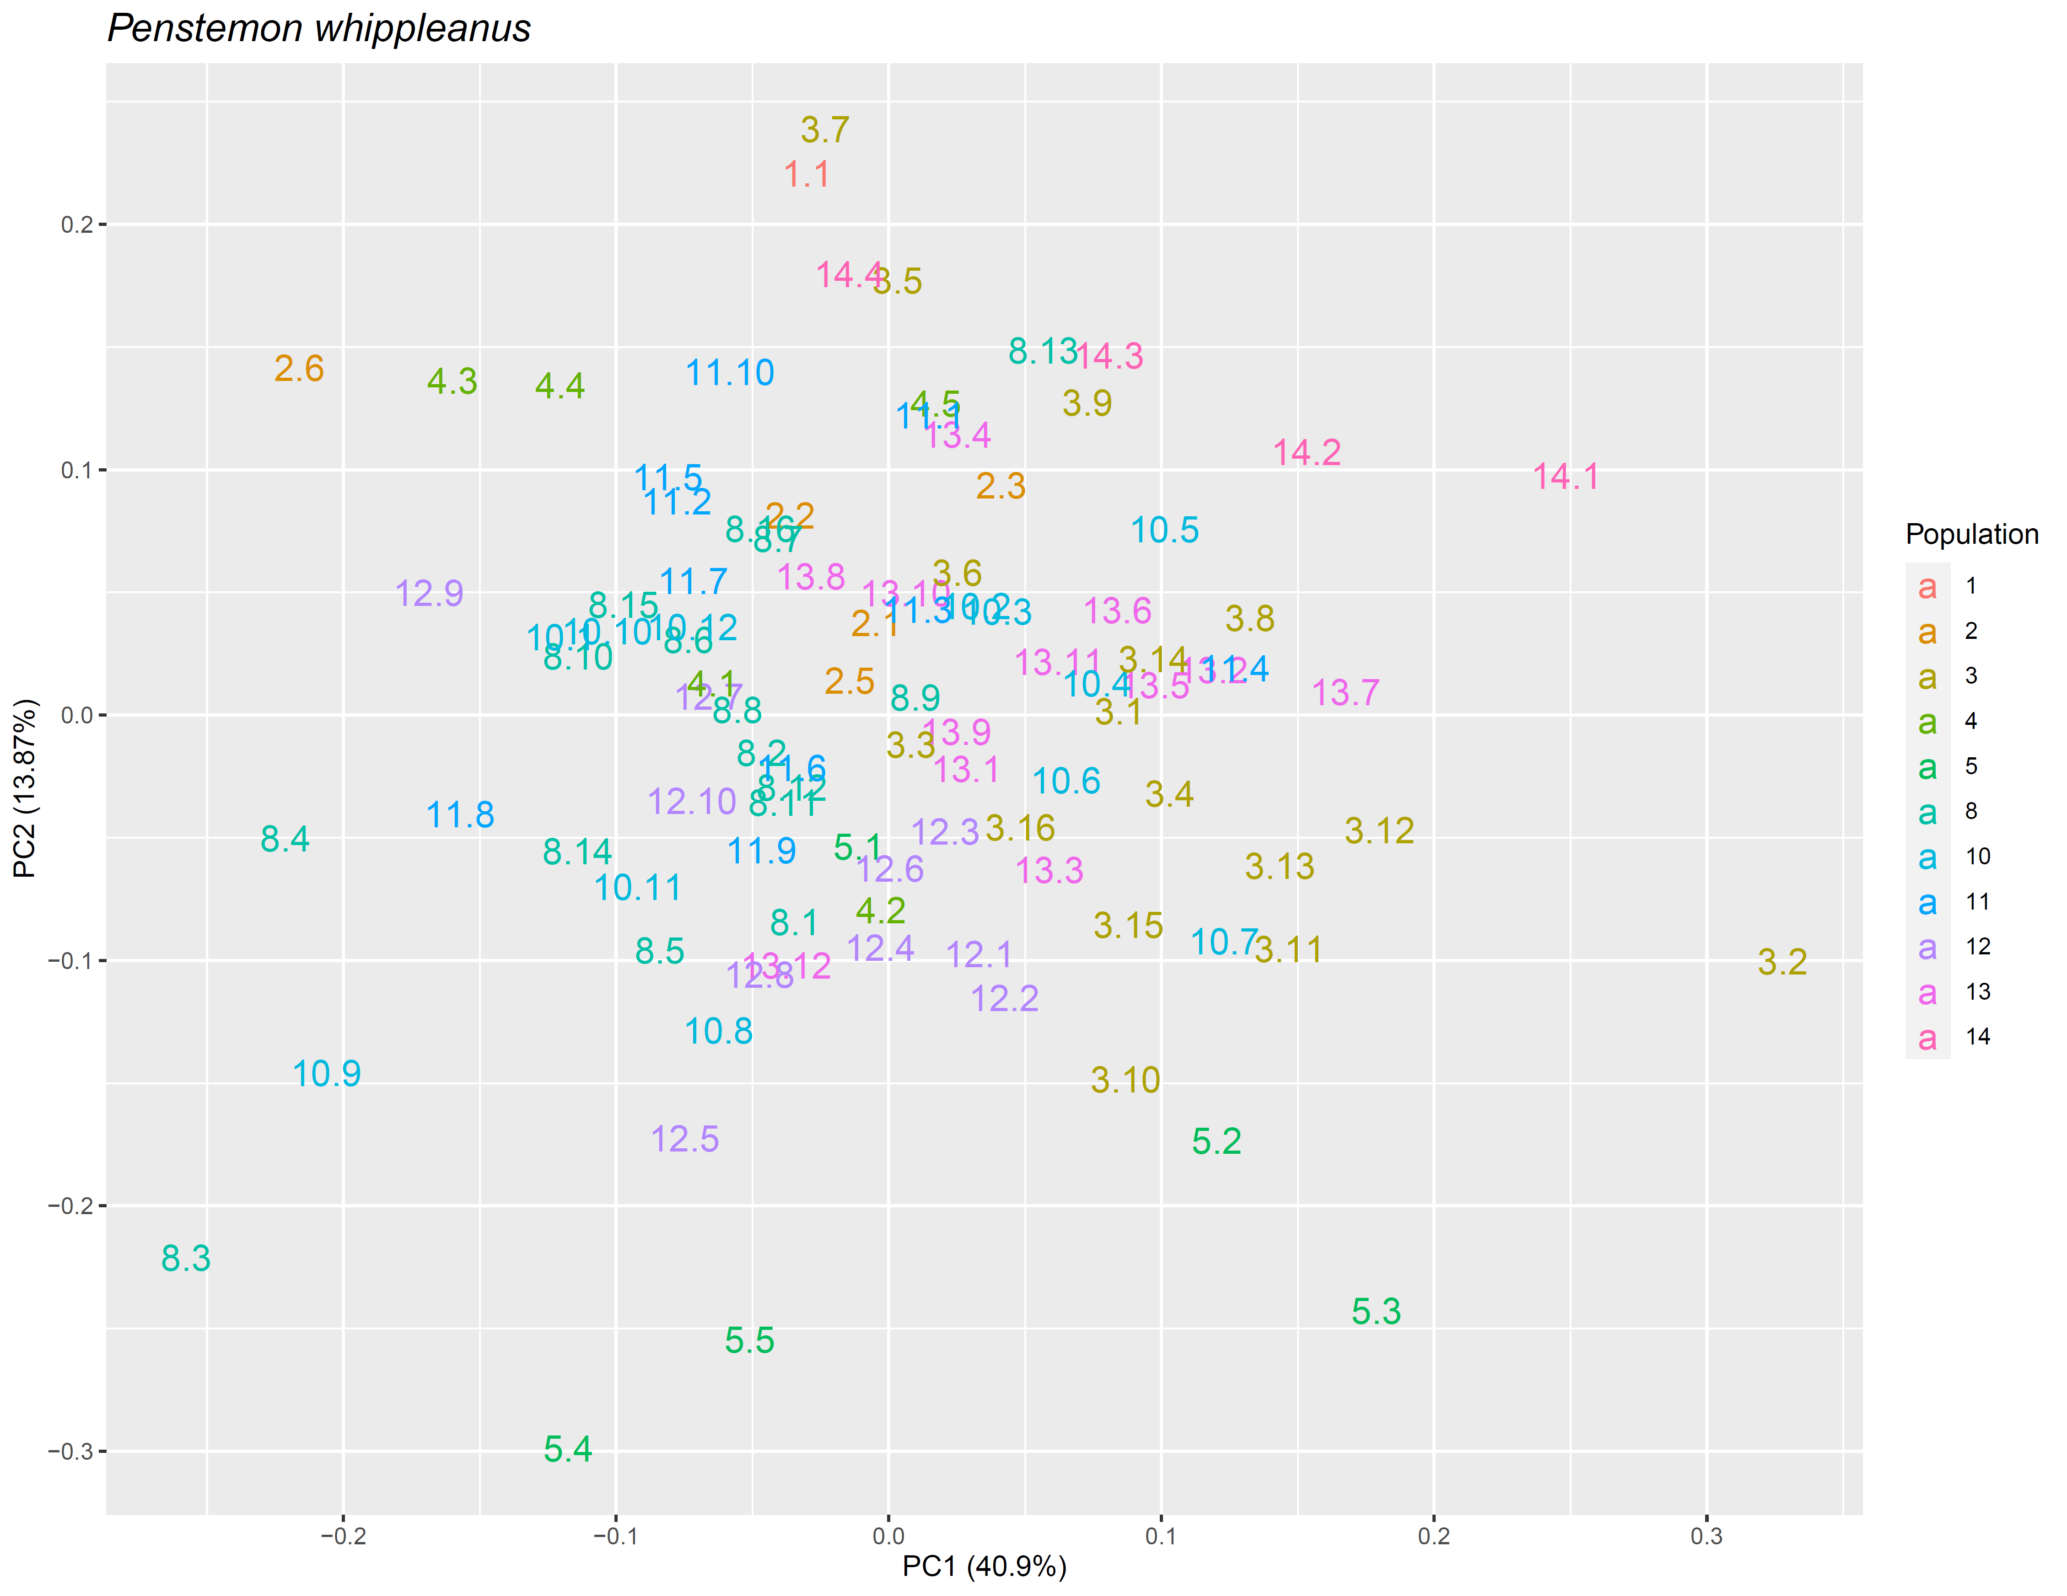
Figure S4. Plot of PC1 and PC2 for P. whippleanus. The numbers in the plot represent the population number and the individual number separated by a period. This graph shows that individuals do not group by population. Numbers instead of standard dots were used in this graph to enhance clarity.

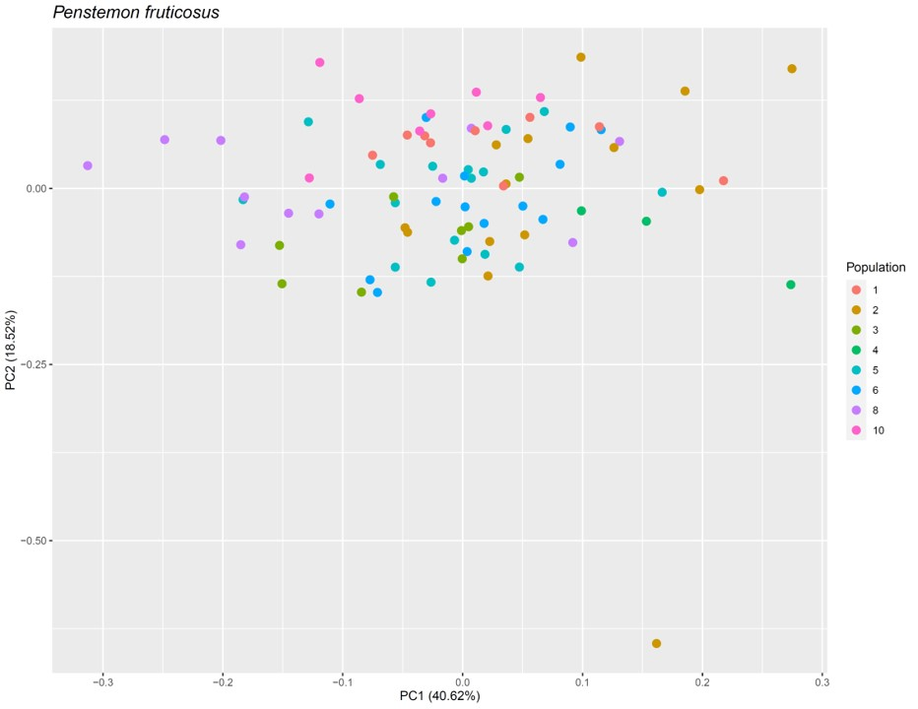Figure S5. Plot of PC1 and PC2. The dots represent individuals colored by population. This graph shows that individuals do not group by population.

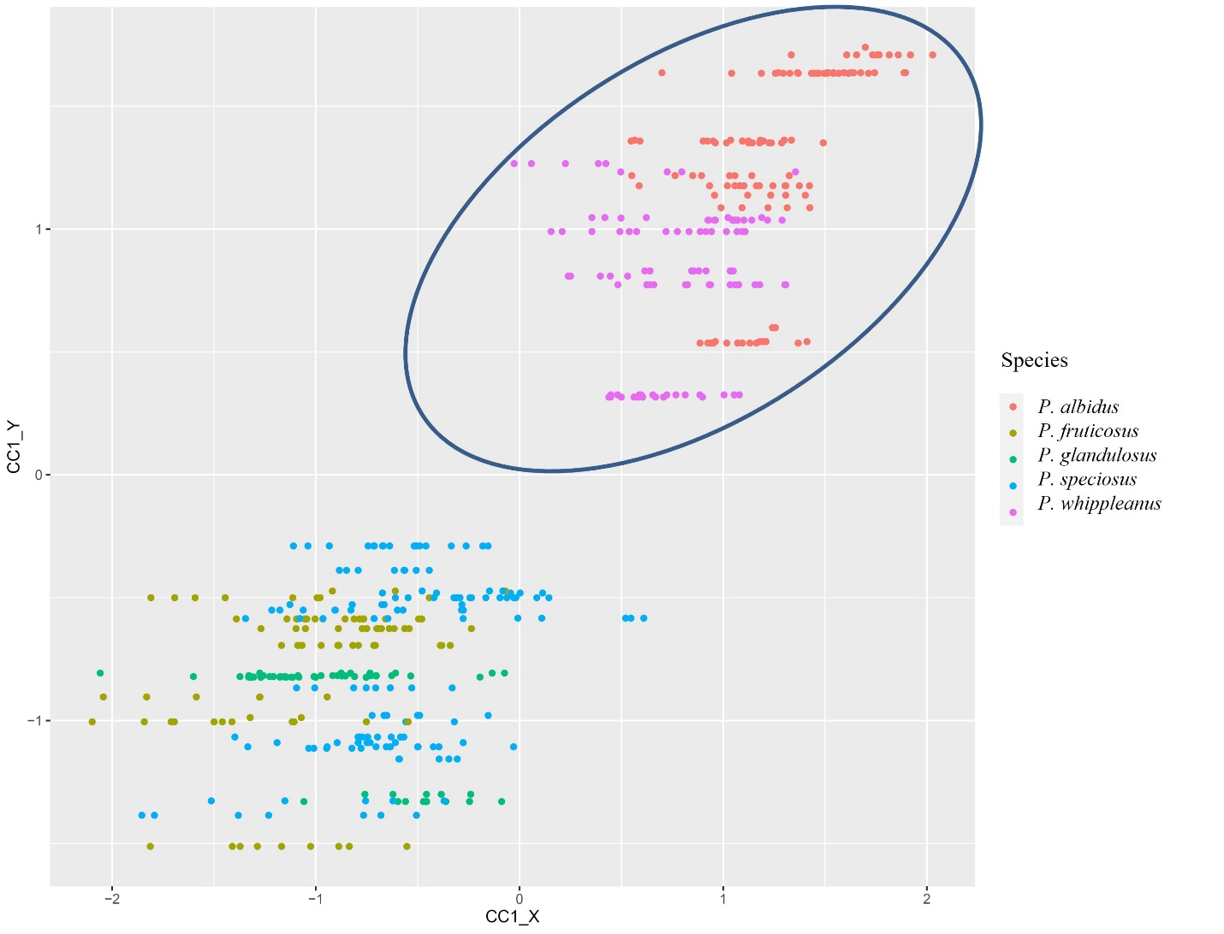
Figure S6. Plot of the first canonical covariate pair where observations are colored by species. The species in the blue circle occur in the Rocky Mountains or east of it.

Literature cited

Nold R. 1999. Penstemons. Portland: Timber Press. ISBN-13: 9780881924299

Strickler D. 1997. Northwest Penstemons: 80 species of' Penstemon native to the Pacific Northwest. Montana: Flower Press. ISBN-13: 9781560445722

