Suplementary Material

Table S1. Number of fruits by replication, forest type and site for each exlusion treatment. MCFdu = montane cloud forest with dense understory, MCFsu = montane cloud forest with a sparse understory, POFdu = pine-oak forest with a dense understory, POFsu = pine-oak forest with a sparse understory, and OA = open area with dense shrub cover.

Treatment | Site | Vegetation type | Replication 1 | Replication 2 | Replication 3 | Replication 4
Small | S1 | MCFsu | 25 | 25 | 25 | 25
 | S1 | MCFdu | 25 | 25 | 25 | 25
 | S1 | PFsu | 25 | 25 | 25 | 25
 | S1 | PFdu | 25 | 25 | 25 | 25
 | S1 | OA | 15 | 15 | 15 | 15
 | S2 | MCFsu | 17 | 17 | 17 | 17
 | S2 | MCFdu | 17 | 17 | 17 | 17
 | S2 | PFsu | 17 | 17 | 17 | 17
 | S2 | PFdu | 17 | 17 | 17 | 17
 | S2 | OA | 8 | 8 | 8 | 8
Small+Medium | S1 | MCFsu | 25 | 25 | 25 | 25
 | S1 | MCFdu | 25 | 25 | 25 | 25
 | S1 | PFsu | 25 | 25 | 25 | 25
 | S1 | PFdu | 25 | 25 | 25 | 25
 | S1 | OA | 25 | 25 | 25 | 25
 | S2 | MCFsu | 17 | 17 | 17 | 17
 | S2 | MCFdu | 17 | 17 | 17 | 17
 | S2 | PFsu | 17 | 17 | 17 | 17
 | S2 | PFdu | 17 | 17 | 17 | 17
 | S2 | OA | 17 | 17 | 17 | 17
Control | S1 | MCFsu | 50 | 17 | 8 | 25
 | S1 | MCFdu | 50 | 25 | 8 | 8
 | S1 | PFsu | 50 | 50 | 50 | 50
 | S1 | PFdu | 50 | 50 | 50 | 50
 | S1 | OA | 50 | 50 | 50 | 50
 | S2 | MCFsu | 25 | 8 | 25 | 25
 | S2 | MCFdu | 25 | 25 | 25 | 25
 | S2 | PFsu | 25 | 25 | 25 | 25
 | S2 | PFdu | 25 | 25 | 25 | 25
 | S2 | OA | 25 | 25 | 25 | 25
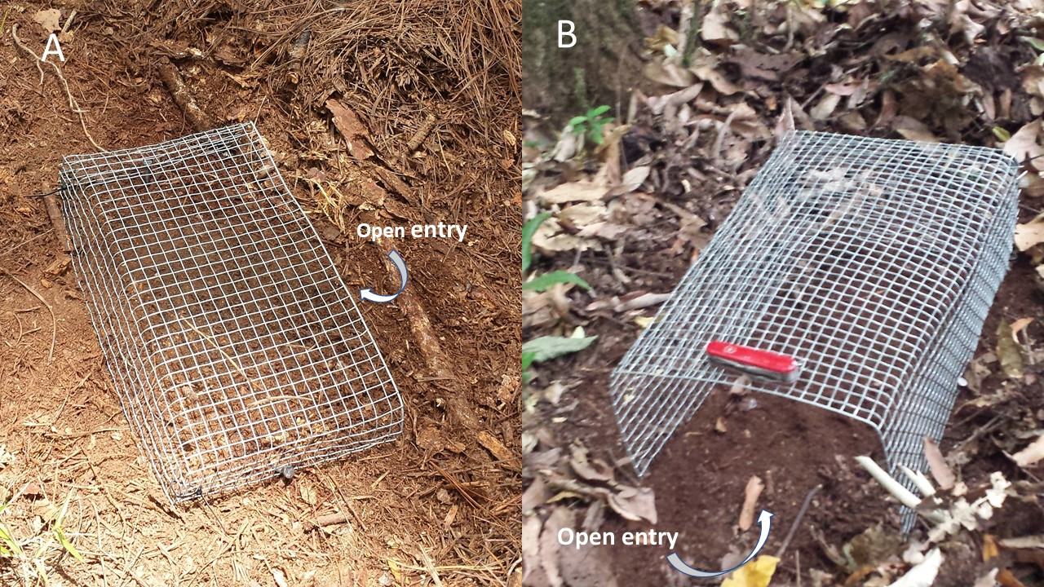
Figure S1. Wire cages used for medium-large (A) and large-sized (B) vertebrate exclusion experiments.

