Supplementary Material

Imperfect detection.

Consider a plant with small seedlings that are not easily detected. Seedlings that are not found and tagged are more likely to be found on the next year after germination simply because they are larger. Nevertheless, it is often difficult to tell such plants from new recruits that germinated early during the current annual transition or developed rapidly due to microsite conditions. Thus, we may incorrectly consider plants that were missed on the previous census to be recently germinated individuals. To analyze the effects of this kind of detection error on the estimation of density dependence, we simulated the density-independent dynamics of a species where individuals are classified into two categories. Small plants, including one or two year olds, are classified in the first category. The dynamics of the system is described by the matrix

$A=\left[\begin{matrix}0.3 & 2.5 \\ 0.2 & 0.3\end{matrix}\right]$,

where a_{1,2} = 2.5 is the average number of seedlings produced on average per adult. Starting at the stable-stage structure, the dynamics of the population was simulated for 100 years. The vector n_{t} with elements n_{i,t} contains the simulated data without error. If there were detection error in the time series, we would incorrectly estimate the number of new recruits f_{t} as

f_{t} = n_{2,t} a_{1,2}p_{t} + n_{1,t-1} a_{1,1}(1 - p_{t – 1}),

where p_{t} is the detection probability on year t. The first element of the sum in this equation corresponds to true new recruits that are detected on the year that they germinate, and the second corresponds to older recruits that survive and are observed for the first time on the second year after they germinated. Under such conditions, we would estimate the number $n_{1,t}^{'}$ of individuals in the first category in year t as those that were tagged and survived plus those that recruited, or

$n_{1,t}^{'}=n_{1,t-1}^{'}a_{1,1}+ f_{t}$.

The number of seedlings produced per adult plant every year would also be incorrectly estimated as

$a_{1,2,t}^{'}=f_{t}/n_{2,t-1}$.

Finally, we regressed $a_{1,2,t}^{'}$ on $n_{1,t-1}^{'}$ to test whether the number of new recruits is affected by the number of small plants in the population, as it would be expected if safe sites are depleted by previous residents. The relationship between these variables is linear (Figure S1). Given that the underlying process is density-independent, we would expect the slope of such regression to be zero. This procedure was repeated 10,000 times for different detection probabilities between 0.5 and 0.95, and we calculated the mean of the slope and the type-I error rate (fraction of significant regressions out of the 10,000 simulations).
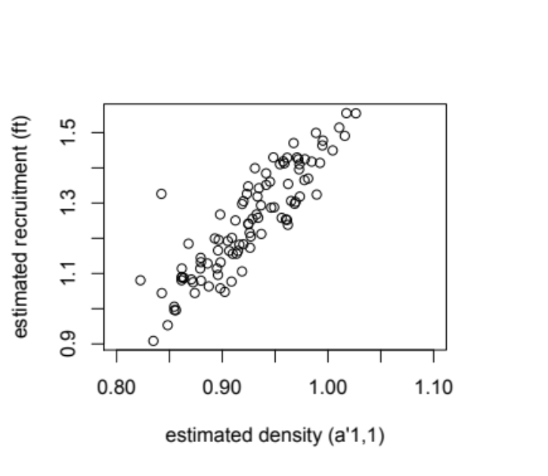
Figure S1. Relationship between estimated density and number of new recruits showing a linear trend. To reduce noise and allow for a clear assessment of the shape of the relationship a matrix with λ = 1 was used with a probability of detection of 0.8.

The regression slopes and the type-I error rates increased as the detection probability diminished, indicating that imperfect detection may result in spurious estimates of density dependence (Figure S2). As it happens in non-structured population models (Freckleton et al. 2006), this problem was particularly important if other sources of variation in time are present, i.e., if the population size is not stable (in the example above λ = 1.007), or if A changes stochastically over time (results not shown). Also, the large type-I error rates that we found are not likely to be as extreme in real situations, where study years are far fewer than in our simulations. However, this would reflect a lack of statistical power rather than the lack of a bias. 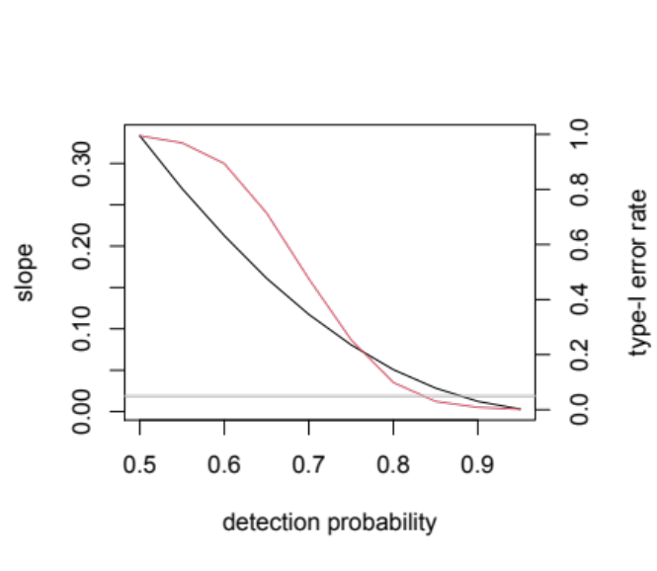
Figure S2. Spurious density dependence induced by imperfect detection. Black: slope of the regression, red: type I error rate, gray: the maximum acceptable error rate α = 0.05.

Note that the model described above is identical to the case of a seed bank described in the main text, although in this case, (1) p_{t} is the probability that a seed remains in the seed bank at time t instead of a variable detection probability, (2) all seeds in the bank germinate after one year, and (3) all seedlings are always detected.

Literature cited

Freckleton RP, Watkinson AR, Green RE, Sutherland WJ. 2006. Census error and the detection of density dependence. Journal of Animal Ecology 75: 837-851.
DOI: https://doi.org/10.1111/j.1365-2656.2006.01121.x

