Supplementary material

Table S1. Compounds identified in Randia species.
No. | Compound class and name | Species | Employed methodologies | Reference
 | Flavonoids
1 | (-) Epicatequin | Randia monantha Benth. | UPLC-MS/MS | Juárez-Trujillo et al. 2018
2 | Kaempferol | Randia monantha Benth.,  Randia ferox (Cham & Schltdl) DC. | UPLC-MS/MS | Juárez-Trujillo et al. 2018; Pappis et al. 2021
3 | Kaempferol-3-О-β-D-galactoside | Randia hebecarpa Benth. | CC and TLC | Nazari et al. 2006
4 | Kaempferol-3-О-α-L-rhamnosyl-(1→6)-β-D-galactosyl-7-О-α-L-rhamnoside | Randia hebecarpa Benth. | CC and TLC | Nazari et al. 2006
5 | Kaempferol 7-O-α-L-dirhamnoside | Randia hebecarpa Benth. | CC and TLC | Nazari et al. 2006
6 | Myricetin-3-О-β-L-rhamnoside | Randia hebecarpa Benth. | CC and TLC | Nazari et al. 2006
7 | Quercetin | Randia monantha Benth.,  Randia ferox (Cham & Schltdl) DC. | UPLC-MS/MS | Juárez-Trujillo et al. 2018; Pappis et al. 2021
8 | Quercetin-3-О-β-D-galactoside | Randia hebecarpa Benth. | CC and TLC | Nazari et al. 2006
9 | Rutin | Randia monantha Benth., Randia ferox (Cham & Schltdl) DC. | UPLC-MS/MS | Juárez-Trujillo et al. 2018; Pappis et al. 2021
10 | Luteolin, | Randia ferox (Cham & Schltdl) DC. | UPLC-MS/MS | Pappis et al. 2021
11 | Apigenin | Randia ferox (Cham & Schltdl) DC. | UPLC-MS/MS | Pappis et al. 2021
 | Coumarins
12 | Scopoletin | Randia monantha Benth. | UPLC-MS/MS | Juárez-Trujillo et al. 2018
13 | Scopolin | Randia monantha Benth. | UPLC-MS/MS | Juárez-Trujillo et al. 2018
 | Phenylpropionic acids
14 | 4-Coumaric acid | Randia monantha Benth, Randia ferox (Cham & Schltdl) DC. | UPLC-MS/MS
15 | Caffeic acid | Randia monantha Benth, Randia ferox (Cham & Schltdl) DC. | UPLC-MS/MS | Juárez-Trujillo et al. 2018; Pappis et al. 2021
16 | Chlorogenic acid | Randia monantha Benth, Randia ferox (Cham & Schltdl) DC. | UPLC-MS/MS | Juárez-Trujillo et al. 2018; Pappis et al. 2021
17 | Ferulic acid | Randia monantha Benth, Randia ferox (Cham & Schltdl) DC. | UPLC-MS/MS | Juárez-Trujillo et al. 2018; Pappis et al. 2021
18 | Vainillin | Randia monantha Benth | UPLC-MS/MS | Juárez-Trujillo et al. 2018
 | Phenolic acids
19 | Gallic acid | Randia monantha Benth. | UPLC-MS/MS | Juárez-Trujillo et al. 2018
20 | 2,4-Dimetoxi-6-metylbenzoic acid | Randia monantha Benth. | UPLC-MS/MS | Juárez-Trujillo et al. 2018
21 | 4-Hydroxybenzoic acid | Randia monantha Benth. | UPLC-MS/MS | Juárez-Trujillo et al. 2018
22 | Vanillic acid | Randia monantha Benth., Randia ferox (Cham & Schltdl) DC. | UPLC-MS/MS | Juárez-Trujillo et al. 2018; Pappis et al. 2021
23 | Benzyl alcohol | Randia matudae Lorence & Dwyer | GC-MS | Setzer et al. 2006
24 | Benzaldehyde | Randia matudae Lorence & Dwyer | GC-MS | Setzer et al. 2006
25 | Benzyl benzoate | Randia matudae Lorence & Dwyer | GC-MS | Setzer et al. 2006
26 | Methyl benzoate | Randia matudae Lorence & Dwyer | GC-MS | Setzer et al. 2006
27 | Veratrole | Randia matudae Lorence & Dwyer
 | Phenolic acids
28 | Benzyl formate | Randia matudae Lorence & Dwyer | GC-MS | Setzer et al. 2006
29 | Methyl salicylate | Randia matudae Lorence & Dwyer | GC-MS | Setzer et al. 2006
30 | trans-Isoeugenol | Randia matudae Lorence & Dwyer | GC-MS | Setzer et al. 2006
31 | trans-Methyl isoeugenol | Randia matudae Lorence & Dwyer | GC-MS | Setzer et al. 2006
32 | Phenylphosphonic acid | Randia aculeata L. | GC-MS | Martínez-Ceja et al. 2022
 | Terpenes
 | Monoterpenes
33 | Borneol
34 | 1,8-Cineole
35 | Citronellol
36 | exo-2-Hydroxycineole
37 | Phytopentaene
38 | Geranial
39 | Geraniol | Randia matudae Lorence & Dwyer | GC-MS | Setzer et al. 2006
40 | cis-Rose oxide
41 | αTerpineol
42 | 4-Terpineol
43 | trans-Verbenyl acetate
44 | Linalool 3,7-oxide
45 | cis-Linalool oxide
46 | trans-Linalool oxide
47 | Linalool
 | Sesquiterpenes
48 | trans-Nerolidol acetate | Randia matudae Lorence & Dwyer | GC-MS | Setzer et al. 2006
49 | Dendrolasin | Randia matudae Lorence & Dwyer | GC-MS | Setzer et al. 2006
50 | (E,E)-α-Farnesene | Randia matudae Lorence & Dwyer | GC-MS | Setzer et al. 2006
51 | Germacrene D | Randia matudae Lorence & Dwyer | GC-MS | Setzer et al. 2006
 | Diterpenoids
52 | Phytol | Randia aculeata L. | GC-MS | Martínez-Ceja et al. 2022
 | Triperpenoids
53 | Cincholic acid 3-О-β-D-quinovopyranosil-28-О-β-D-glucopyranoside | Randia hebecarpa Benth. | CC and TLC | Nazari et al. 2006
54 | Quinovic acid 3-О-β-quinovopyranosil-28-О-β-D-glucopyranoside | Randia hebecarpa Benth. | CC and TLC | Nazari et al. 2006
55 | Oleanolic acid | Randia echinocarpa Moc. & Sessé ex DC. | CC, TLC, IR and NMR | Bye et al. 1991
56 | Oxoquinovic acid | Randia echinocarpa Moc. & Sessé ex DC. | CC, TLC, IR and NMR | Bye et al. 1991
57 | Quinovic acid | Randia echinocarpa Moc. & Sessé ex DC. | CC, TLC, IR and NMR | Bye et al. 1991
58 | Ursolic acid | Randia echinocarpa Moc. & Sessé ex DC. | CC, TLC, IR and NMR | Bye et al. 1991
 | Triperpenoids
59 | Squalene | Randia echinocarpa Moc. & Sessé ex DC., Randia aculeata L. | CC, TLC and GC-MS | Cano-Campos et al. 2011, Martínez-Ceja et al. 2022
60 | Cycloartenol | Randia aculeata L. | GC-MS | Martínez-Ceja et al. 2022
 | Steroids
61 | β-sitosterol | Randia echinocarpa Moc. & Sessé ex DC., Randia aculeata L. | CC, TLC, IR, NMR and GC-MS | Bye et al. 1991; Cano-Campos et al. 2011; Martínez-Ceja et al. 2022
62 | Campesterol | Randia echinocarpa Moc. & Sessé ex DC., Randia aculeata L. | CC, TLC and GC-MS | Cano-Campos et al. 2011; Martínez-Ceja et al. 2022
63 | Stigmasterol | Randia echinocarpa Moc. & Sessé ex DC., Randia aculeata L. | CC, TLC and GC-MS | Cano-Campos et al. 2011; Martínez-Ceja et al. 2022
 | Alkaloids
64 | Methyl nicotinate | Randia matudae Lorence & Dwyer | GC-MS | Setzer et al. 2006
 | Others
65 | Hexadecyl acetate | Randia matudae Lorence & Dwyer | GC-MS | Setzer et al. 2006
66 | Arachidic acid | Randia monantha Benth., Randia aculeata L. | GC-MS | Juárez-Trujillo et al. 2018; Martínez-Ceja et al. 2022
67 | Hexadecanoic acid | Randia echinocarpa Moc. & Sessé ex DC., Randia monantha Benth., Randia aculeata L. | CC and GC-MS | Cano-Campos et al. 2011; Juárez-Trujillo et al. 2018; Martínez-Ceja et al. 2022
68 | α- Linoleic acid | Randia aculeata L. | GC-MS | Martínez-Ceja et al. 2022
69 | Linoleic acid | Randia monantha Benth., Randia aculeata L. | GC-MS | Juárez-Trujillo et al. 2018; Martínez-Ceja et al. 2022
70 | Octadecanoic acid | Randia monantha Benth., Randia aculeata L. | GC-MS | Juárez-Trujillo et al. 2018; Martínez-Ceja et al. 2022
71 | Oleic acid | Randia monantha Benth. | GC-MS | Juárez-Trujillo et al. 2018
72 | Azelaic acid | Randia aculeata L. | GC-MS | Martínez-Ceja et al. 2022
73 | Gluconic acid | Randia aculeata L. | GC-MS | Martínez-Ceja et al. 2022
74 | Hexadecanal | Randia echinocarpa Moc. & Sessé ex DC., R. matudae Lorence & Dwyer | CC, TLC and GC-MS | Setzer et al. 2006; Cano-Campos et al. 2011
75 | 2-Hexadecanol | Randia matudae Lorence & Dwyer | GC-MS | Setzer et al. 2006
76 | cis-11-Hexadecenal | Randia matudae Lorence & Dwyer | GC-MS | Setzer et al. 2006
77 | 2-Heptanol | Randia matudae Lorence & Dwyer | GC-MS | Setzer et al. 2006
78 | cis-3-Hexenol | Randia matudae Lorence & Dwyer | GC-MS | Setzer et al. 2006
79 | trans-3-Hexenol | Randia matudae Lorence & Dwyer | GC-MS | Setzer et al. 2006
80 | Phenethyl alcohol | Randia matudae Lorence & Dwyer | GC-MS | Setzer et al. 2006
81 | D-mannitol | Randia echinocarpa Moc. & Sessé ex DC., R. hebecarpa Benth. | CC, TLC, IR, NMR and GC-MS | Bye et al. 1991; Nazari et al. 2006; Cano-Campos et al. 2011
82 | Threitol | Randia aculeata L. | GC-MS | Martínez-Ceja et al. 2022
83 | Xylitol | Randia aculeata L. | GC-MS | Martínez-Ceja et al. 2022
84 | Arabinitol | Randia aculeata L. | GC-MS | Martínez-Ceja et al. 2022
85 | Ribitol | Randia aculeata L. | GC-MS | Martínez-Ceja et al. 2022
86 | Glucitol | Randia aculeata L. | GC-MS | Martínez-Ceja et al. 2022
87 | Inositol | Randia aculeata L. | GC-MS | Martínez-Ceja et al. 2022
88 | Threonic acid | Randia aculeata L. | GC-MS | Martínez-Ceja et al. 2022
89 | 3-Eicosyne | Randia aculeata L. | GC-MS | Martínez-Ceja et al. 2022
90 | Dibutyl phthalate | Randia aculeata L. | GC-MS | Martínez-Ceja et al. 2022
91 | 2,2-Dimethyl-3-(3,7,16,20-tetramethyl-heneicosa-3,7,11,15,19-pentaenyl)-oxirane | Randia aculeata L. | GC-MS | Martínez-Ceja et al. 2022
92 | Oxirane, 2,2-dimethyl-3-(3,7,12,16,20-pentamethyl-3,7,11,15,19-heneicosapentaenyl)-, (all-E)- | Randia aculeata L. | GC-MS | Martínez-Ceja et al. 2022
93 | 2-Deoxy-D-ribonic acid | Randia aculeata L. | GC-MS | Martínez-Ceja et al. 2022
94 | 6-Methyl-5-hepten-2-ol | Randia matudae Lorence & Dwyer | GC-MS | Setzer et al. 2006
95 | Octadecanal | Randia echinocarpa Moc. & Sessé ex DC. | CC, TLC and GC-MS | Cano-Campos et al. 2011
96 | 1-Octen-3-ol | Randia matudae Lorence & Dwyer | GC-MS | Setzer et al. 2006
97 | Pentadecanal | Randia echinocarpa Moc. & Sessé ex DC. | CC, TLC and GC-MS | Cano-Campos et al. 2011
98 | 2-Pentadecanone | Randia matudae Lorence & Dwyer | GC-MS | Setzer et al. 2006
99 | 1-Hexadecanol | Randia matudae Lorence & Dwyer | GC-MS | Setzer et al. 2006
100 | 2-Hexadecanol | Randia matudae Lorence & Dwyer | GC-MS | Setzer et al. 2006
CC, Column Chromatography; TLC, Thin Layer Chromatography; UV, Ultraviolet; IR, Infrared; NMR, Nuclear Magnetic Resonance; GC-MS, Gas Chromatography Mass Spectrometry; UPLC-MS/MS, Ultra Performance Liquid Chromatography - Tandem Mass Spectrometry. The structure of the numbered compounds is presented in Figure S1.

Table S2. Biological activities for the main compounds identified in Randia species.
Secondary metabolites | Compounds | Tested activity/study | Reference
Phenolics | Rutin | Anticancer and antiinflammatory | Ben Sghaier et al. 2016; Torres-Rego et al. 2016
Phenolics | Scopoletin | Anti-obesity and antihepatosteatosis | Ham et al. 2016
Phenolics | Chlorogenic acid | Antiproliferative in A459 cells, antiviral and antiinflammatory | Wang et al. 2020; Li et al. 2021
Phenolics | Vanillic acid | Antiinflammatory | Calixto-Campos et al. 2015
 | Kaempferol glycosides | Antinociceptive and antiinflammatory | De Melo et al. 2009
 | α-terpineol | Antifungal | An et al. 2018
Terpenes | Linalool | Antiinflammatory and anticancer | Kim et al. 2019; Rodenak-Kladniew et al. 2020
 | Quinovic acid | Anticancer and cell apoptosis | Dietrich et al. 2014; Khayam et al. 2020
Sterols | β-sitosterol | Antiinflammatory  Antimutagenic | Cano-Campos et al. 2011; Chakraborty et al. 2021
Others | Linoleic acid | Cell apoptosis  Antimutagenic | Cano-Campos et al. 2011; Ham et al. 2018
Others | Oleic acid | Antiinflammatory | Pegoraro et al. 2020
Others | Palmitic acid | Antiviral  Antiinflammatory  Antimutagenic | Librán-Pérez et al. 2019; Cano-Campos et al. 2011; Prasath et al. 2021

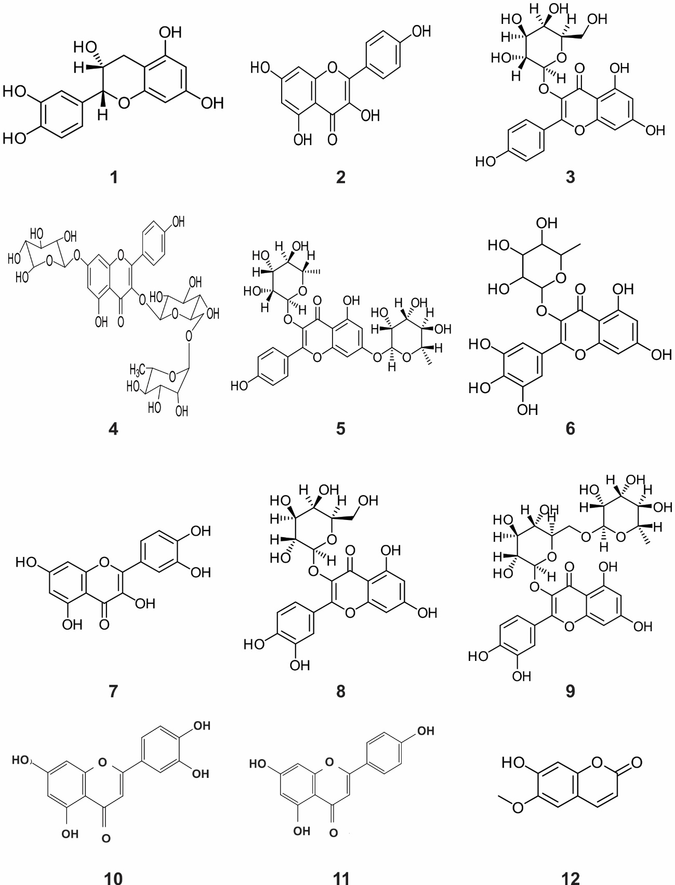
Figure S1. Structures of identified phytochemical compounds in Randia. The compound names and cites are included in the Table S1.

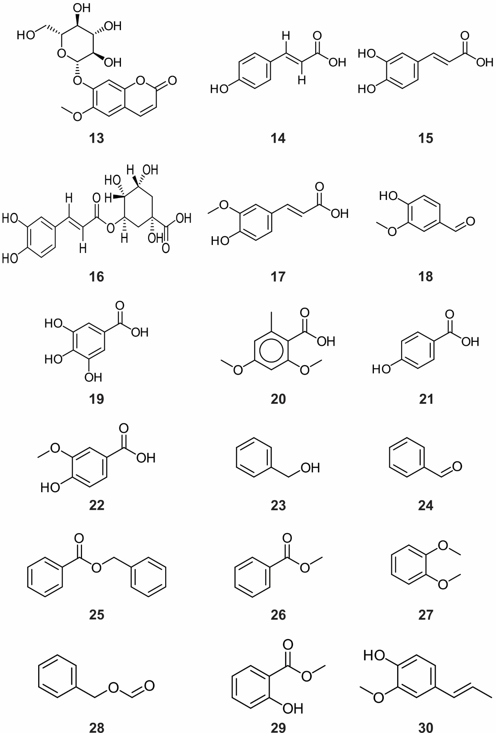
Figure S1. Structures of identified phytochemical compounds in Randia (Continuation).

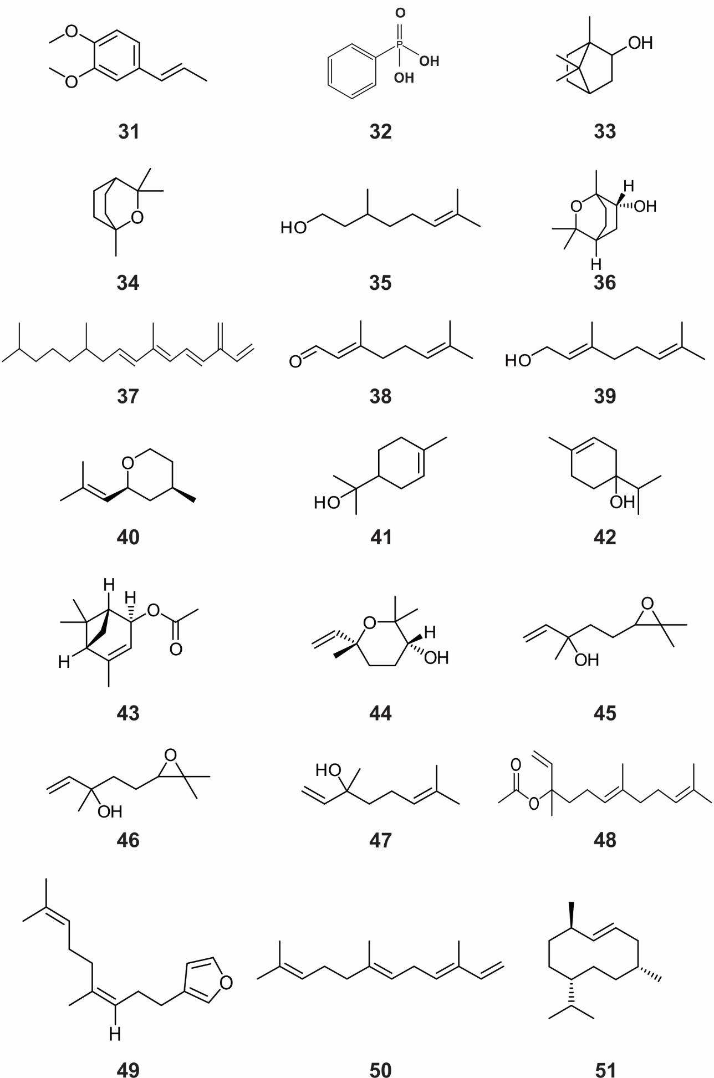

Figure S1. Structures of identified phytochemical compounds in Randia (Continuation).

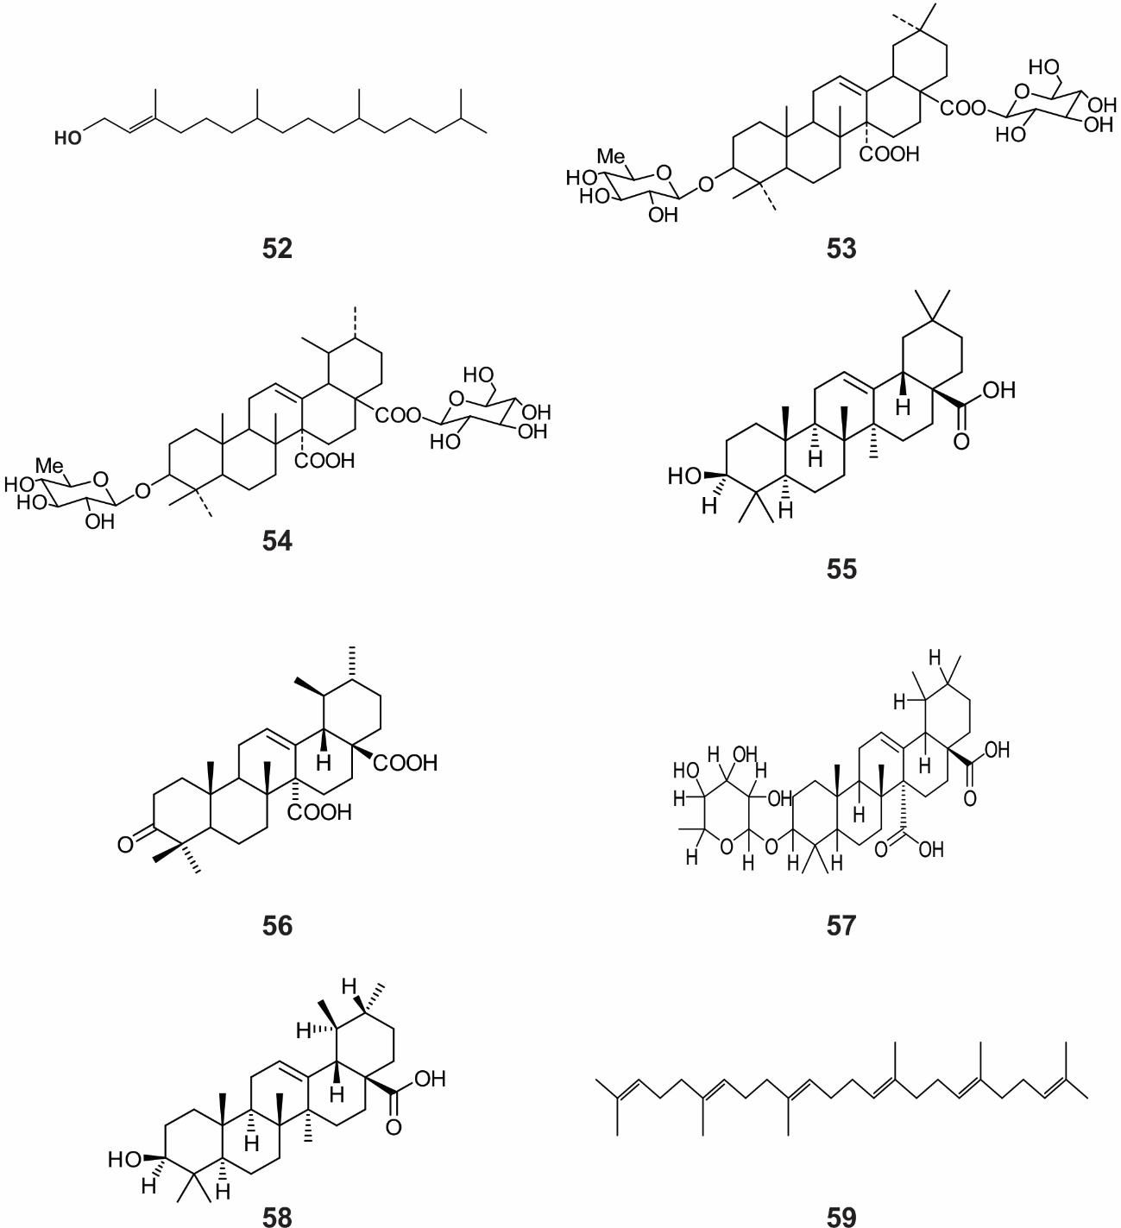
Figure S1. Structures of identified phytochemical compounds in Randia (Continuation).

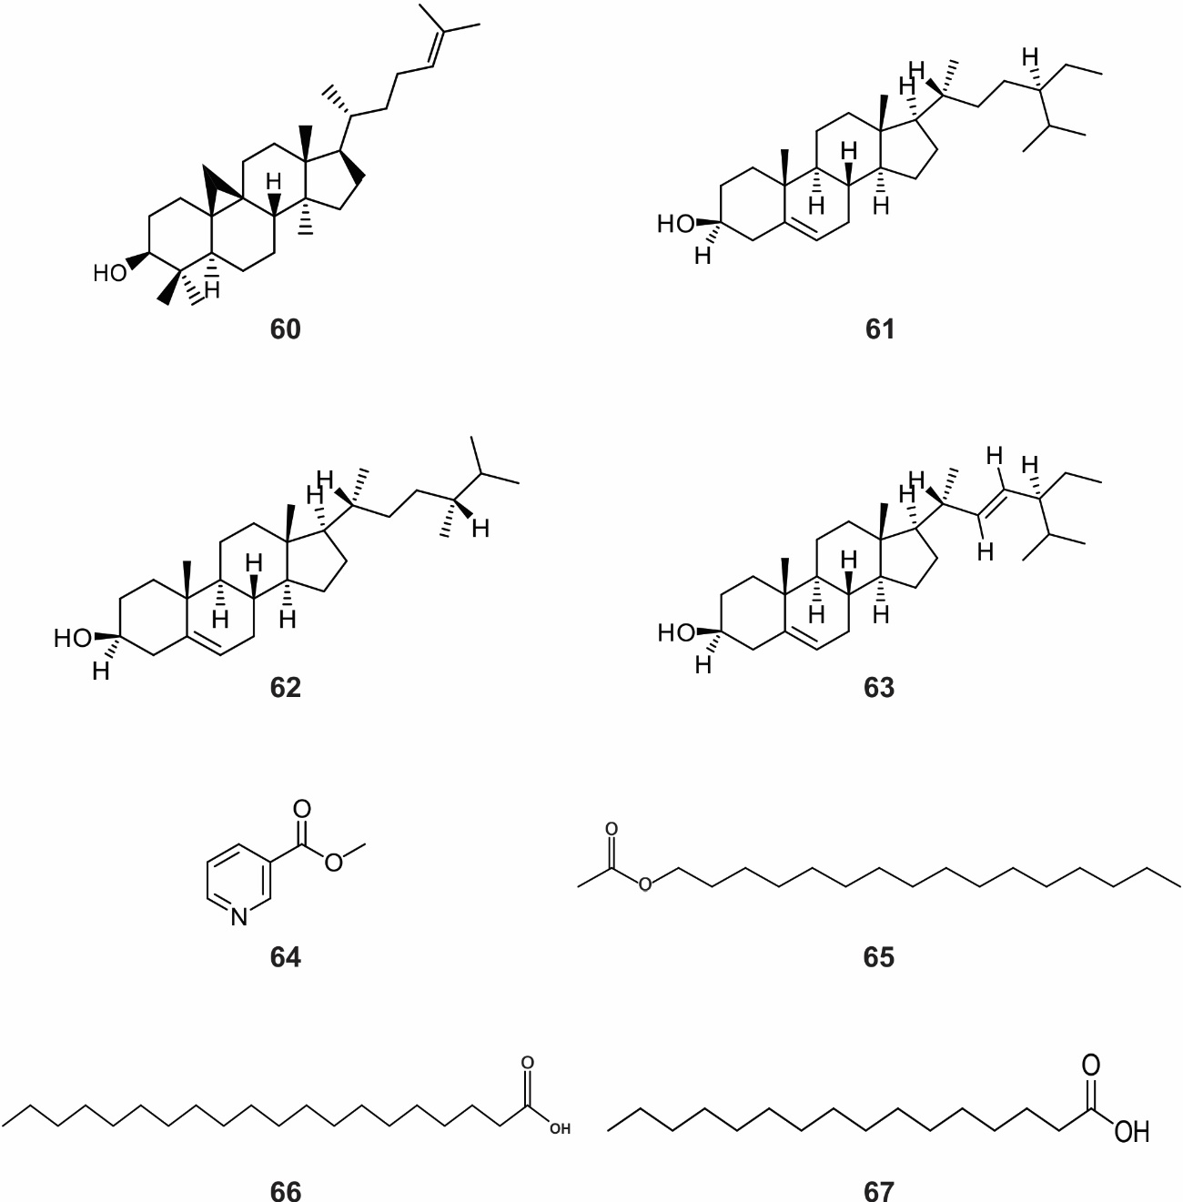
Figure S1. Structures of identified phytochemical compounds in Randia (Continuation).

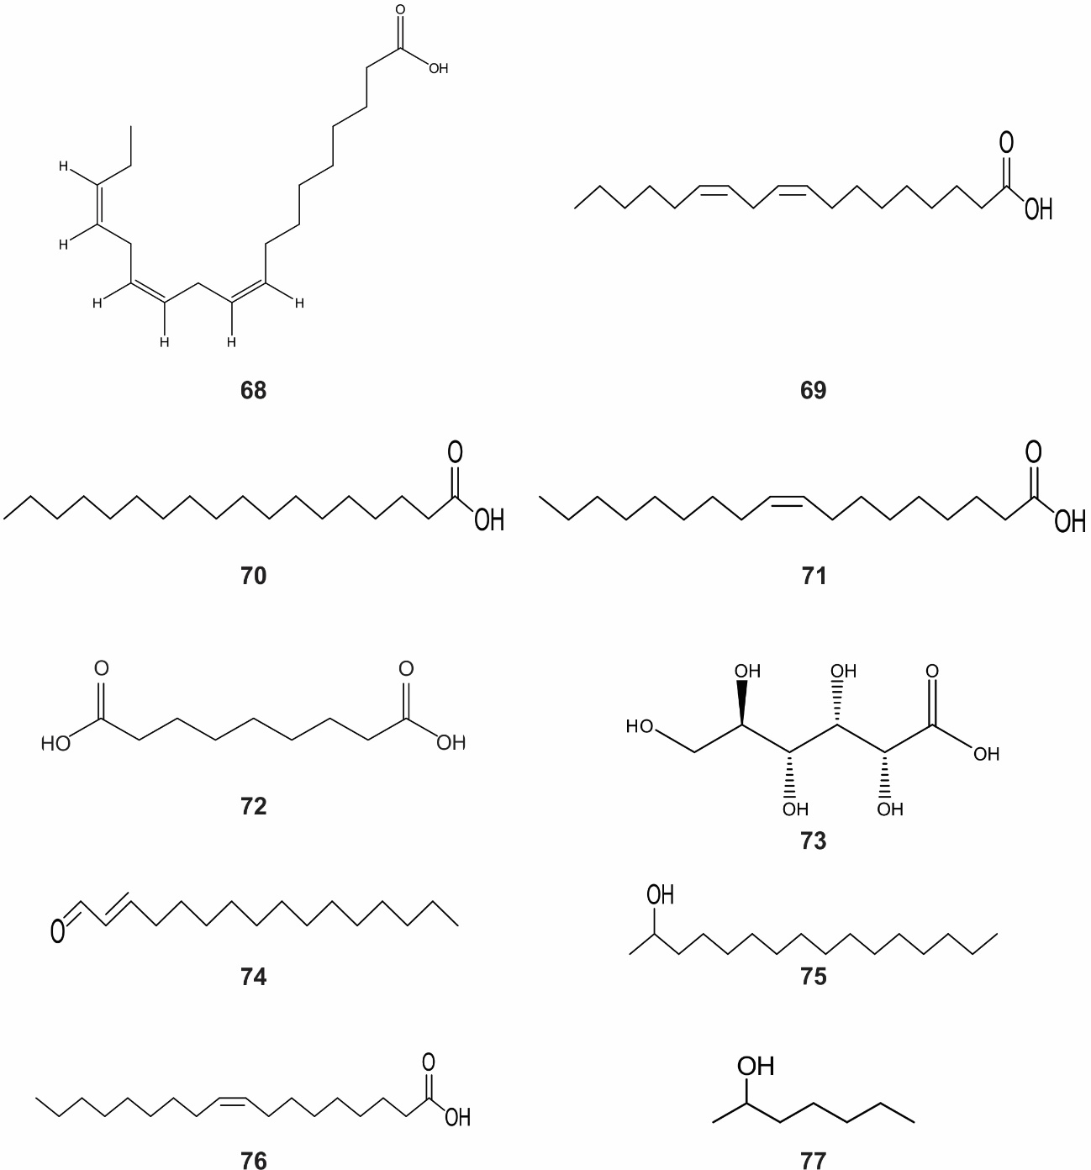
Figure S1. Structures of identified phytochemical compounds in Randia (Continuation).

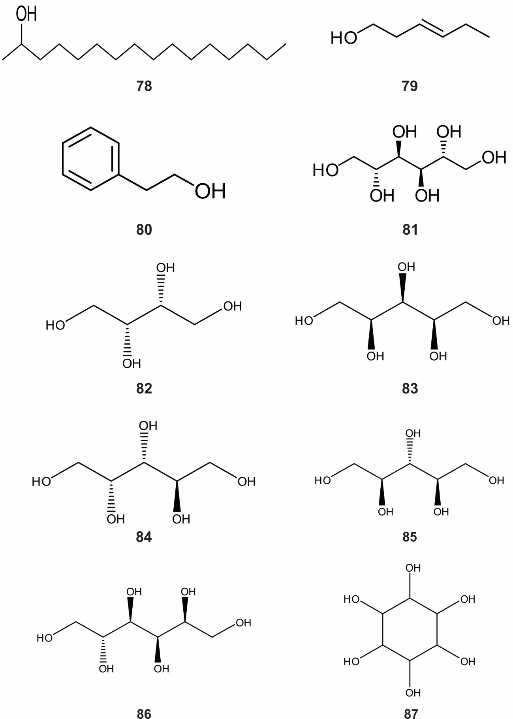
Figure S1. Structures of identified phytochemical compounds in Randia (Continuation).

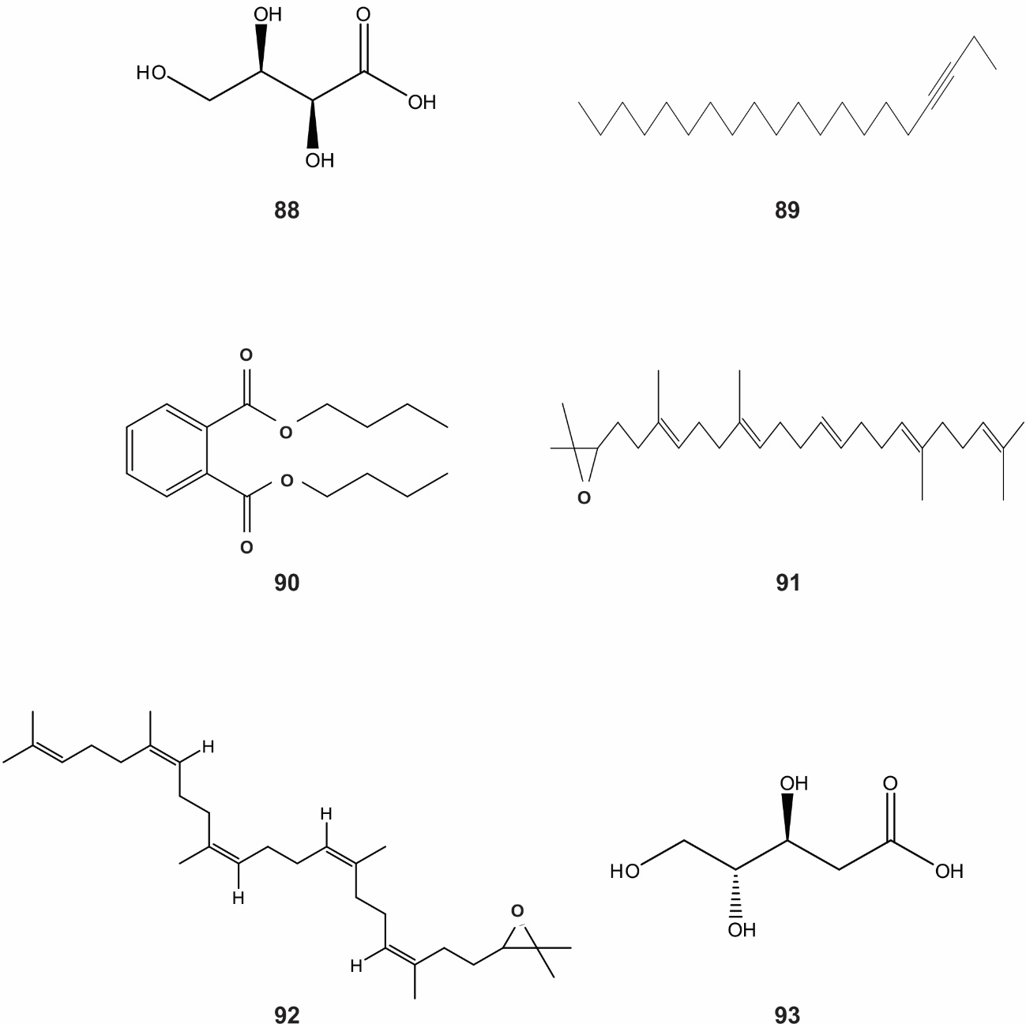
Figure S1. Structures of identified phytochemical compounds in Randia (Continuation).

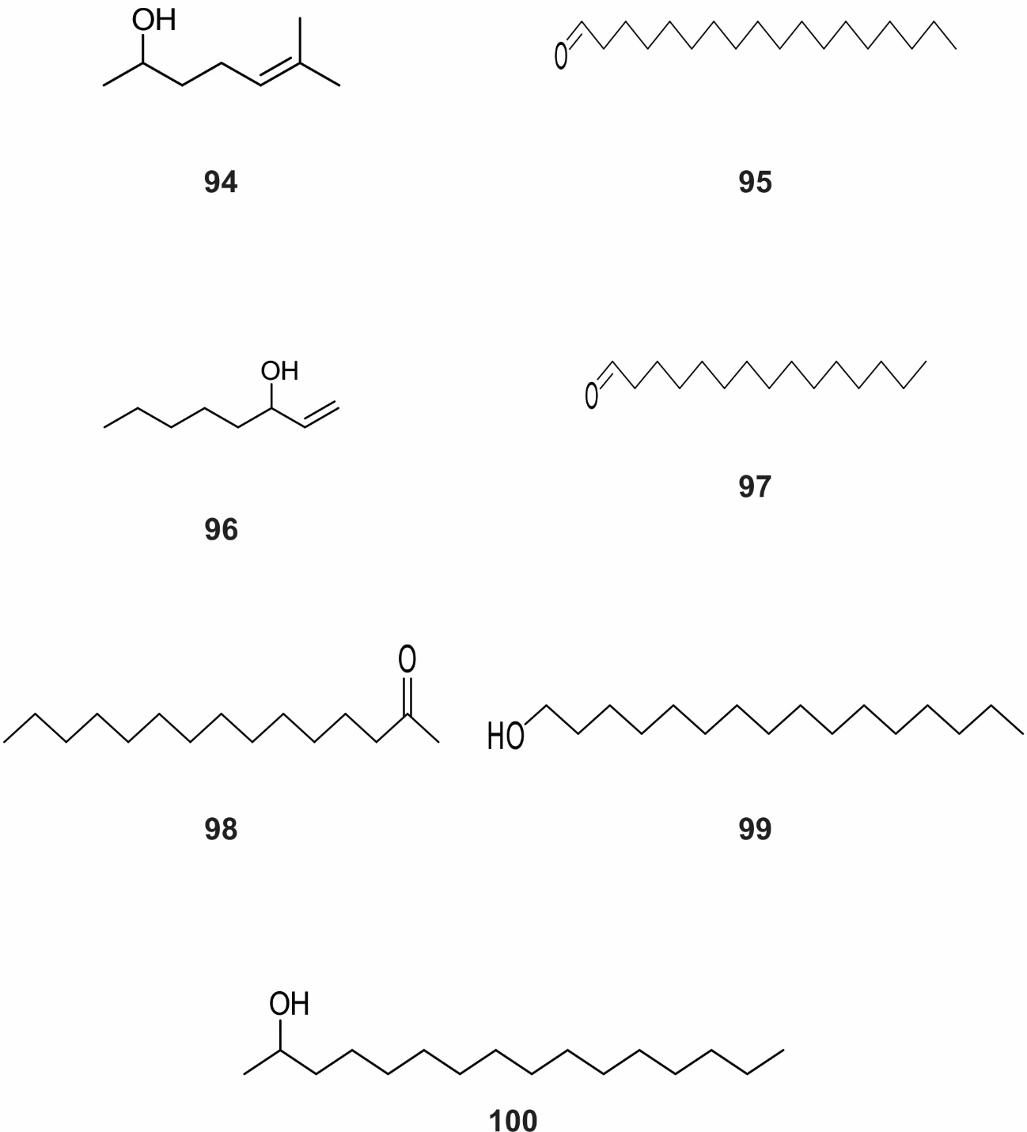
Figure S1. Structures of identified phytochemical compounds in Randia (Continuation).

Literature cited
An P, Yang X, Yu J, Qi J, Ren X, Kong Q. 2018. α-terpeinol and terpene-4-ol, the critical components of tea tree oil, exert antifungal activities in vitro and in vivo against Aspergillus niger in grapes by inducing morphous damage and metabolic changes of fungus. Food Control 98: 42-53. DOI: https://doi.org/10.1016/j.foodcont.2018.11.013
Ben Sghaier M, Pagano A, Mousslim M, Ammari Y, Kovacic H, Luis J. 2016. Rutin inhibits proliferation, attenuates superoxide production and decreases adhesion and migration of human cancerous cells. Biomedicine & Pharmacotherapy 84: 1972-1978. DOI: https://doi.org/10.1016/j.biopha.2016.11.001
Bye R, Linares E, Mata R, Albor C, Casteñeda PC, Delgado G. 1991. Ethnobotanical and phytochemical investigation of Randia echinocarpa (Rubiaceae). Anales del Instituto de Biología Serie Botánica 62: 87-106.
Calixto-Campos C, Carvalho TT, Hohmann MSN, Pinho-Ribeiro FA, Fattori V, Manchope MF, Zarpelon AC, Bacarat MM, Georgetti SR, Casagrande R, Verri WA. 2015. Vanillic acid inhibits inflammatory pain by inhibition neutrophil recruitment, oxidative stress, cytokine production, and NFkB activation in mice. Journal of Natural Products 78: 1799-1808. DOI: https://doi.org/10.1021/acs.jnatprod.5b00246
Cano-Campos MC, Díaz-Camacho SP, Uribe-Beltrán Md. J, López-Angulo G, Montes-Avila J, Paredes-López O, Delgado-Vargas F. 2011. Bio-guided fractionation of the antimutagenic activity of methanolic extract from the fruit of Randia echinocarpa (Sessé et Mociño) against 1-nitropyrene. Food Research International 44: 3087-3093. DOI: https://doi.org/10.1016/j.foodres.2011.08.006
Chakraborty K, Joy M, Raola VK. 2021. Anti-inflammatory β-sitosterols from the Asiatic loop-root mangrove Rhizopora mucronata attenuate 5-lipoxygenase and cyclooxygenase-2 enzymes. Steroids 172: 1-10. DOI: https://doi.org/10.1016/j.steroids.2021.108860
De Melo GO, Malvar D do C, Vanderlinde FA, Rocha FF, Pires PA, Costa EA, de Matos LG, Kaiser CR, Costa SS. 2009. Antinociceptive and anti-inflammatory kaempferol glycosides from Sedum dendroideum. Journal of Ethnopharmacology 124: 228-232. DOI: https://doi.org/10.1016/j.jep.2009.04.024
Dietrich F, Kaiser S, Rockenbach L, Figueiró F, Scussel-Bergarmir L, Monte-da Cunha F, Bueno-Morrone F, González-Ortega G, Oliveira-Battastini AM. 2014. Quinovic acid glycosides purified fraction from Uncaria tomentosa induces cell death by apoptosis in the T24 human bladder cancer cell line. Food and Chemical Toxicology 67: 222-229. DOI: https://doi.org/10.1016/j.fct.2014.02.037
Ham JR, Lee HI, Choi RY, Sim MO, Choi MS, Kwon EY, Yun KW, Kim MJ, Lee MK. 2016. Anti-obesity and anti-hepatosteatosis effects of dietary scopoletin in high-fat diet fed mice. Journal of Functional Foods 25: 433-446. DOI: https://doi.org/10.1016/j.jff.2016.06.026
Juárez-Trujillo N, Monribot-Villanueva JL, Alvarado-Olivarez M, Luna-Solano G, Guerrero-Analco JA, Jiménez-Fernández M. 2018. Phenolic profile and antioxidative properties of pulp and seeds of Randia monantha Benth. Industrial Crops and Products 124: 53-58. DOI: https://doi.org/10.1016/j.indcrop.2018.07.052
Khayam AU, Patel H, Faoila NA, Figueroa Milla AE, Dilshad E, Mirza B, Huang Y, Sheikh MS. 2020. Quinovic acid purified from medicinal plant Fagonia indica mediates anticancer effects via death receptor 5. Molecular and Cellular Biochemistry 474: 159-169. DOI: https://doi.org/10.1007/s11010-020-03841-4
Kim MG, Kim SM, Min JH, Kwon OK, Park MH, Park JW, Ahn HI, Hwang JY, Oh SR, Lee JW, Ahn KS. 2019. Anti-inflammatory effects of linalool on ovalbumin-induced pulmonary inflammation. International Immunopharmacology 74: 1-9. DOI: https://doi.org/10.1016/j.intimp.2019.105706
Li Y, Yang D, Jia Y, He L, Li J, Yu C, Liao C, Yu Z, Zhang C. 2021. Research note: Anti-inflammatory effects and antiviral activities of baicalein and chlorogenic acid against infectious bursal disease virus in embryonic eggs. Poultry Science 100: 1-6. DOI: https://doi.org/10.1016/j.psj.2021.01.010
Librán-Pérez M, Pereiro M, Figueras A, Novoa B. 2019. Antiviral activity of palmitic acid via autophagic flux inhibition in zebrafish (Danio rerio). Fish & Shellfish Immunology 95: 595-605. DOI: https://doi.org/10.1016/j.fsi.2019.10.055
Nazari AS, Dias SA, da Costa WF, Bersani-Amado CA, Vidotti GJ, de Souza MC, Sarragiotto MH. 2006. Anti-inflammatory and antioxidant activities of Randia hebecarpa and major constituents. Pharmaceutical Biology 44: 7-9. DOI: https://doi.org/10.1080/13880200500496504
Pegoraro NS, Camponogara C, Cruz L, Oliveira SM. 2020. Oleic acid exhibits an expressive anti-inflammatory effect in croton oil-induced irritant contact dermatitis without the occurrence of toxicological effects in mice. Journal of Ethnopharmacology 267: 1-12. DOI: https://doi.org/10.1016/j.jep.2020.113486
Prasath KG, Alexpandi R, Parasuraman R, Pavithra M, Ravi AV, Pandian SK. 2021. Anti-inflammatory potential of myristic acid and palmitic acid synergism against systemic candidiasis in Danio rerio (Zebrafish). Biomedicine & Pharmacotherapy 133: 1-16. DOI: https://doi.org/10.1016/j.biopha.2020.111043
Rodenak-Kladniew B, Castro MA, Crespo R, Galle M, García-de Bravo M. 2020. Anti-cancer mechanisms of linalool and 1,8-cineole in non-small cell lung cancer A459 cells. Heliyon 6: 1-12. DOI: https://doi.org/10.1016/j.heliyon.2020.e05639
Setzer WN, Noletto JA, Lawton RO. 2006. Chemical composition of the floral essential oil of Randia matudae from Monteverde, Costa Rica. Flavour and Fragrance Journal 21: 244-246. DOI: https://doi.org/10.1002/ffj.1567
Torres-Rego M, Furtado AA, Bitencourt MOA, Lima MCJS, Andrade RCLC, Azevedo EP, Soares EP, Tomaz JC, Lopes NP, da Silava-Júnior AA, Zucolotto SM, Fernandes-Pedrosa MF. 2016. Anti-inflammatory activity of aqueous extract and bioactive compounds identified from the fruits of Hancornia speciosa Gomes (Apocynaceae). BMC Complementary and Alternative Medicine 16: 1-10. DOI: https://doi.org/10.1186/s12906-016-1259-x
Wang L, Du H, Chen P. 2020. Chlorogenic acid inhibits the proliferation of human lung cancer A459 cell lines by targeting annexin A2 in vitro and in vivo. Biomedicine & Pharmacotherapy 131: 1-13. DOI: https://doi.org/10.1016/j.biopha.2020.110673

