Supplemenary material

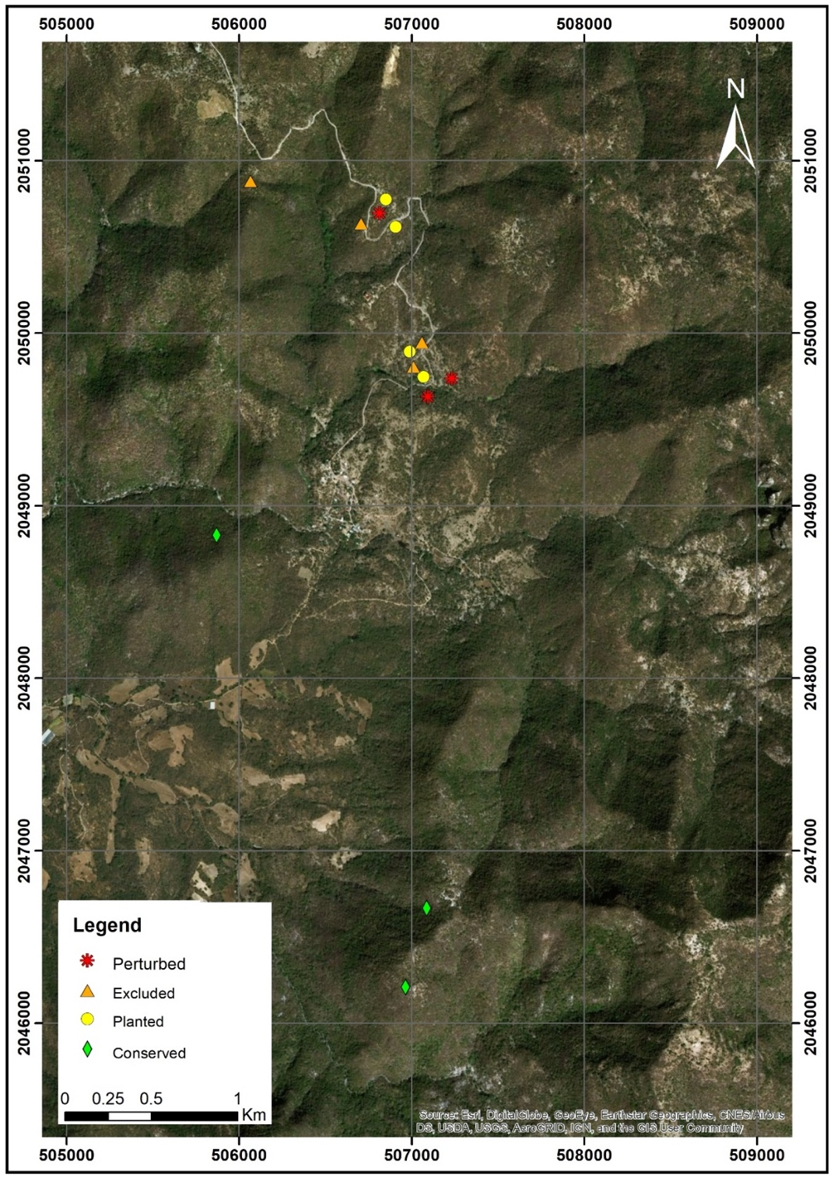
Figure S1. Experimental design of 14 50 × 50m plots at El Limón de Cuauchichinola, Sierra de Huautla, Morelos, Mexico. Plots marked with green diamonds are conserved habitat, plots marked with yellow circles are restoration plantings, plots marked with orange triangles were left unplanted (called excluded) and plots marked with red asterisk are perturbed habitat. Elaborated by Iris Juan Baeza.

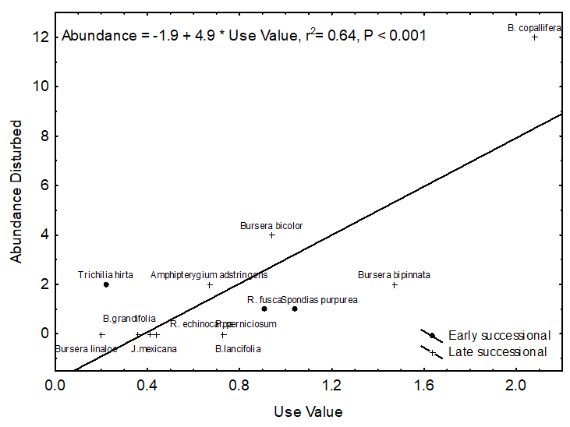

Figure S2. Correlation between Use value and abundance of trees in disturbed habitats for 13 dioecious species (ten late-successionals and three early-successionals) in El Limón de Cuauchichinola, Sierra de Huautla, Morelos. Value of r² and regression line are shown. Correlation is not significant when B. copallifera is excluded (r = 0.49, P > 0.05).

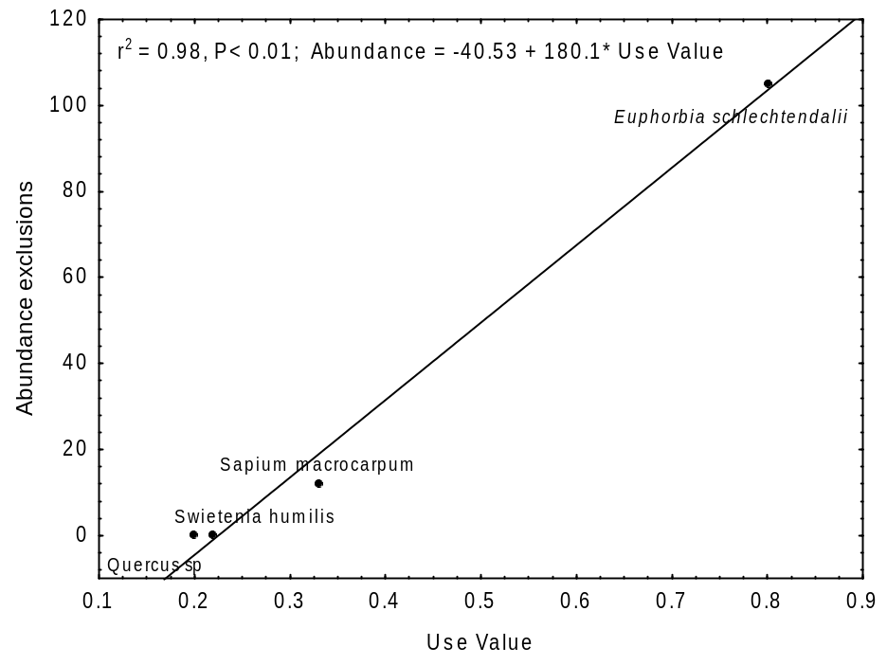
Figure S3. Correlation between Use value and abundance of trees in disturbed habitats for 4 monoecious species in El Limón de Cuauchichinola, Sierra de Huautla, Morelos. Value of r² and regression line are shown.

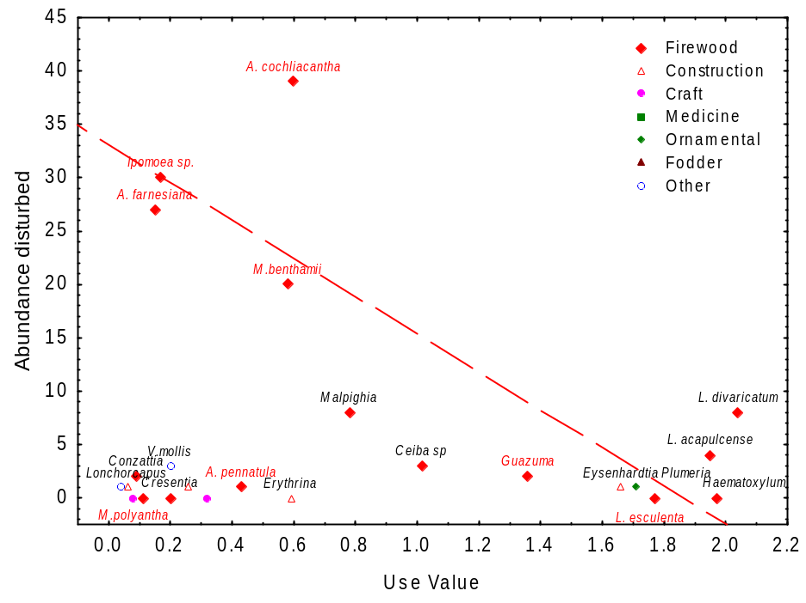
Figure S4. Correlation between Use value and abundance of trees in the disturbed habitat for 20 hermaphrodite species with seven categories of use in El Limón de Cuauchichinola, Sierra de Huautla, Morelos. Regression line includes six early successional species used primarily for firewood (r²=0.074, P < 0.05).

