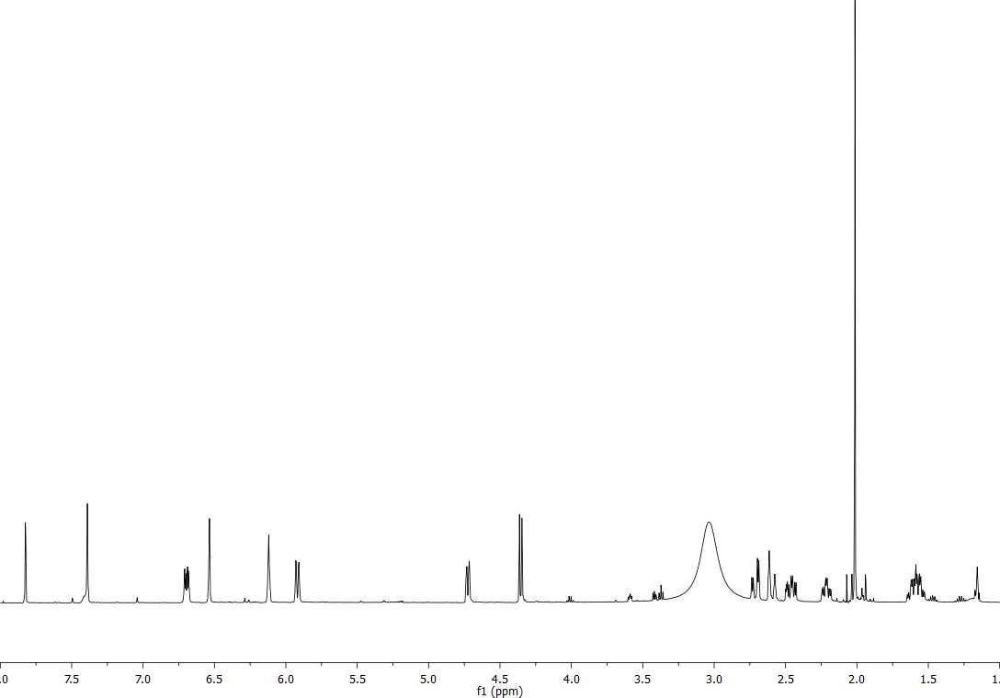
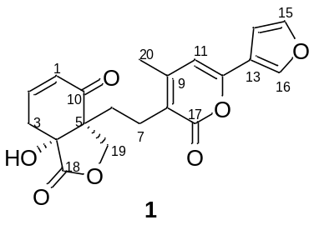Supplementary Material

Figure S1. ¹H NMR spectrum of amarissinin A (1, 500 MHz, CDCl₃-DMSO-d₆)
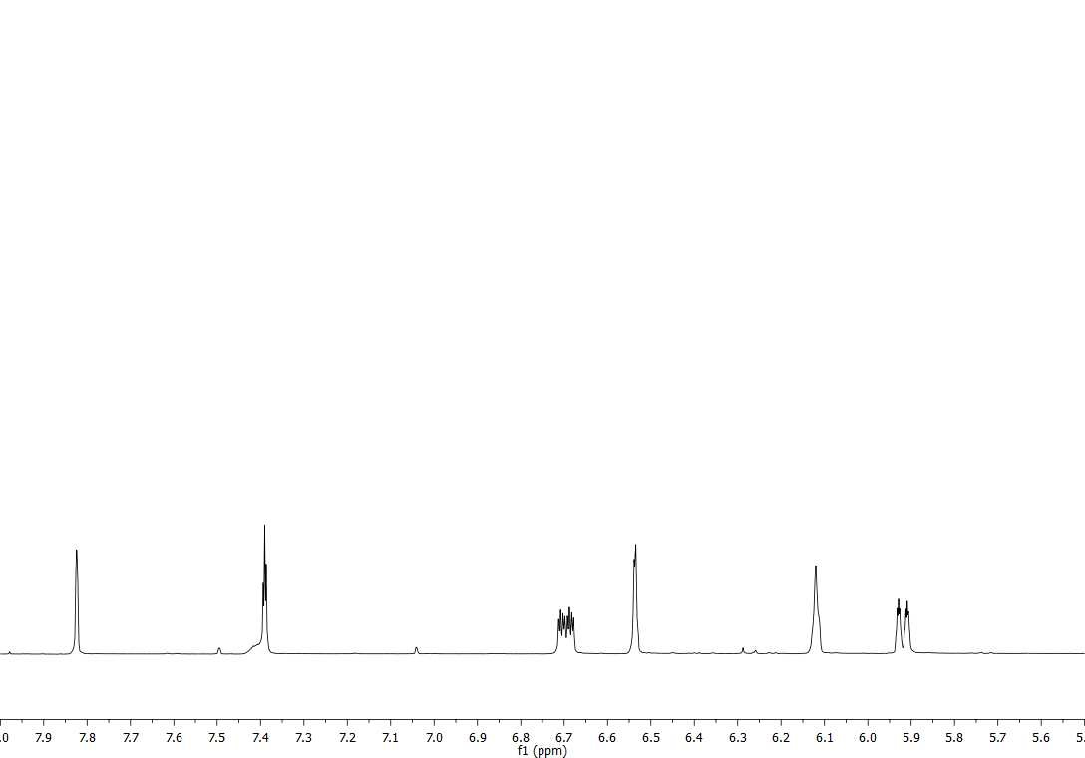
Figure S2. Expansion of the ¹H NMR spectrum of amarissinin A (1, 500 MHz, CDCl3-DMSO-d₆)
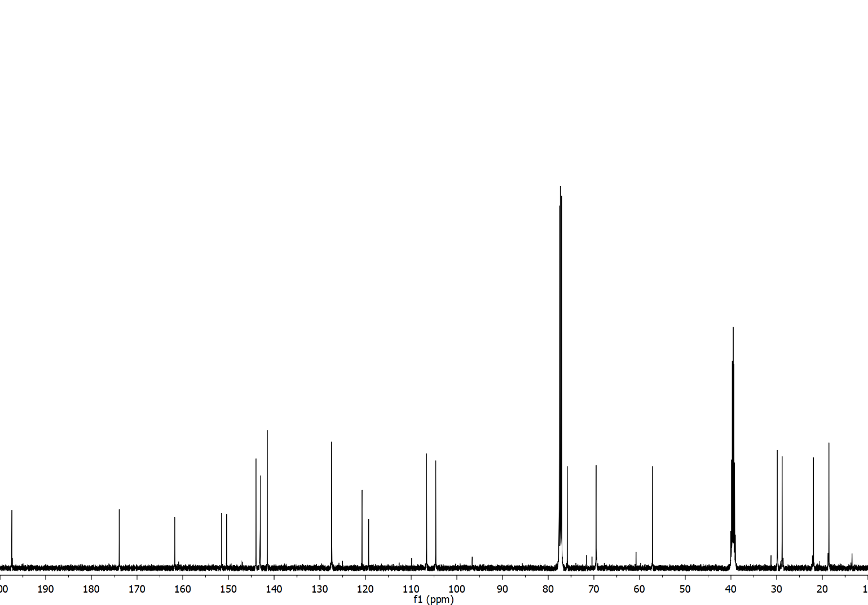
Figure S3. ¹³C NMR spectrum of amarissinin A (1, 125 MHz, CDCl₃-DMSO-d₆)
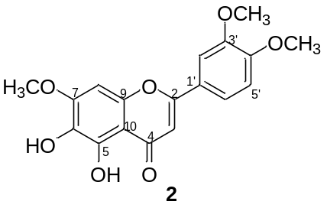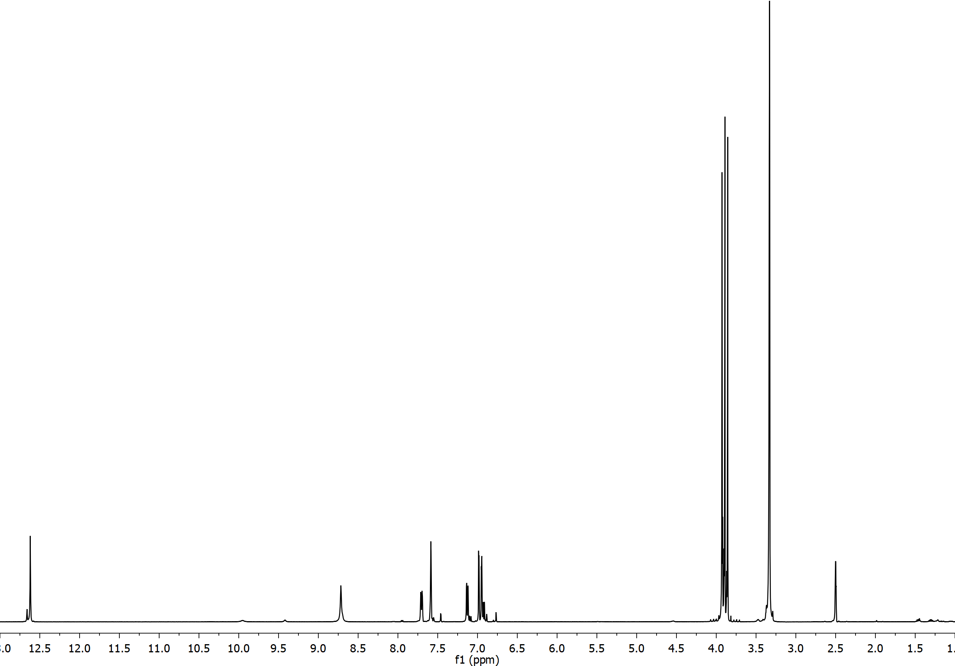
Figure S4.¹H NMR spectrum of 5,6-dihydroxy-7,3’,4’-trimethoxyflavone (2, 500 MHz, DMSO-d₆)
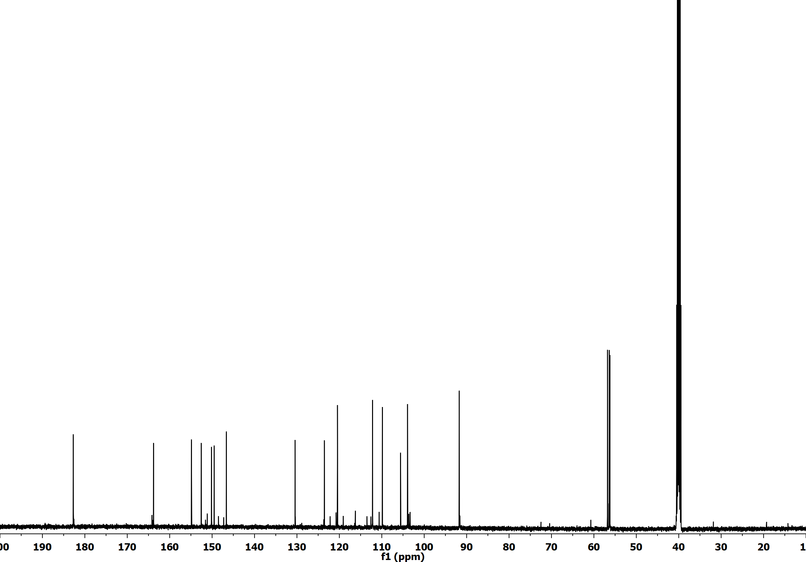
Figure S5. ¹³C NMR spectrum of 5,6-dihydroxy-7,3’,4’-trimethoxyflavone (2, 125 MHz, DMSO-d₆)

Table S1. Volatile metabolites detected by GC-MS. This table presents the average ± SD of normalized amounts in % of volatile compounds present in the acetone extract from Salvia urica.
No. Compound | Class | Compound name | % ± SD
1 | Alkane | Undecane | 1.85 ± 0.02
2 | Alkane | Dodecane | 3.39 ± 0.12
3 | Alkane | Tridecane | 5.25 ± 0.21
4 | Alkane | Tetradecane | 1.40 ± 0.07
5 | Alkane | 2,2-Dimethyleicosane | 0.34 ± 0.17
6 | Aromatic | 2-Allyl quinizarin | 4.62 ± 0.50
7 | Aromatic | 3,4,5,6,7,8-hexahydrocyclobuta[5,6]cycloocta[7,8]naphtho[2,3-d][1,3]dioxol-1(2H)-one | 2.15 ± 0.21
8 | Alkane | Tricosane | 0.82 ± 0.42
9 | Aromatic | Santonin | 1.22 ± 0.62
10 | Triterpene | Squalene | 1.13 ± 0.69
11 | Alkane | Nonacosane | 2.34 ± 1.19
12 | Sterol | Stigmasterol | 10.05 ± 5.24
13 | Triterpene | β-amyrin | 25.84 ± 0.98
14 | Triterpene | α-amyrenone | 17.68 ± 0.88
15 | Triterpene | α-amyrin | 17.38 ± 8.70
16 | Triterpene | Sterculin A | 4.53 ± 2.36

